Rehearsal-1 : Windchill Upgrade from 12.0.2.11 to 13.0.2.5

Schindler CRD Applications

Exported on 2025-08-19 05:09:48

Table of Contents

1 4

2 Windchill Upgrade from 12.0.2.11 to 13.0.2.5 6

3 Prerequisites: 7

4 Rehost Source Windchill (12.0.2.11) with Prod Data: 8

5 Vault Copy on Target Server: 9

6 WinDU Execution on Source (CRDWSR0245): 10

6.1 WinDU Potential Problem-1: ListCheckedOutWorkflowLifecycleTemplates 12

7 Convert links from Legacy to Flexible mode with FlexibleChangeConverter tool: 15

8 Target Windchill 13.0.2.0 Installation: 31

9 SSL Configuration 32

10 Windchill CPS 13.0.2.5 Installation 33

11 Take AppData Folder Backup 34

12 Active Directory Configuration 35

13 Disable SSL Configuration 36

14 Copy Source Customizations to Target 37

15 Copy Vault Folders 38

16 Import Source DB to target and update the entries 39

17 Import the Source DS onto Target DS 44

18 Prerequisites Before Running Upgrade Manager 50

19 Run Upgrade Manager 51

20 Enable SSL Configuration 69

21 Windchill Starting Issue: 70

22 Importing License 72

23 Recheck AD Configuration 73

24 Vault Configuration 74

25 Clean Unreferenced Vault Files 80

26 Index Search Installation and Configuration 83

27 Post Upgrade WinDU 84

27.1 WinDU Potential Problem-1: Processes Missing Team 85

27.2 WinDU Potential Problem-2: List Multiple State 87

27.3 WinDU Potential Problem-3: DanglingPBORef 89

28 Windchill Configuration Assistant 91

29 Windchill, DS and Apache as Windows Services 102

29.1 Apache: 102

29.2 Windchill: 102

29.3 Windchill DS (Open DJ): 104

30 Disable unused Workflows/Life Cycles enabled for Source WinDU 106

31 Perform Check Syntax for Workflows 108

32 Add Windchill Shell as Shortcut 109

33 Errors in Method Server Log 111

33.1 Error-1: 111

33.2 Error-2: 112

33.3 Error-3: 112

33.4 Error-4: 113

34 Performance Tuning: 116

35 Windchill Stop and Start Shortcuts on Desktop: 117

36 Procedure to Stop Windchill, Clean Cache and Start Windchill: 118

# 

* Windchill Upgrade from 12.0.2.11 to 13.0.2.5
* Prerequisites:
* Rehost Source Windchill (12.0.2.11) with Prod Data:
* Vault Copy on Target Server:
* WinDU Execution on Source (CRDWSR0245):
  + WinDU Potential Problem-1: ListCheckedOutWorkflowLifecycleTemplates
* Convert links from Legacy to Flexible mode with FlexibleChangeConverter tool:
* Target Windchill 13.0.2.0 Installation:
* SSL Configuration
* Windchill CPS 13.0.2.5 Installation
* Take AppData Folder Backup
* Active Directory Configuration
* Disable SSL Configuration
* Copy Source Customizations to Target
* Copy Vault Folders
* Import Source DB to target and update the entries
* Import the Source DS onto Target DS
* Prerequisites Before Running Upgrade Manager
* Run Upgrade Manager
* Enable SSL Configuration
* Windchill Starting Issue:
* Importing License
* Recheck AD Configuration
* Vault Configuration
* Clean Unreferenced Vault Files
* Index Search Installation and Configuration
* Post Upgrade WinDU
  + WinDU Potential Problem-1: Processes Missing Team
  + WinDU Potential Problem-2: List Multiple State
  + WinDU Potential Problem-3: DanglingPBORef
* Windchill Configuration Assistant
* Windchill, DS and Apache as Windows Services
  + Apache:
  + Windchill:
  + Windchill DS (Open DJ):
* Disable unused Workflows/Life Cycles enabled for Source WinDU
* Perform Check Syntax for Workflows
* Add Windchill Shell as Shortcut
* Errors in Method Server Log
  + Error-1:
  + Error-2:
  + Error-3:
  + Error-4:
* Performance Tuning:
* Windchill Stop and Start Shortcuts on Desktop:
* Procedure to Stop Windchill, Clean Cache and Start Windchill:

# Windchill Upgrade from 12.0.2.11 to 13.0.2.5

# Prerequisites:

1. Need Admin access on Windchill Application server.
2. Need Windchill Administrator privileges.

# Rehost Source Windchill (12.0.2.11) with Prod Data:

1. Schindler team rehosted the environment with latest data, validated all the functionalities and provided the confirmation to move ahead with upgrade process.

# Vault Copy on Target Server:

1. Create PDMLVault folder in D drive

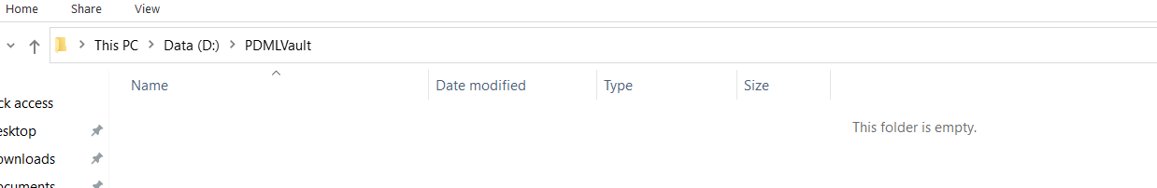

1. Open cmd in Administrator mode and run below command

robocopy \\CRDWSR0245\d$\PDMLVault D:\PDMLVault /MIR /MT:8

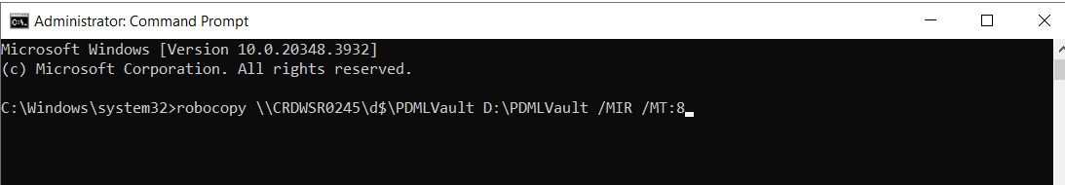

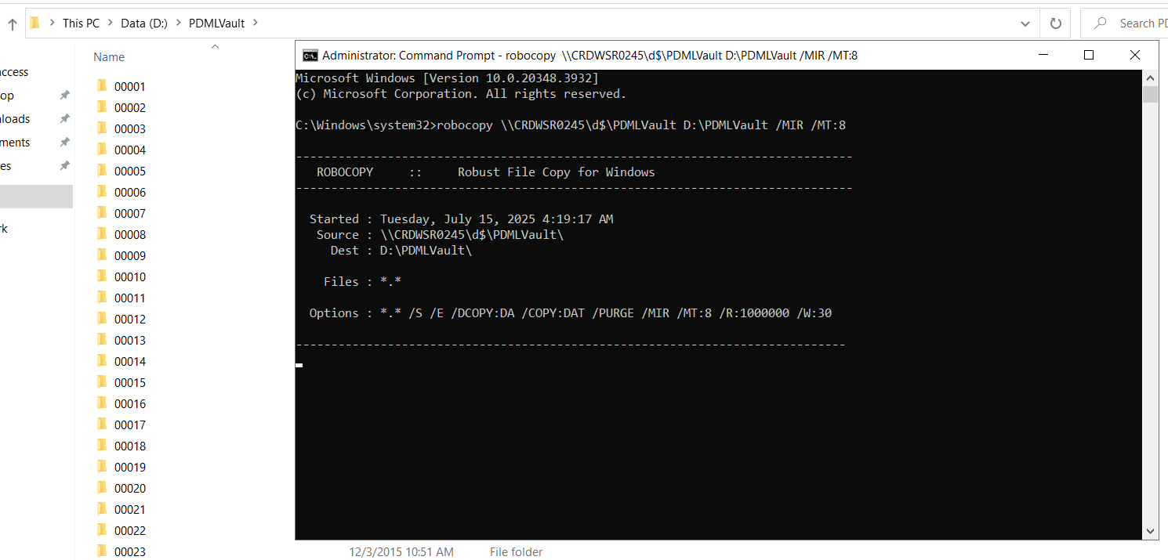

# WinDU Execution on Source (CRDWSR0245):

1. Log into Windchill Application server with admin access.
2. Make sure source Windchill is up & running.
3. Please verify the reported Potential Problems by WinDU in earlier rehearsal for better execution.
4. Launch Windchill Shell as an administrator.

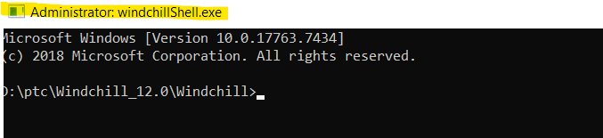

4. Run WinDu from Windchill Shell as shown below.

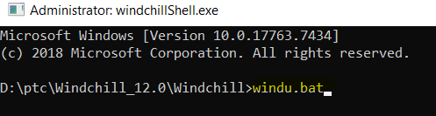

5. After successful execution of the WinDU it will launch the below page.

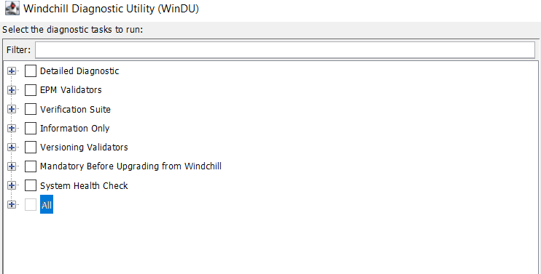

6. Make sure to de-select everything.

7. Select "**Mandatory Before Upgrading from Windchill**" checkbox and click on Run as shown below.

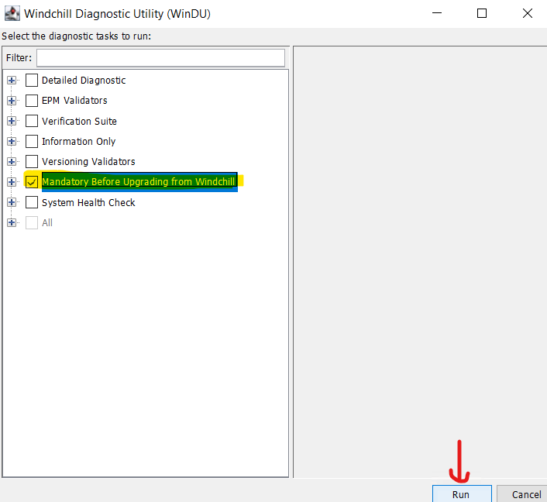

8. Provide the Windchill admin credentials, click on Yes and wait for the WinDU execution.

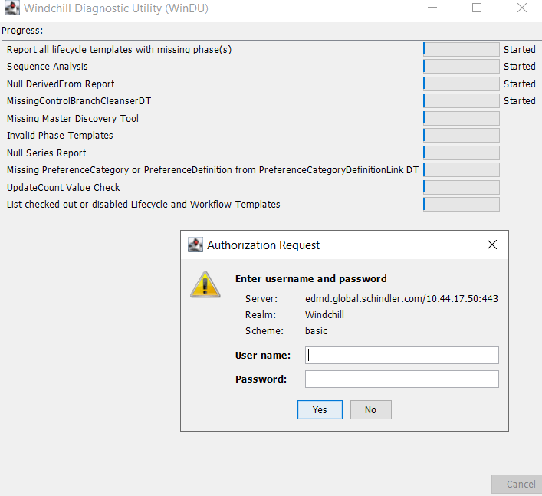

9. WinDU will take time for the execution (For Rh-1 started WinDU at 5:00 PM IST on 24th June 2025 and it got completed at 6:10 PM IST on 24th June 2025).

10. Below is the issue reported by WinDU. Click on the HTML link to open the report.

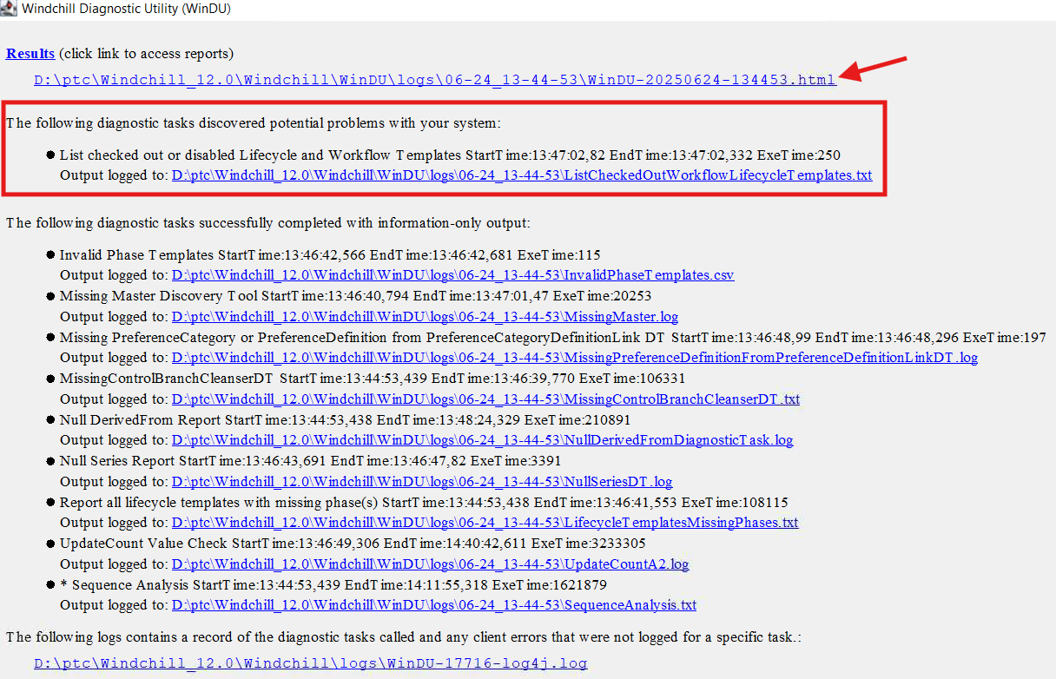

## WinDU Potential Problem-1: ListCheckedOutWorkflowLifecycleTemplates

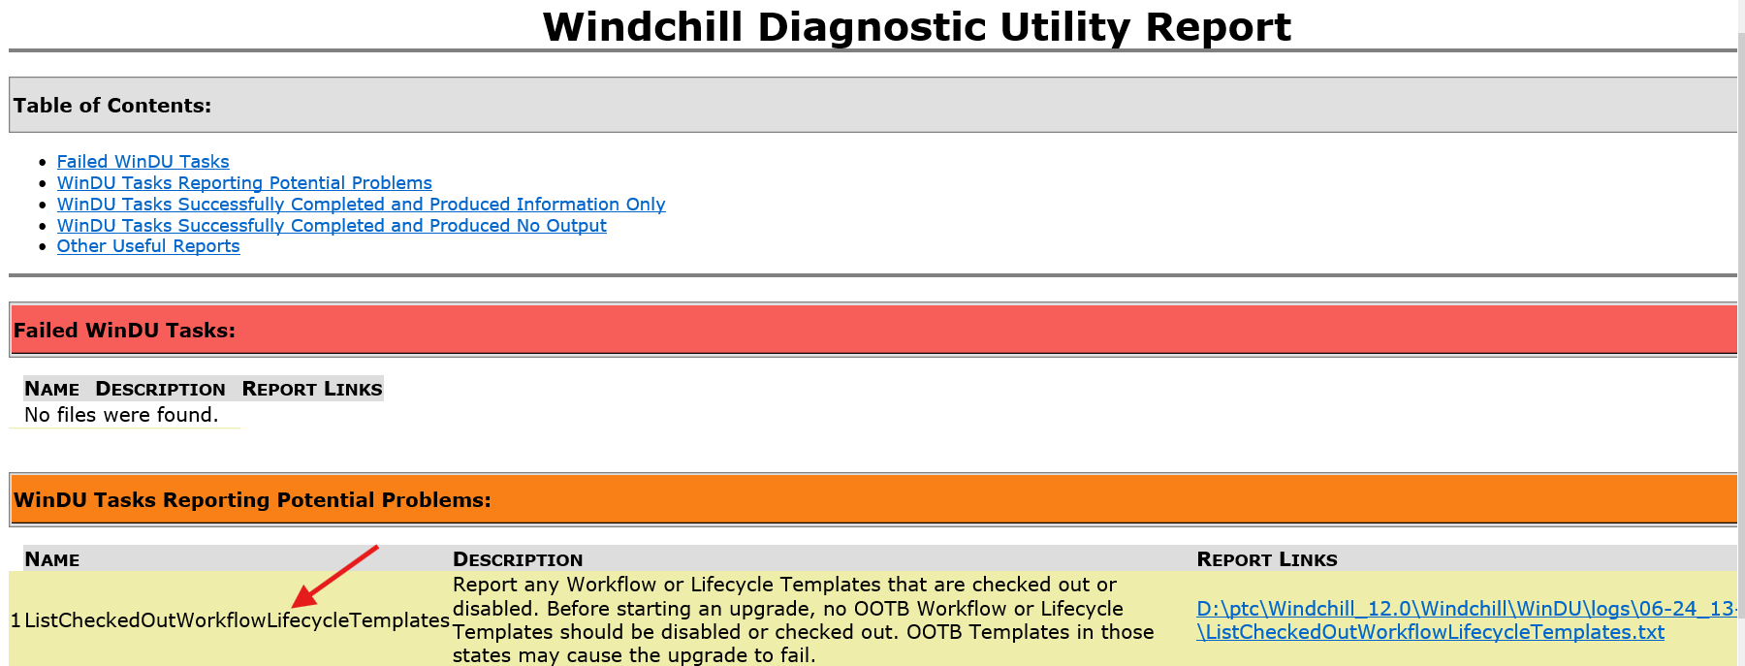

1. Open ListCheckedOutWorkflowLifecycleTemplates.txt file as shown below.

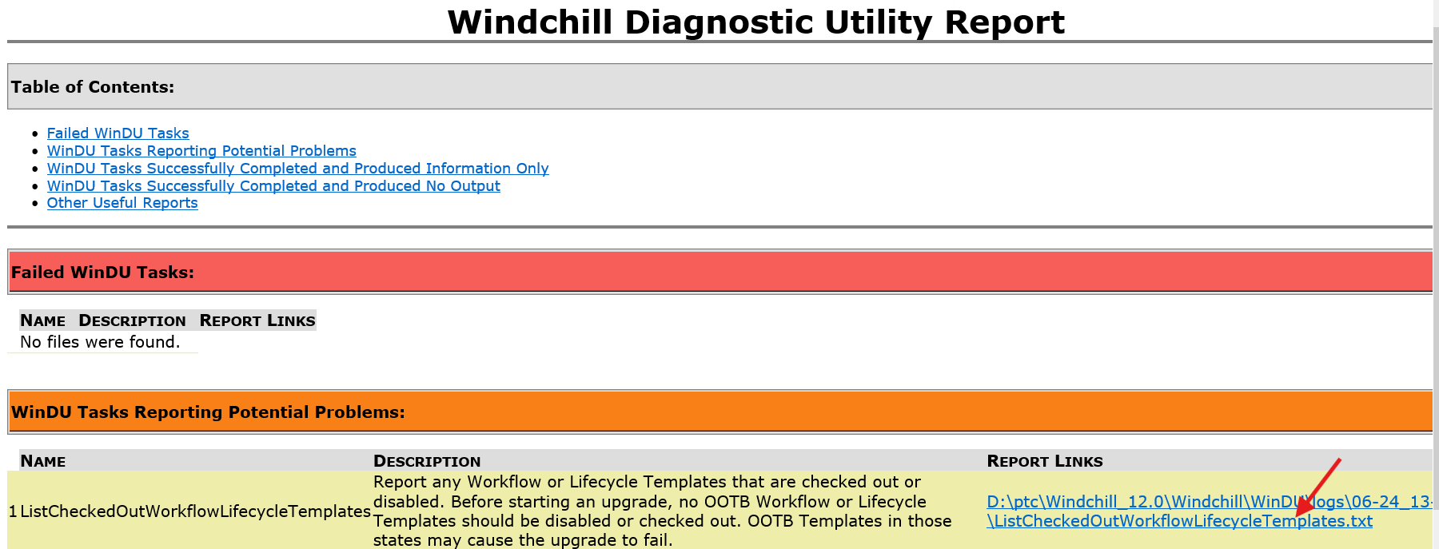

2. Below is the info available in the ListCheckedOutWorkflowLifecycleTemplates.txt file. Enable/check-in the lifecycles and workflows that are reported.

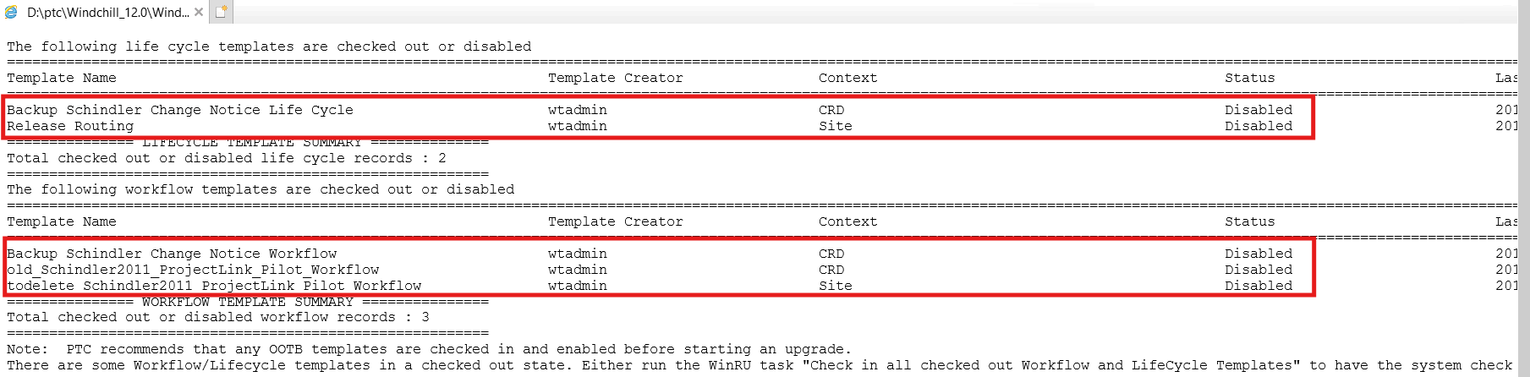

3. Below are the screenshots of the Lifecycles before enabling.

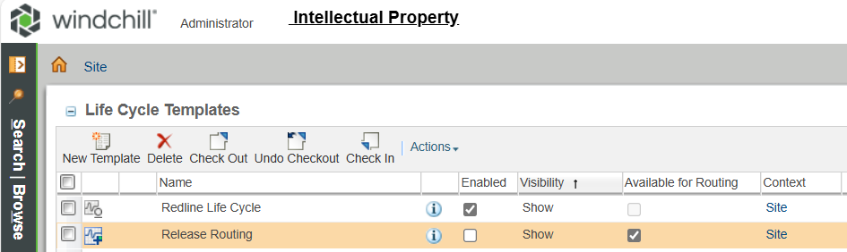

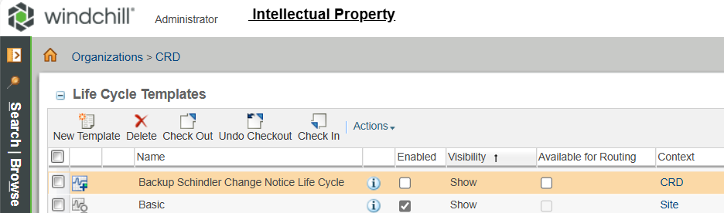

4. Below are the screenshots of the Lifecycles after enabling (Note: Disable Post Upgrade).

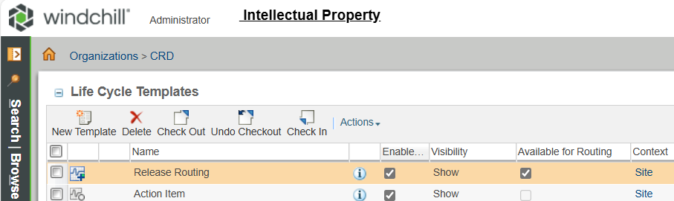

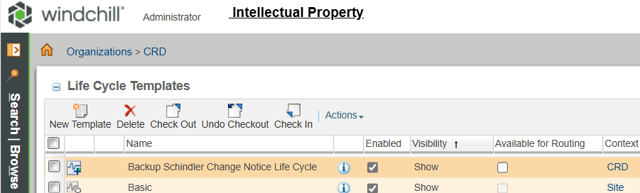

5. Below are the screenshots of the Workflows before enabling.

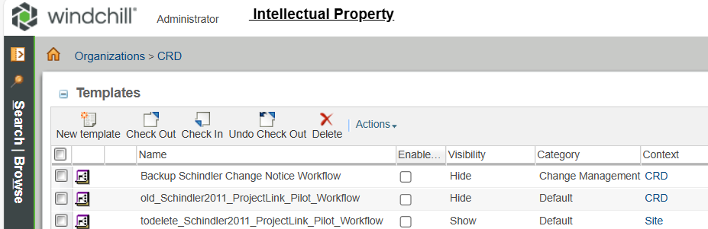

6. Below are the screenshots of the Workflows after enabling and making them as Visible (Note: Revert the changes Post Upgrade).

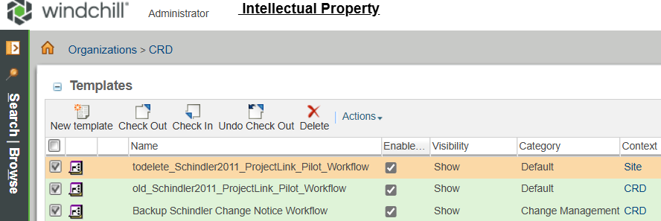

7. Re-run the WinDU to make sure the issue got resolved.

8. WinDU executed successfully and no potential problems were reported (For Rh-1 second time started WinDU at 9:10 AM IST on 25th June 2025 and it got completed at 10:05 AM IST on 25th June 2025).

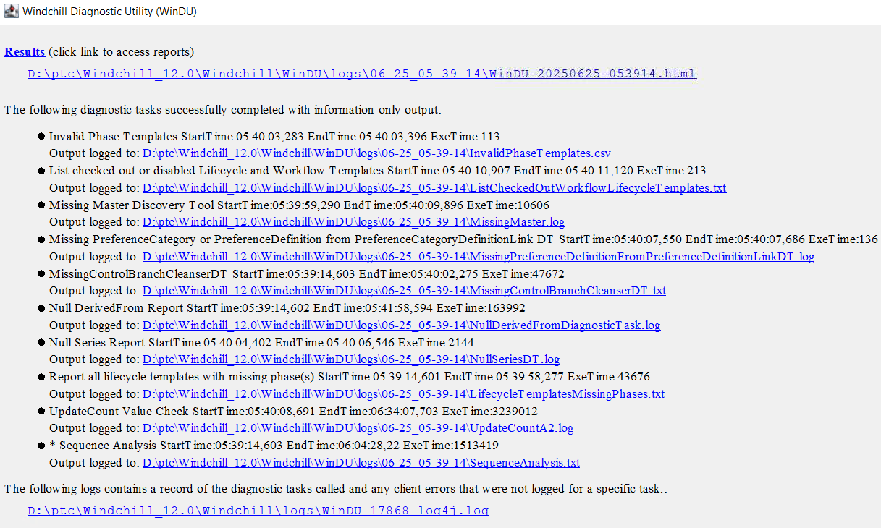

# Convert links from Legacy to Flexible mode with FlexibleChangeConverter tool:

1. Nagesh and team completed this activity by modifying two OOTB classes and following the below articles.

* [Article - CS419883 - Removal of Legacy Links from Windchill 13.0.2.0](https://www.ptc.com/en/support/article/CS419883?source=search)
* [Article - CS262354 - How to convert the change objects and links from Legacy to Flexible mode with FlexibleChangeConverter tool in Windchill PDMLink](https://www.ptc.com/en/support/article/CS262354?source=search)
* Create Service now Ticket to take backup of database.

INC1270525 created for backup

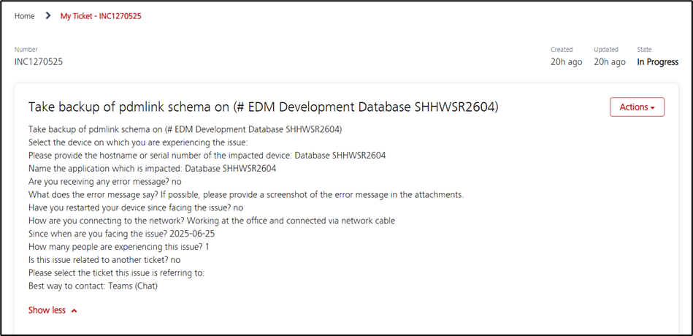

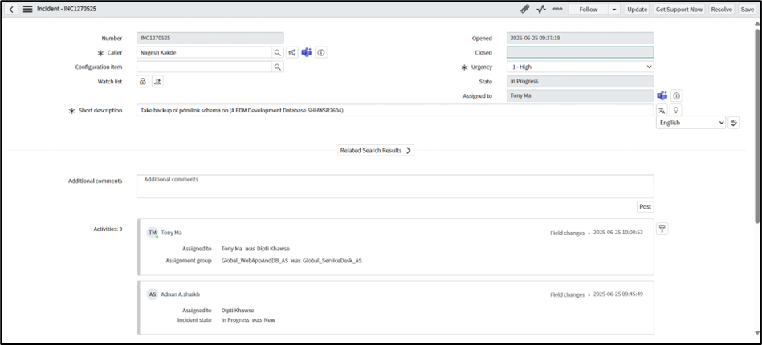

* Open windchill shell in Administrator mode and run below command

java wt.change2.flexible.FlexibleChangeConverter -action report

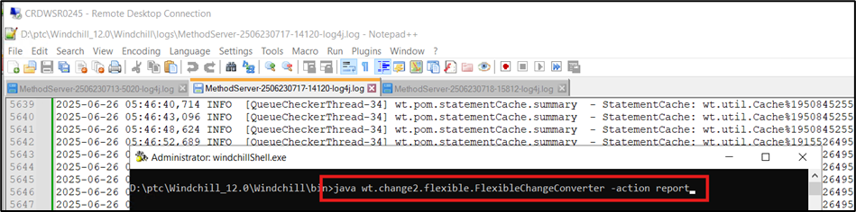

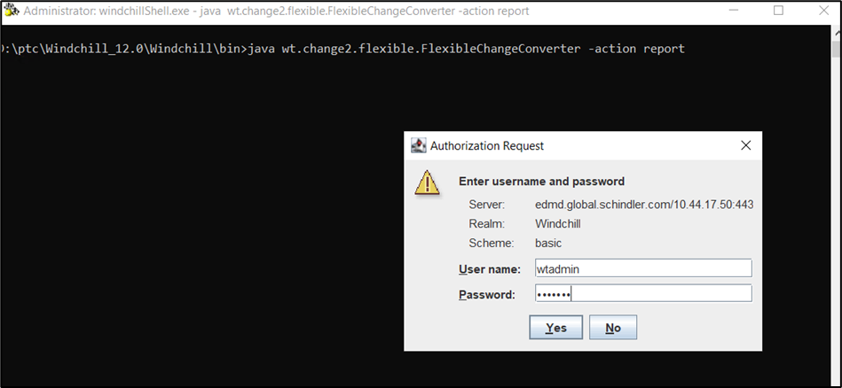

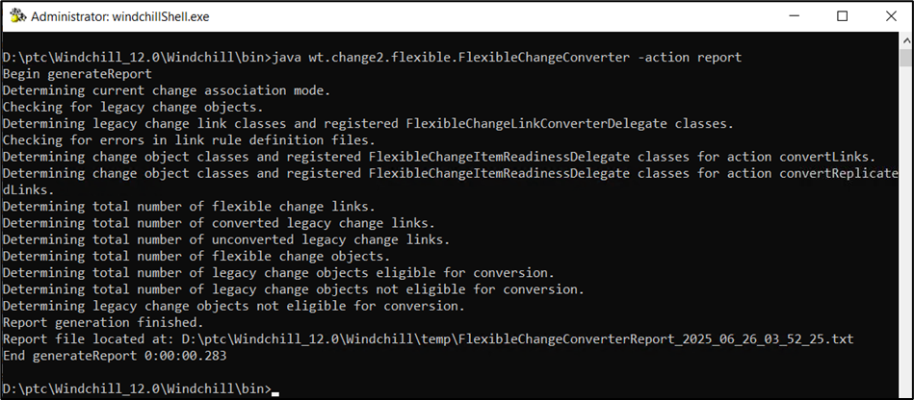

* Report is generated in temp folder

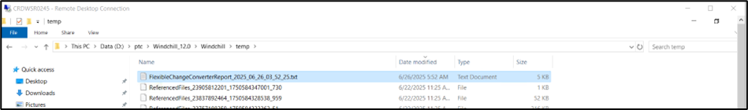

* Current mode is Mixed.
* There are Unconverted Legacy links are available in system.

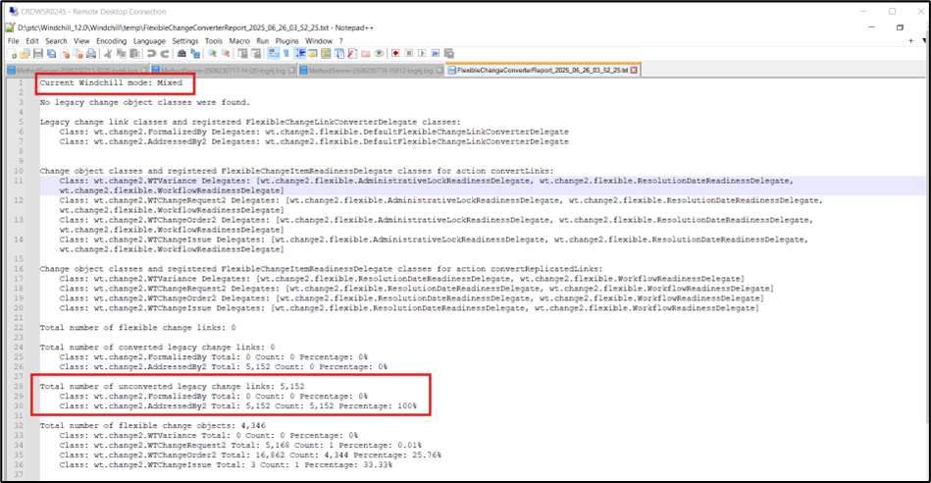

* Run below command to convert Legacy Links

java wt.change2.flexible.FlexibleChangeConverter -action convertLinks

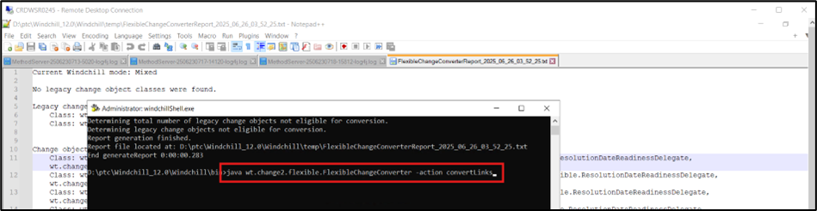

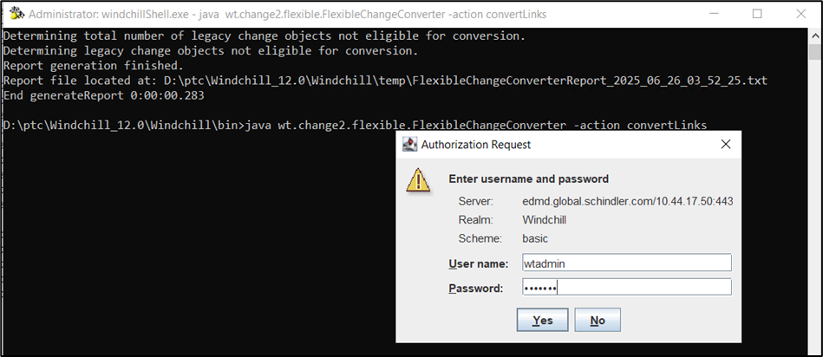

* Enter Yes

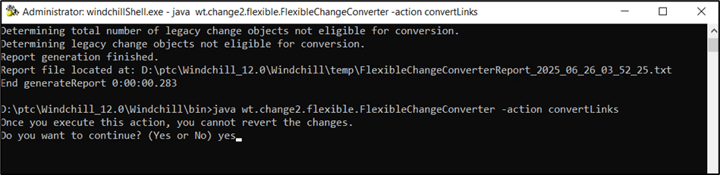

* Legacy Links are converted.
* Validate Non Eligible Change objects.

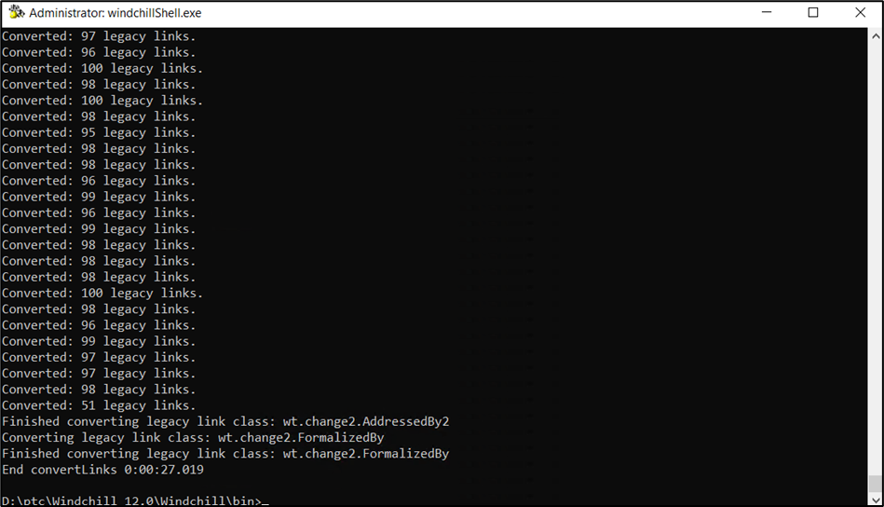

* Copy Non Eligible Change objects to excel file.

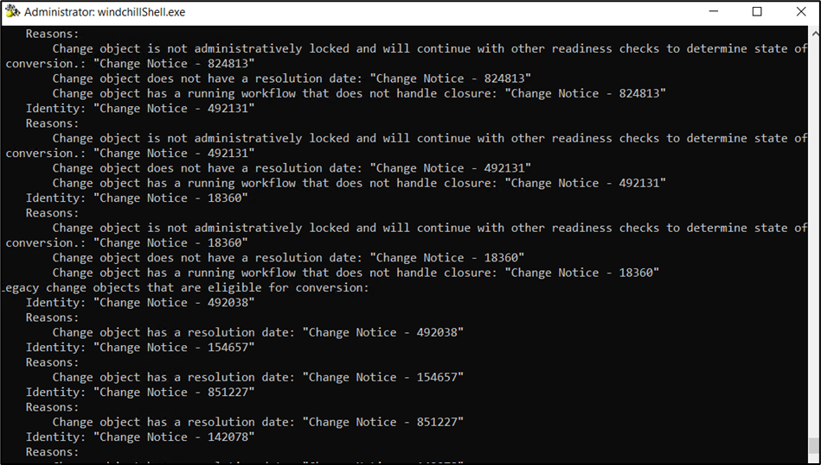

* Run below command again to check the count of Unconverted links

Run java wt.change2.flexible.FlexibleChangeConverter -action report

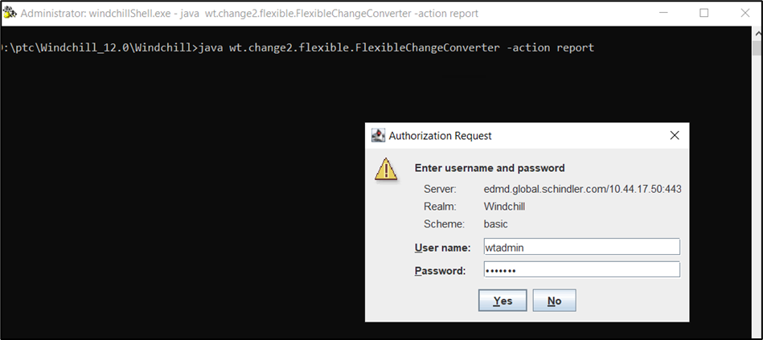

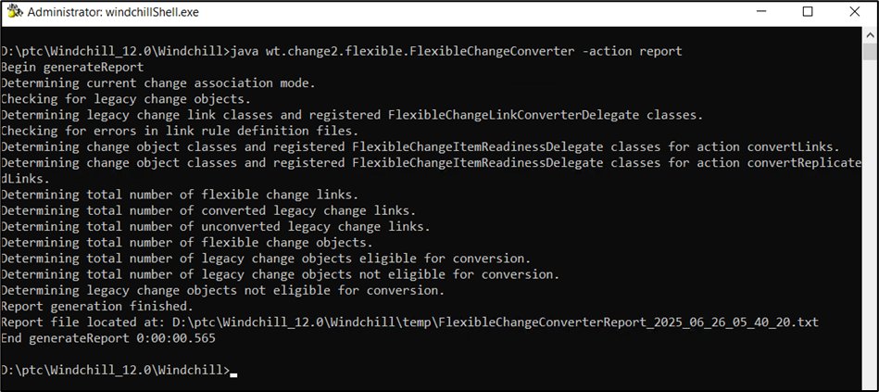

* Total 114 Change Objects are not converted due to running workflows.

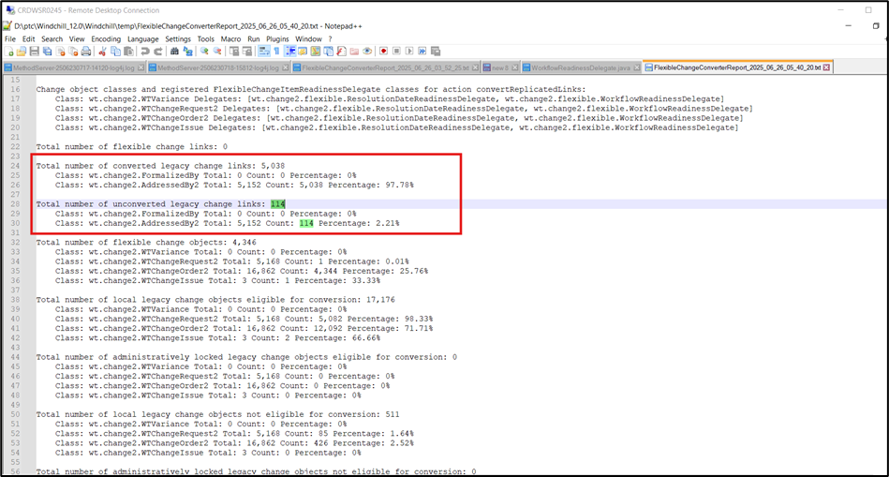

* OOTB delegate has been customized to bypass the running workflow conditions.
* Deploy customized Delegate to bypass the running workflows.

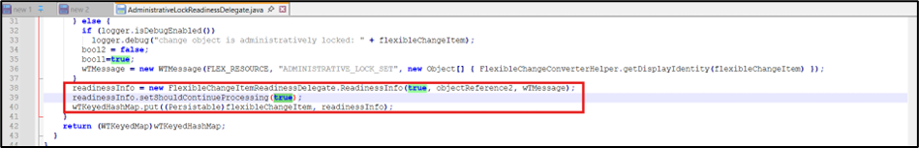

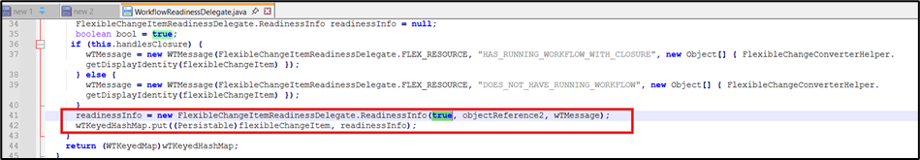

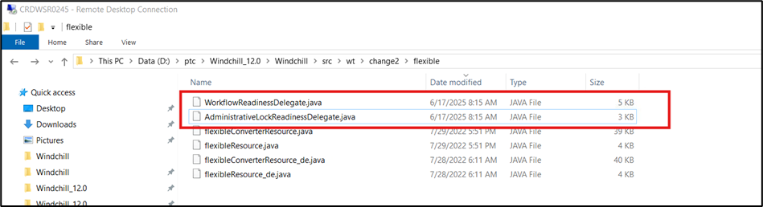

* Compile java files using below commands

ant -f bin/tools.xml class -Dclass.source=D:\ptc\Windchill_12.0\Windchill\src\wt\change2\flexible\ -Dclass.includes=WorkflowReadinessDelegate.java -Dclass.force=true

ant -f bin/tools.xml class -Dclass.source=D:\ptc\Windchill_12.0\Windchill\src\wt\change2\flexible\ -Dclass.includes=AdministrativeLockReadinessDelegate.java -Dclass.force=true

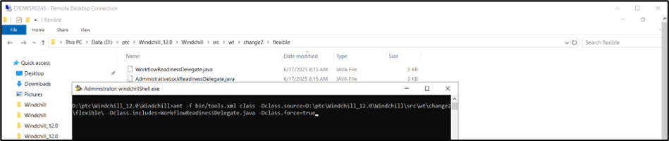

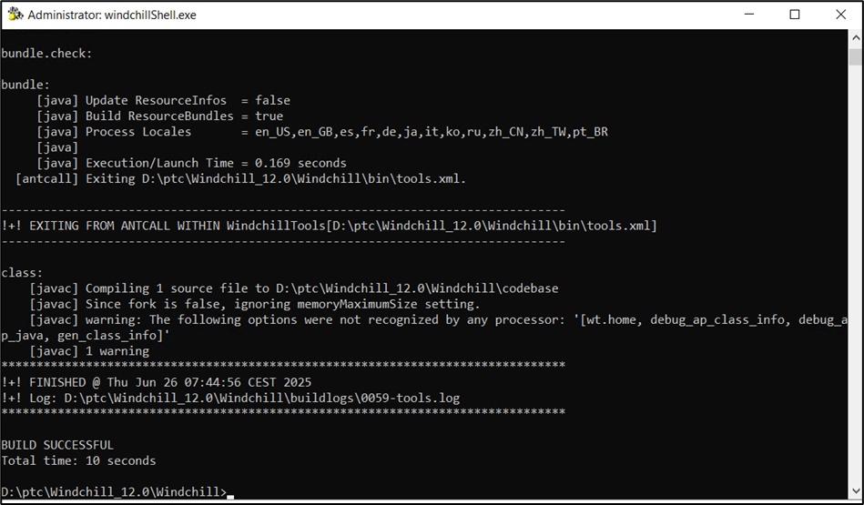

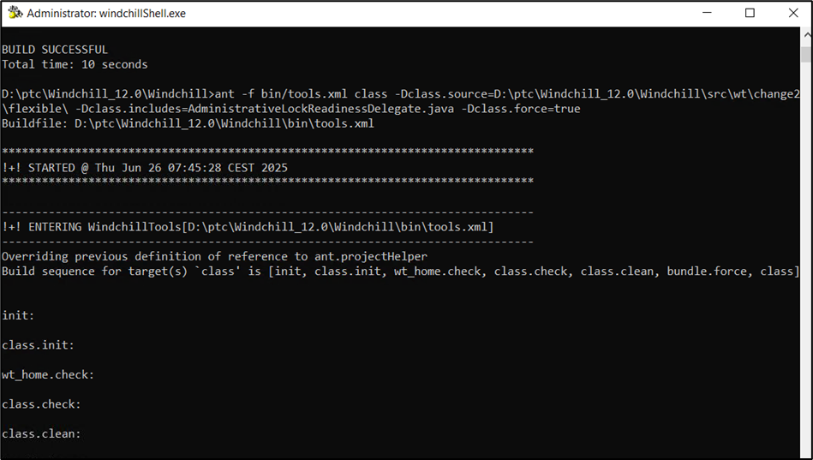

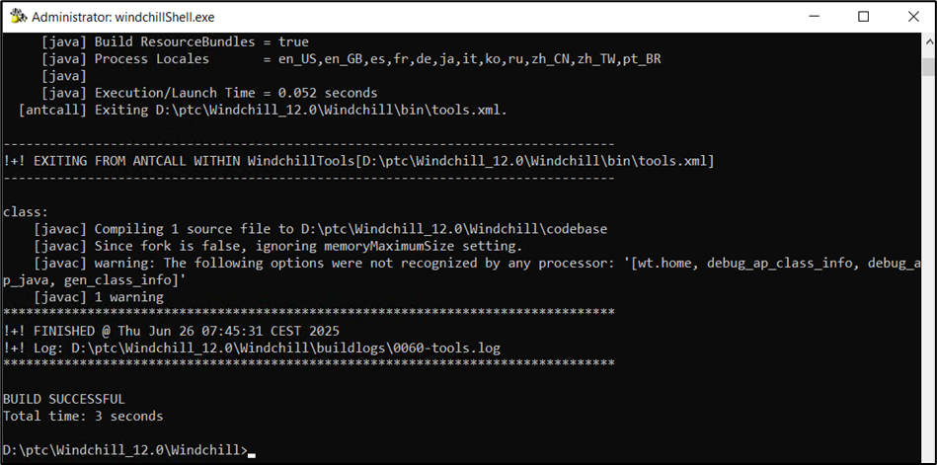

* Validate .class files are created under codebase directory.

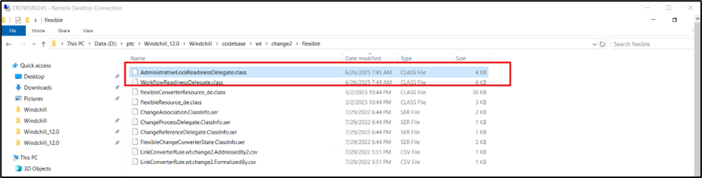

* Take restart with clearing cache

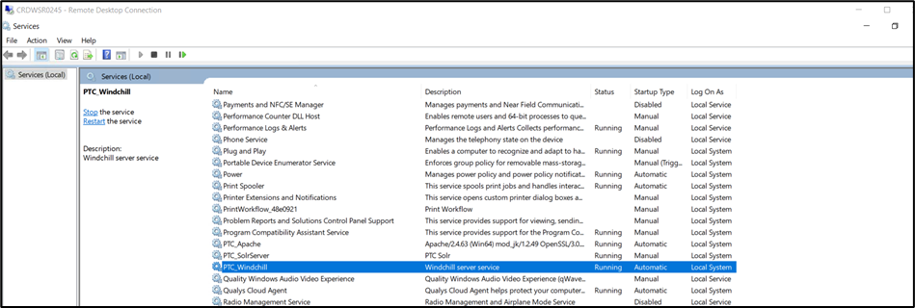

* Run java wt.change2.flexible.FlexibleChangeConverter -action convertLinks

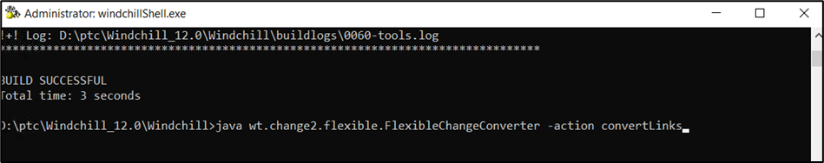

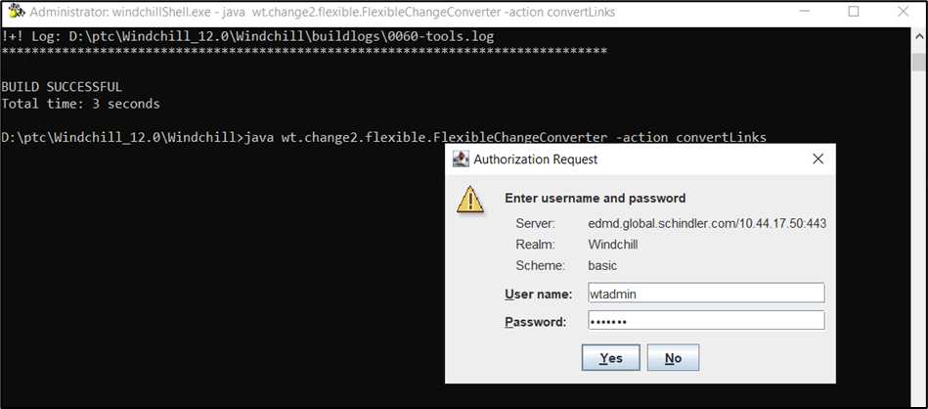

* Enter Yes

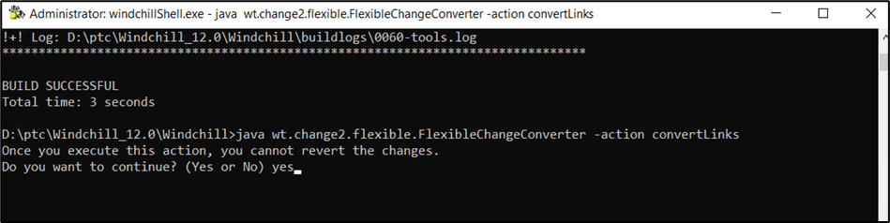

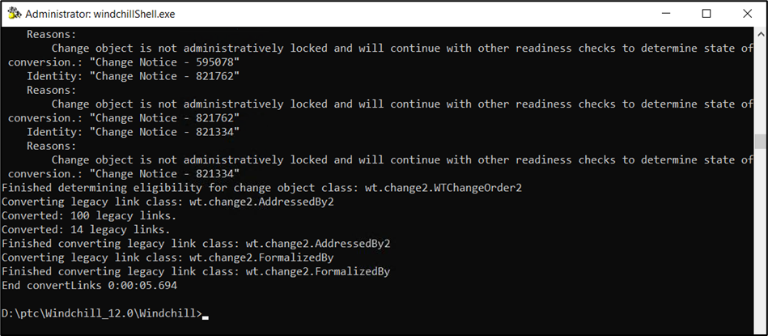

* Run below command again to check the count of Unconverted links

Run java wt.change2.flexible.FlexibleChangeConverter -action report

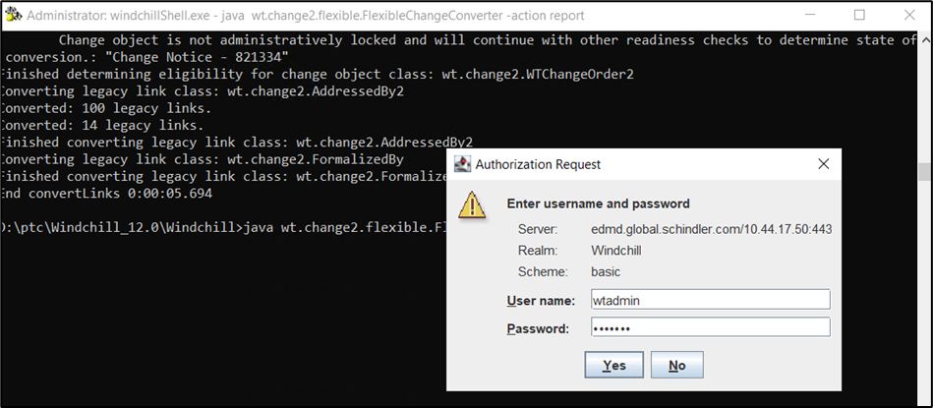

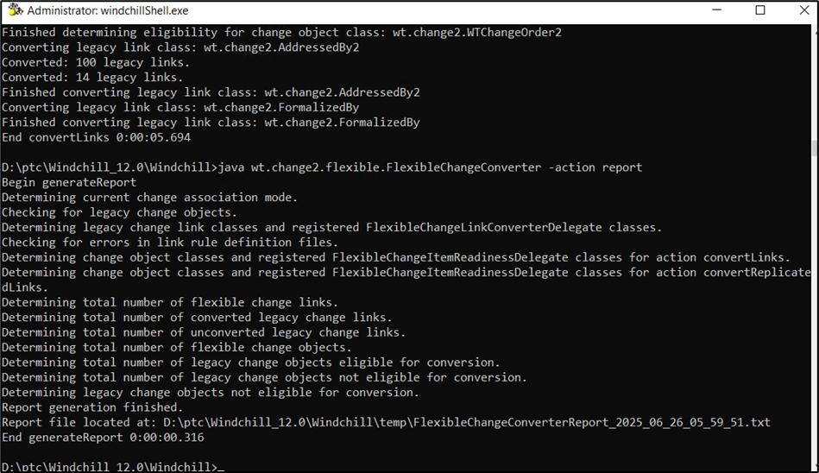

* Total Unconverted Legacy Link count is 0

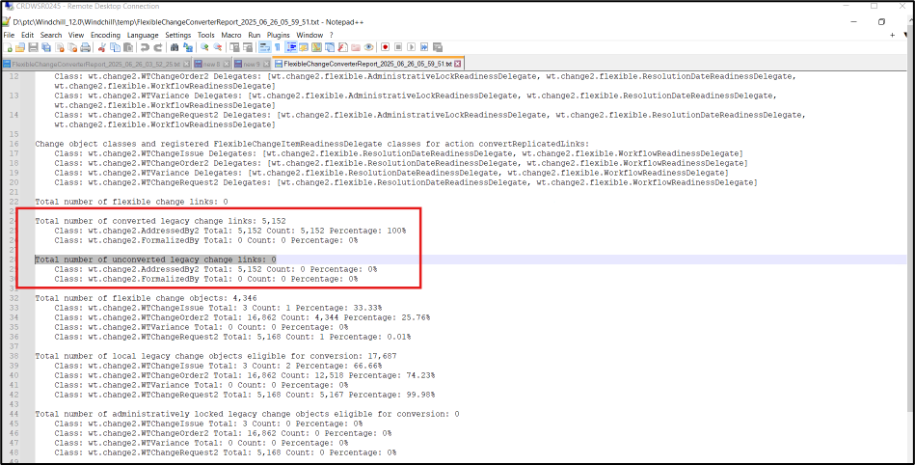

* Run below command to convert all EligibleObjects

java wt.change2.flexible.FlexibleChangeConverter -action convertEligibleObjects

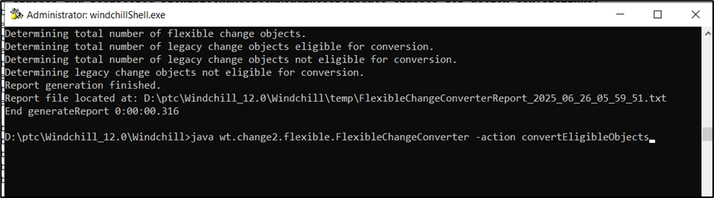

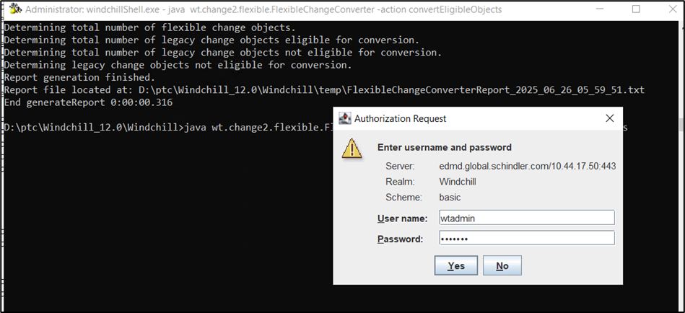

* Enter Yes

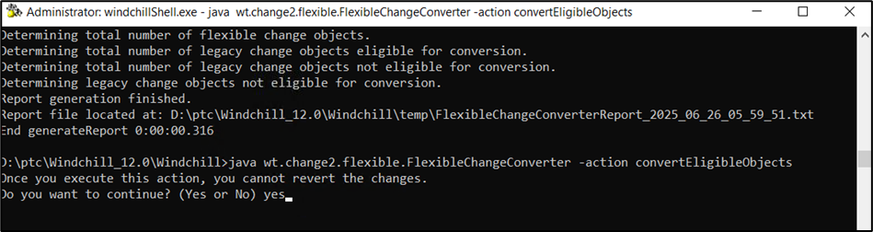

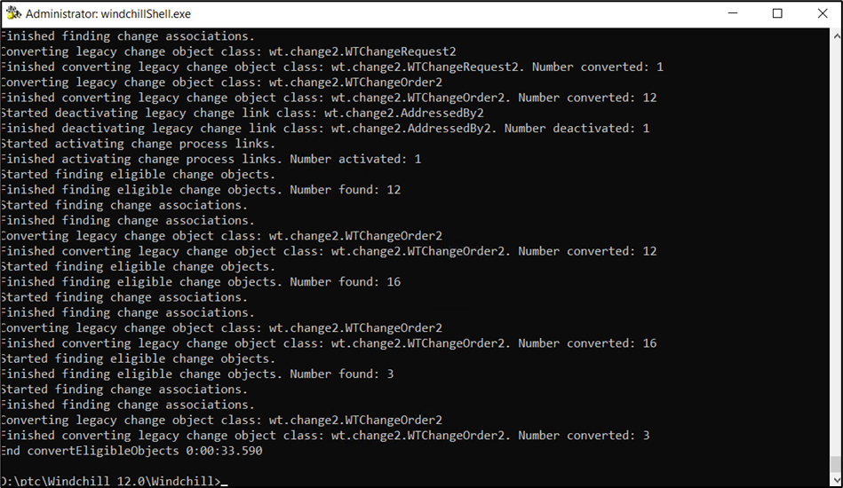

* Run below command again to check the count

Run java wt.change2.flexible.FlexibleChangeConverter -action report

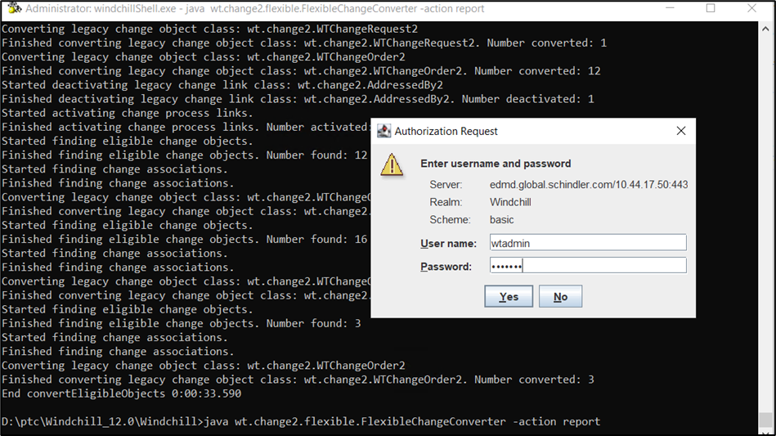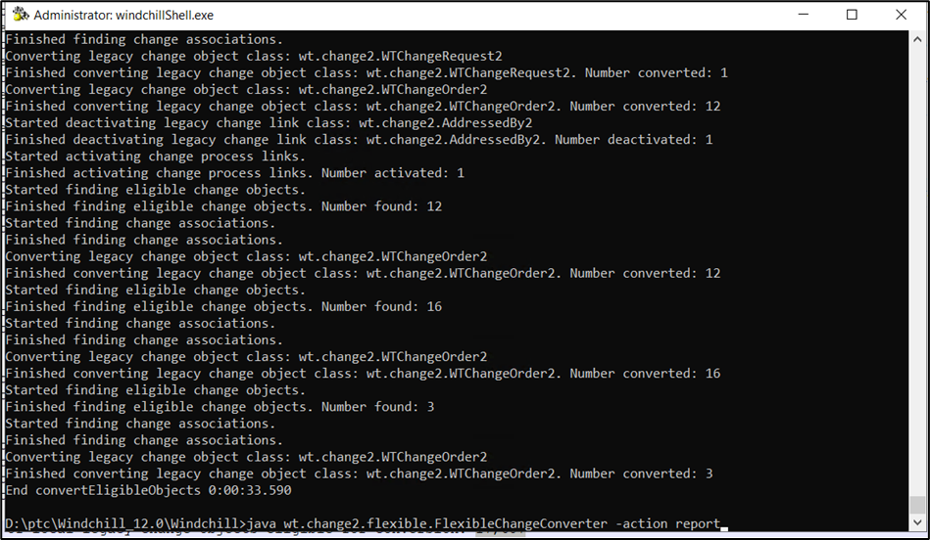

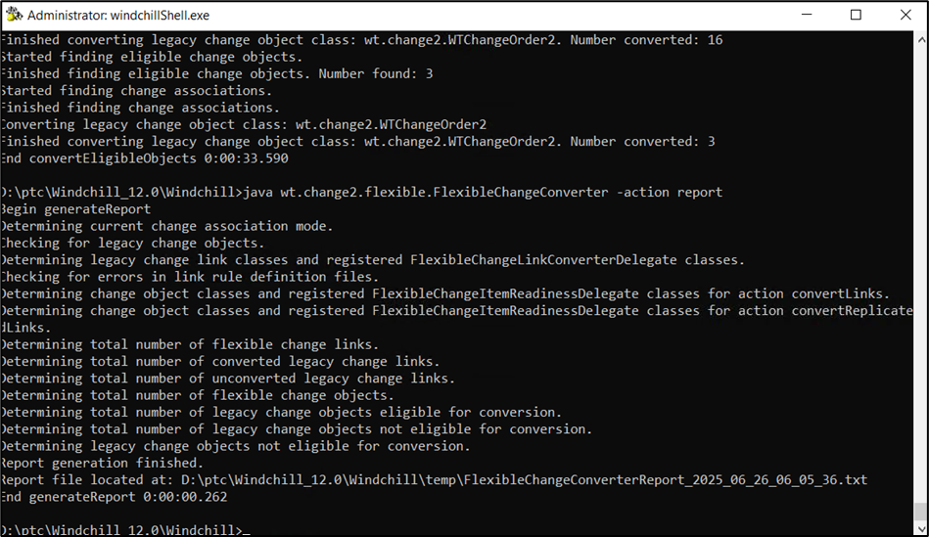

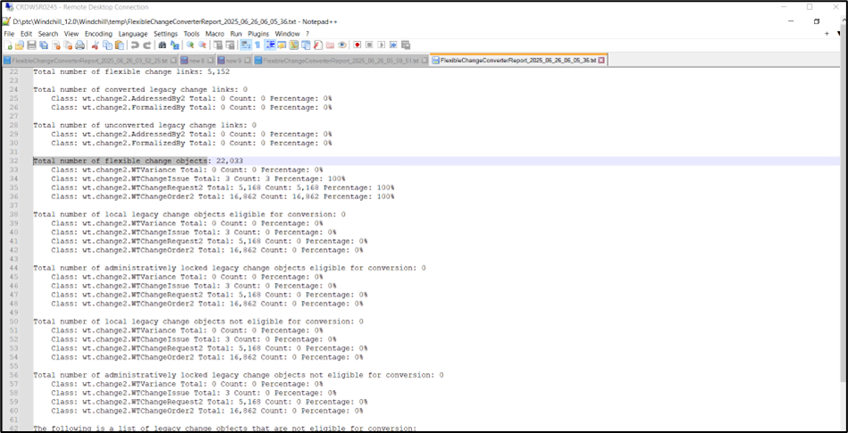

* Run below command to set System in Flexible Mode

java wt.change2.flexible.FlexibleChangeConverter -action setFlexible

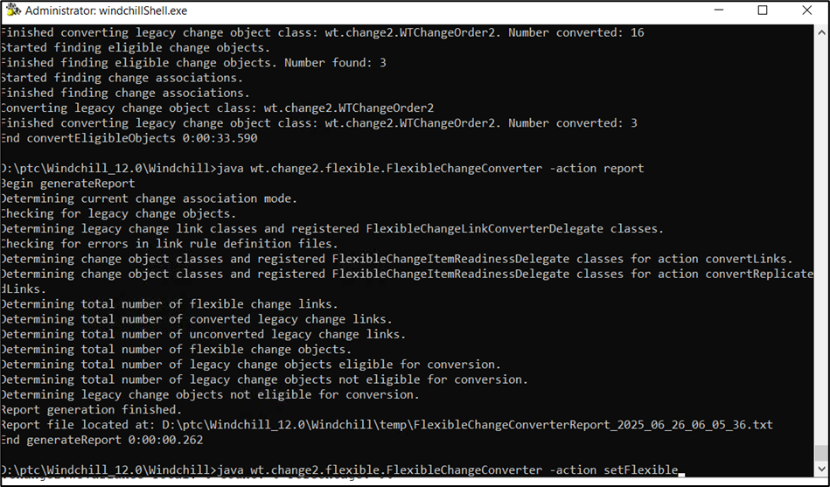

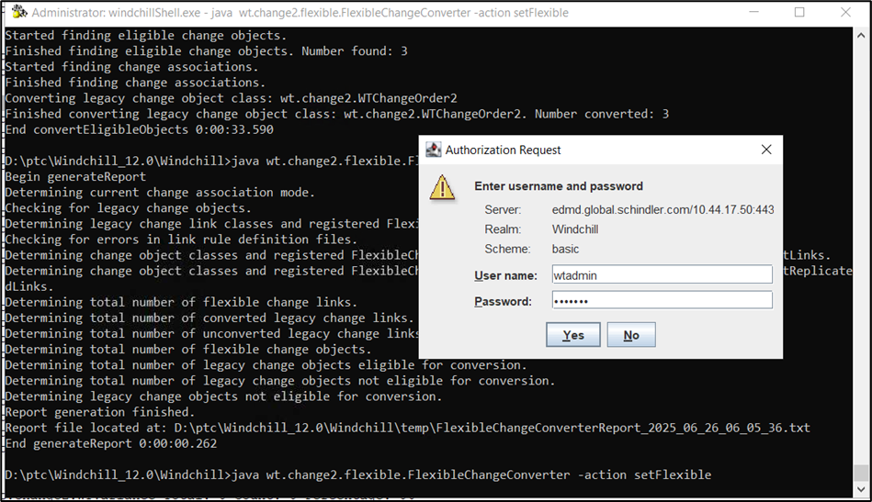

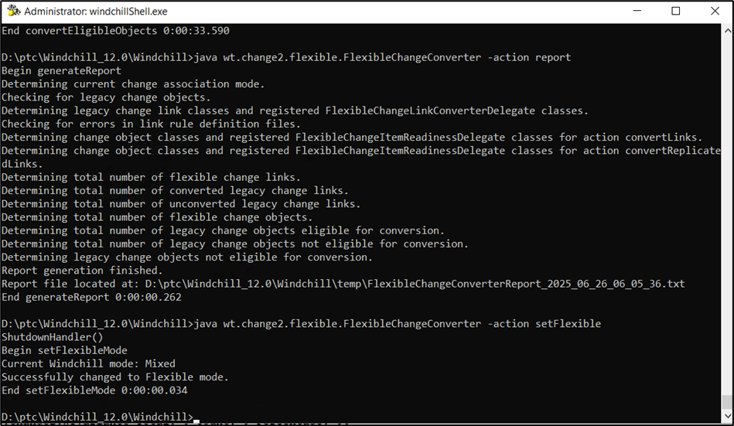

# Target Windchill 13.0.2.0 Installation:

1. Please refer the below link for target Windchill preparation.

URL: [Target Windchill 13.0.2.5 Preparation - Schindler CRD Applications - CRD Confluence](https://confluence.schindler.com/spaces/SCA/pages/608896699/Target+Windchill+13.0.2.5+Preparation)

# SSL Configuration

1. Please refer the below link for SSL configuration.

URL: [SSL/HTTPS Configuration - Schindler CRD Applications - CRD Confluence](https://confluence.schindler.com/spaces/SCA/pages/610404954/SSL+HTTPS+Configuration)

# Windchill CPS 13.0.2.5 Installation

1. Please refer the below link for Windchill CPS installation.

URL: [Windchill CPS 13.0.2.5 Installation - Schindler CRD Applications - CRD Confluence](https://confluence.schindler.com/spaces/SCA/pages/613187963/Windchill+CPS+13.0.2.5+Installation)

# Take AppData Folder Backup

1. Login to the server with the userid who installed Windchill 13.0 and take backup of AppData folder.

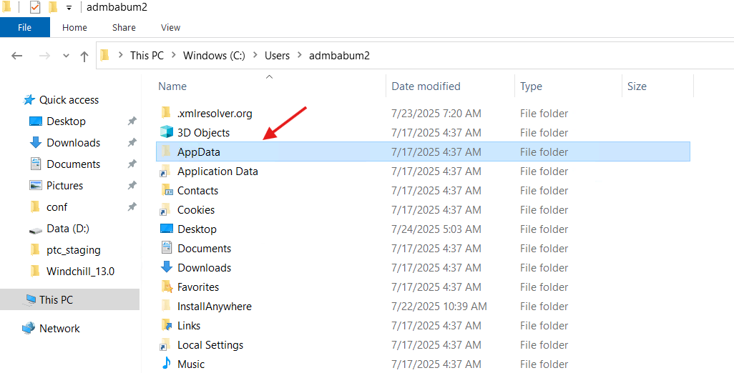

# Active Directory Configuration

1. Please refer the below link for Active Directory Configuration on target Windchill.

URL: [Active Directory Configuration - Schindler CRD Applications - CRD Confluence](https://confluence.schindler.com/spaces/SCA/pages/613188727/Active+Directory+Configuration)

# Disable SSL Configuration

1. Follow the section "Revert https to http" in the below document to disable SSL configuration.

URL: [SSL/HTTPS Configuration - Schindler CRD Applications - CRD Confluence](https://confluence.schindler.com/spaces/SCA/pages/610404954/SSL+HTTPS+Configuration)

# Copy Source Customizations to Target

# Copy Vault Folders

Team completed this activity.

# Import Source DB to target and update the entries

1. Raised the respective tickets to take source DB export and import it on target.
2. DB team completed the import activity from source to target successfully.
3. Requested DB team to execute the below query with sa on target DB.

USE "pdmlink"  
GO  
EXEC sp_change_users_login Auto_Fix, 'pdmlink', NULL, 'GHgarnUfEZa#789'

4. DB team executed the above query and provided the below confirmation to move forward.

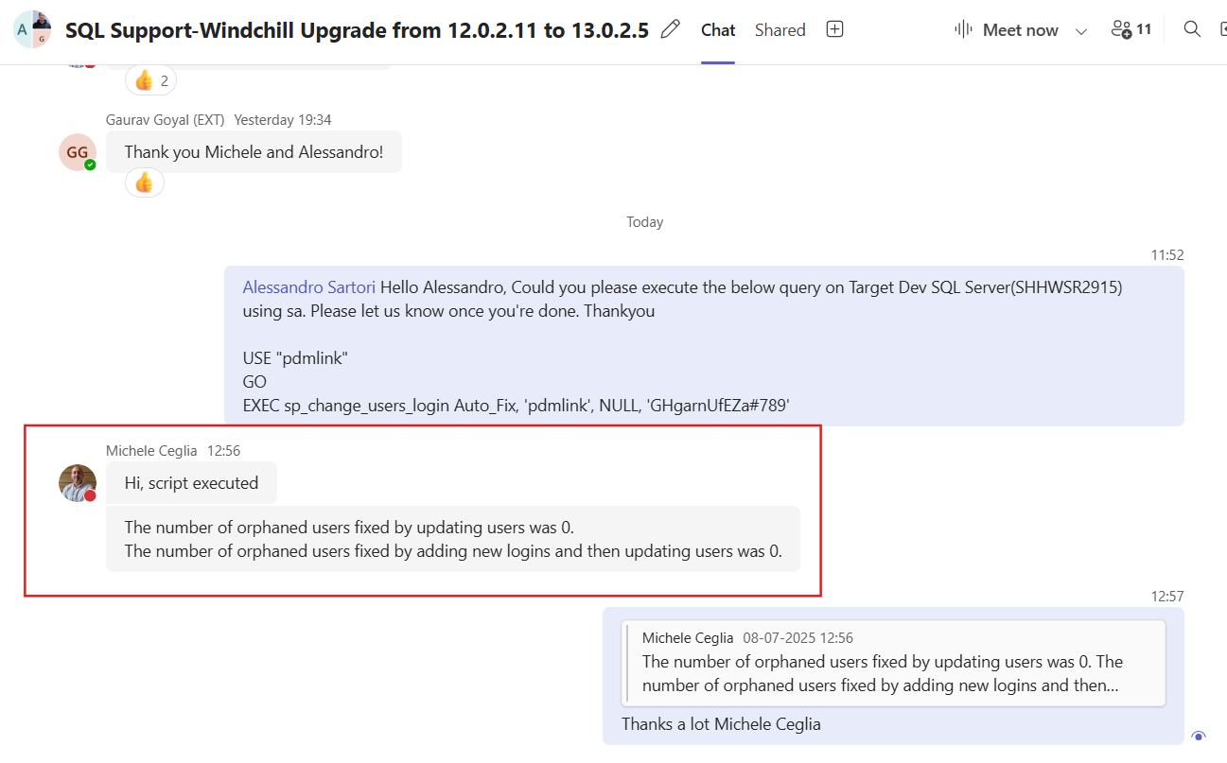

5. Login to DB with pdmlink user and execute the below queries as pdmlink.

6. Execute the below query to verify repository.

select * from pdmlink.pdmlink.Repository;

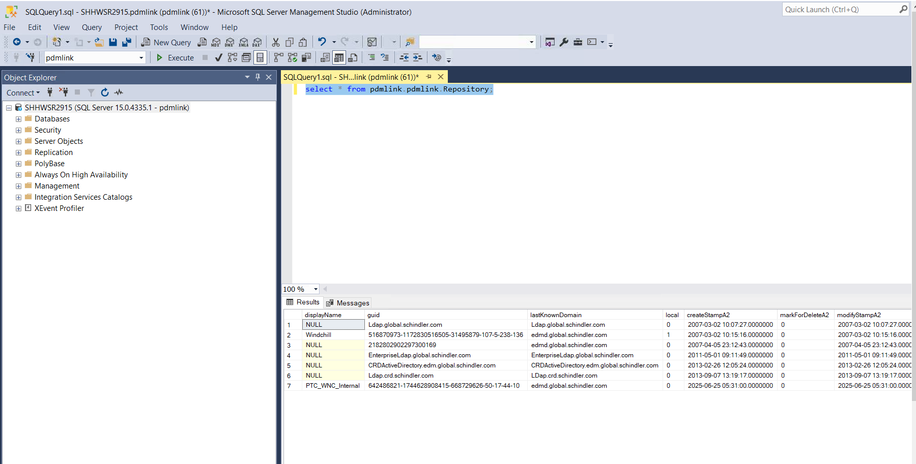

7. Take backup of the repository table as shown below.

select * into RepositoryBackupBfrUpgradeManager08072025 from Repository;

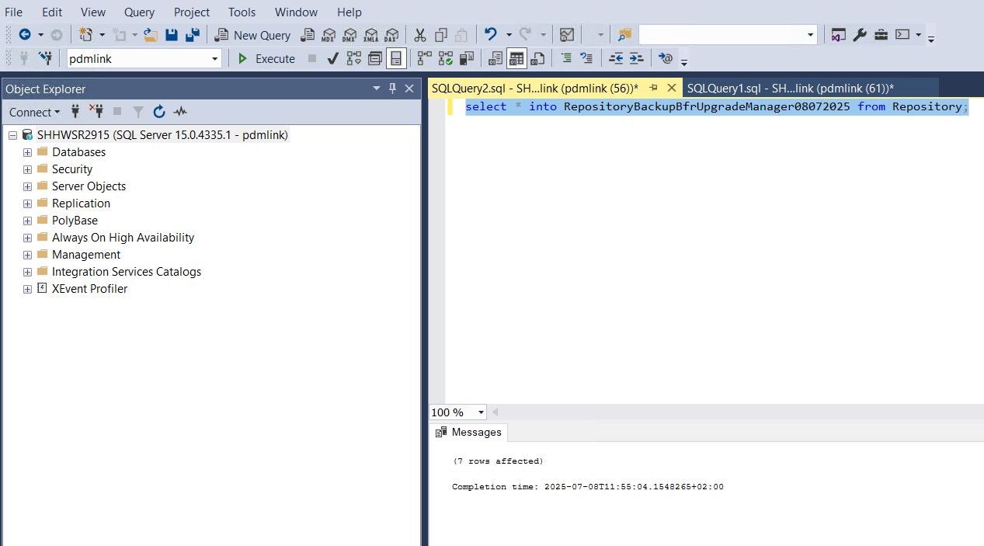

8. Execute the below queries to update source repositories to target.

9. Query:

* Update pdmlink.pdmlink.Repository SET lastKnownDomain='[edm-d.global.schindler.com](http://edm-d.global.schindler.com)' WHERE local=1;
* Update pdmlink.pdmlink.Repository SET lastKnownDomain='[edm-d.global.schindler.com](http://edm-d.global.schindler.com)' WHERE idA2A2=9134706;

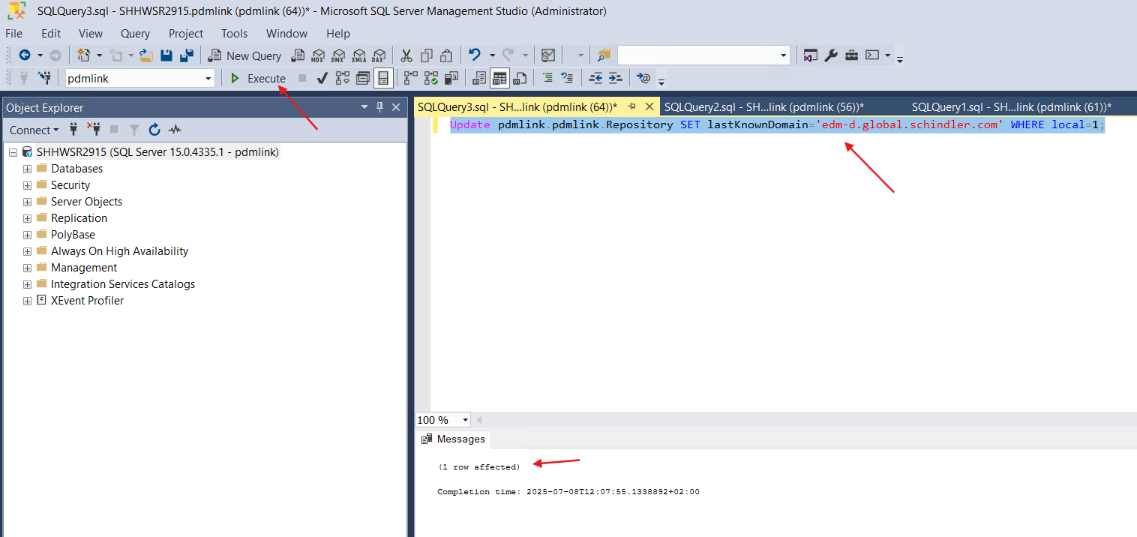

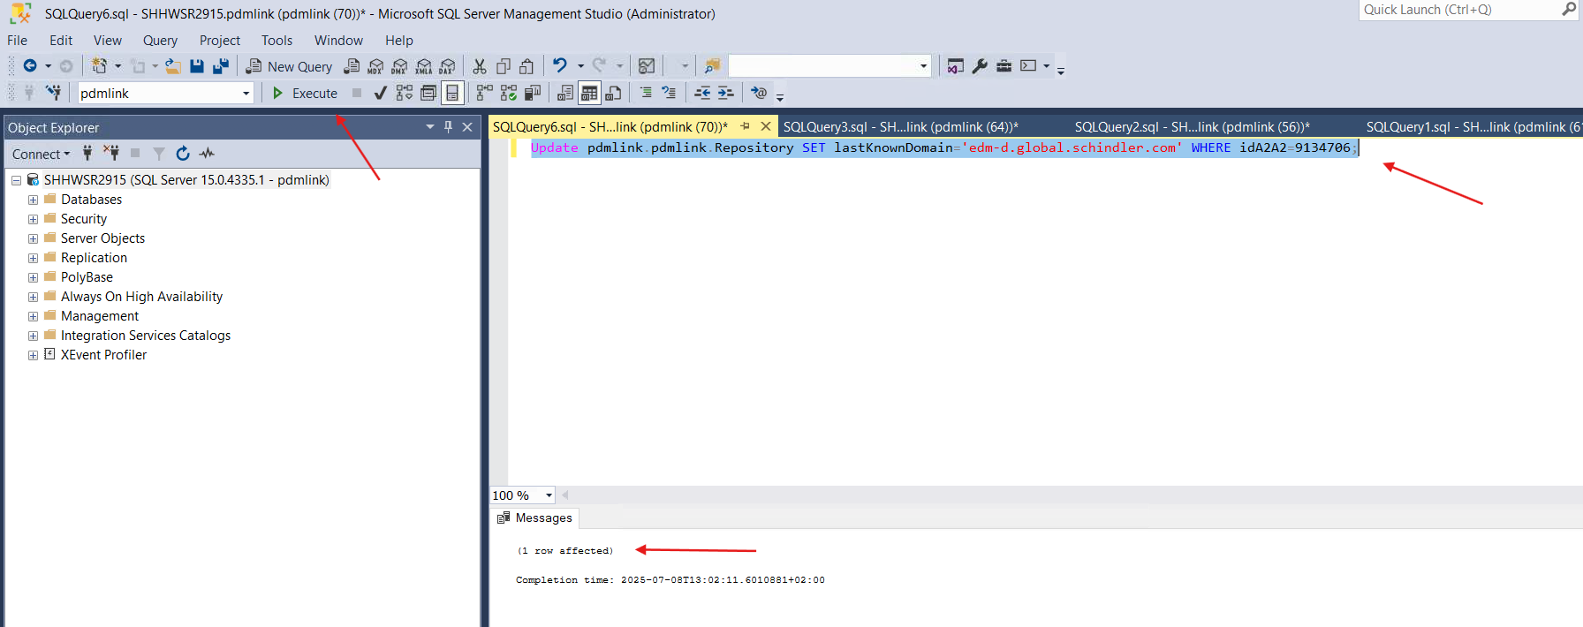

10. Execute the below query to make sure the values got updated successfully.

select * from pdmlink.pdmlink.Repository;

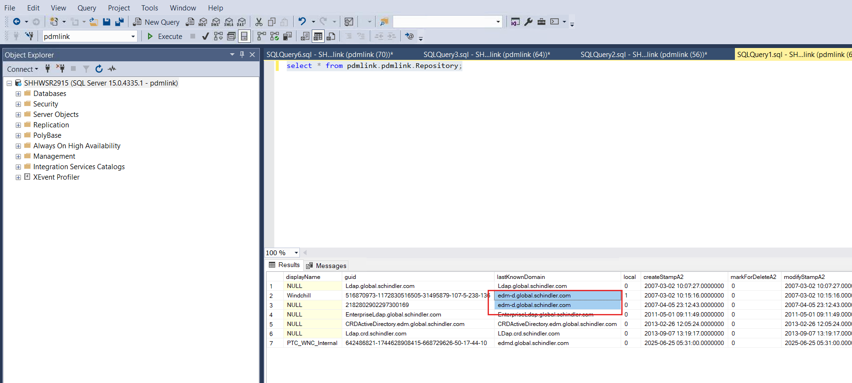

11. Execute the below query to verify FvHost details.

select * from pdmlink.pdmlink.FvHost;

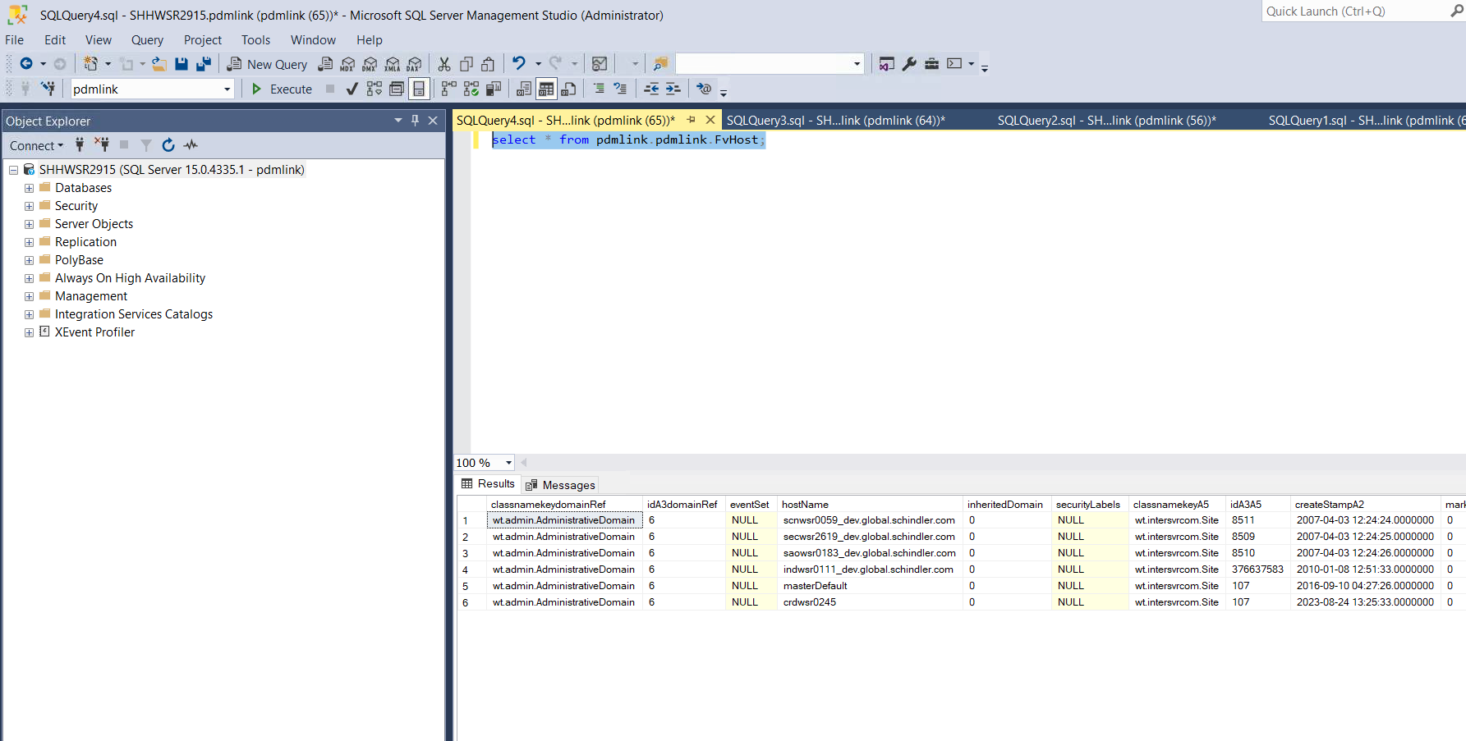

12. Take backup of FvHost table by executing below query.

select * into FvHostBackupBfrUpgradeManager08072025 from FvHost;

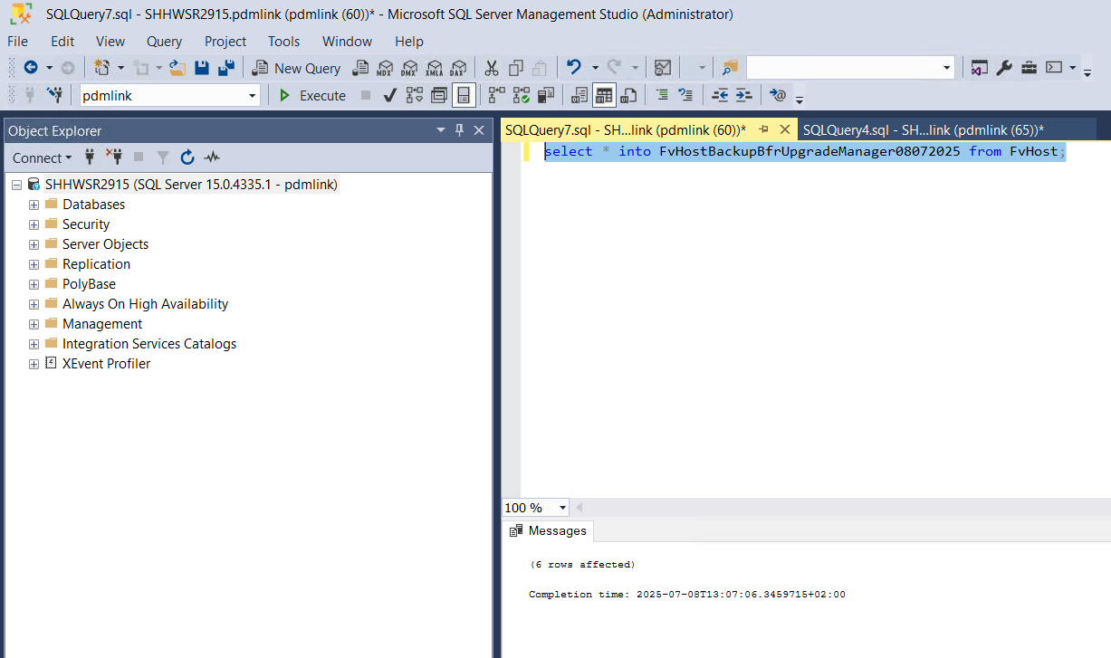

13. Execute the below query to update FvHost.

* Update pdmlink.pdmlink.FvHost SET hostName='crdwsr0276' where hostName='crdwsr0245';

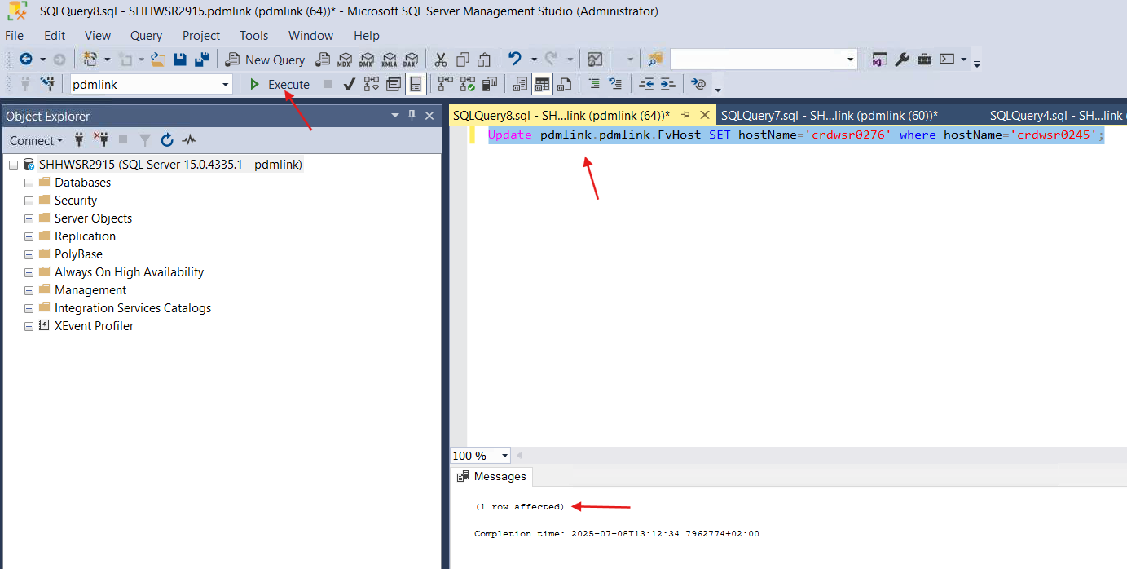

14. Execute the below query to ensure the values got updated.

* select * from pdmlink.pdmlink.FvHost;

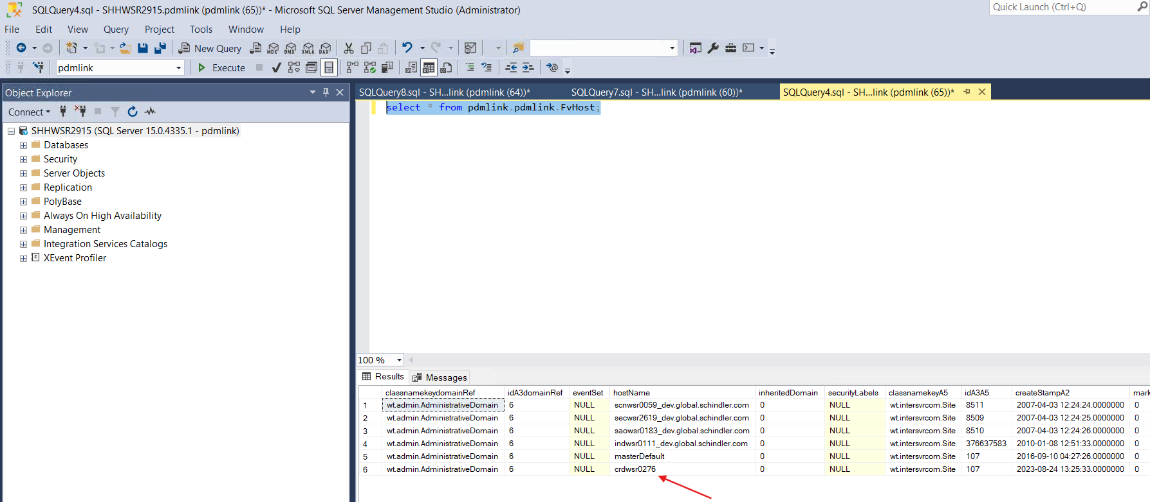

15. Take backup of site.xconf file and update the property as shown below.

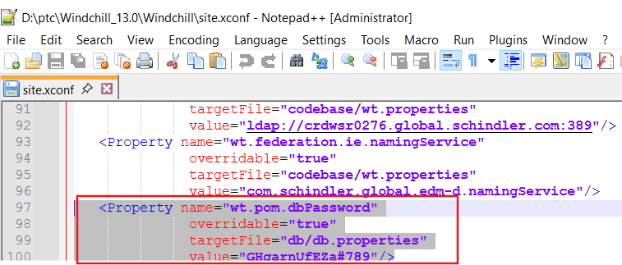

16. Launch Windchill Shell as an administrator and execute the below command to propagate the changes.

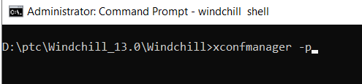

17. Make sure the changes propagated successfully.

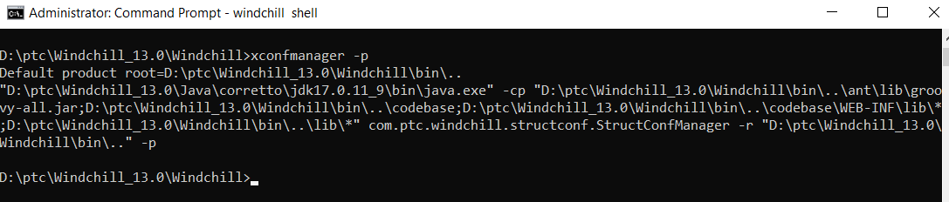

# Import the Source DS onto Target DS

1. Log into Source Windchill server to take Source DS backup.
2. Navigate to the following location and launch control-panel.bat as administrator.

D:\ptc\Windchill_12.0\WindchillDS\bat

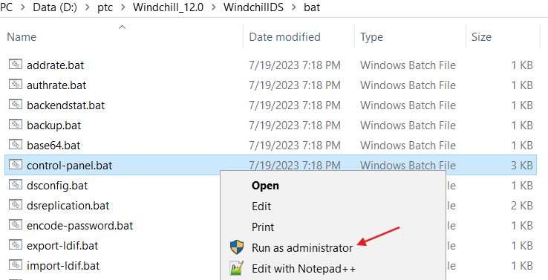

4. Click on Ok.

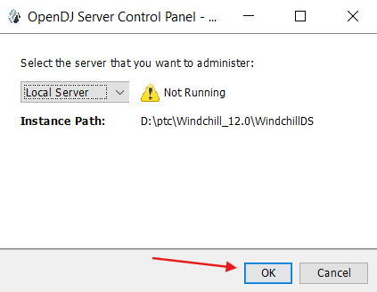

5. Start the Open DJ.

6. Click on Export LDIF.

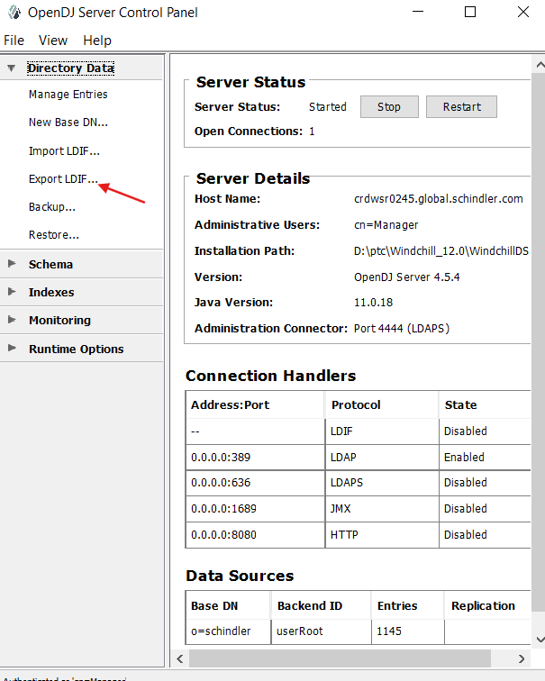

7. Click on Browse button and provide the location for the backup and click on Ok.

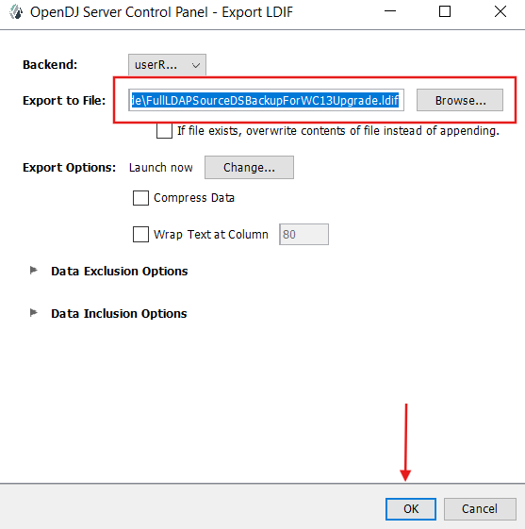

8. Make sure the export is completed successfully.

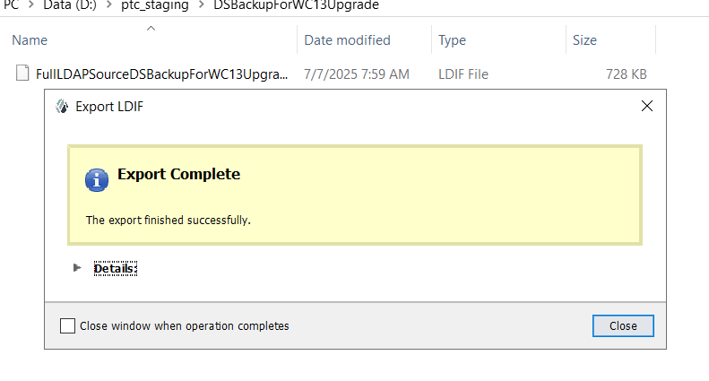

9. Copy and move the Source LDAP backup file to target server.

10. Log into target application server.

11. Navigate to the following location and launch control-panel.bat as administrator.

 D:\ptc\Windchill_13.0\WindchillDS\bat

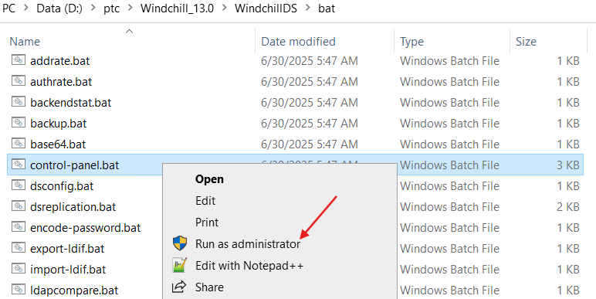

12. Click on Ok.

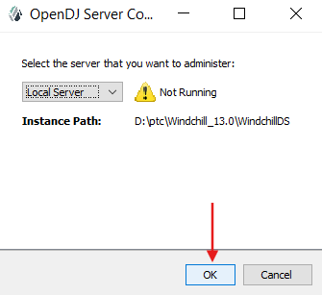

13. Click on Start.

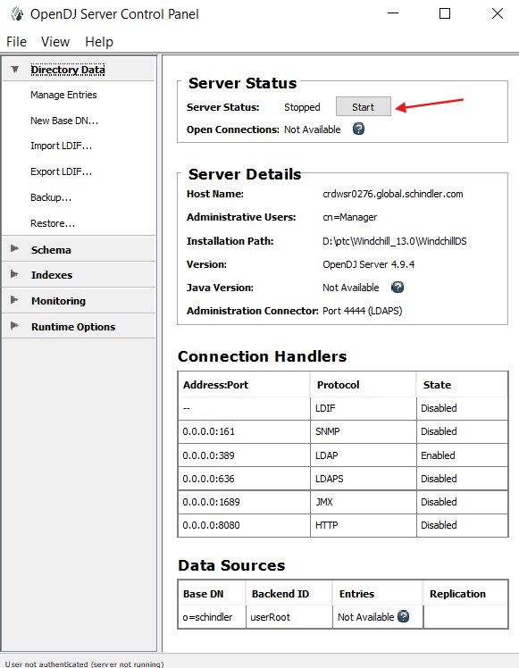

14. Provide username/password and click on Ok.

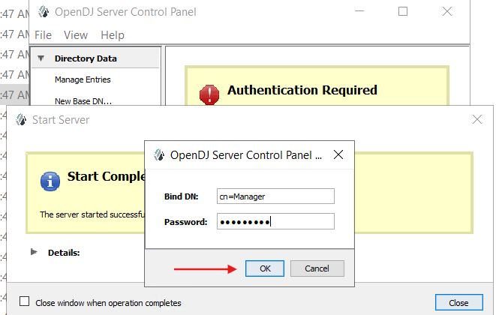

15. Click on Import LDIF.

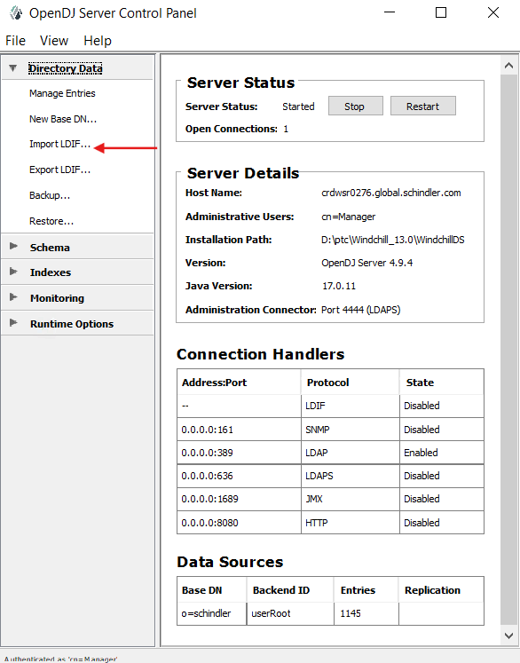

16. Browse and provide the source ldap file copied from source to target and click on Ok as shown below.

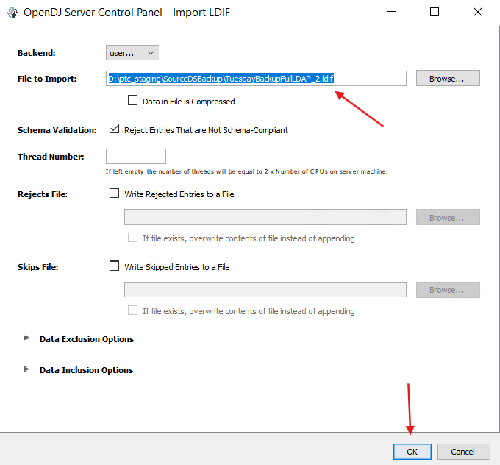

17. Import got failed with the below error.

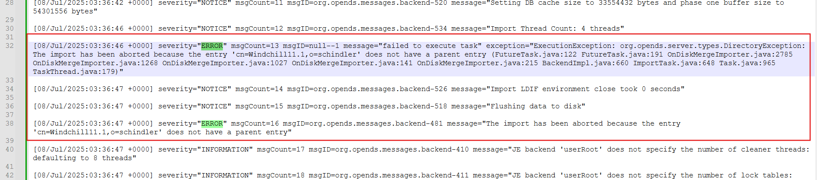

18. Replaced the entire Windchill DS folder from the backups.

19. Followed the below article to resolve the issue.

[Article - CS378905 - Import data from WindchillDS to OpenDJ failed with errors :The import has been aborted because the entry xxx does not have a parent entry in Windchill PDMLink](https://www.ptc.com/en/support/article/CS378905)

19. Replaced  objectClass: ptcSubtree with objectclass: organizationalRole in source ldap file and saved the file.

20. Started Open DJ.

21. Click on Import LDIF as shown below.



22. Browse and provide the updated ldif file, unselect Reject Entries That are Not Schema-Compliant and click on Ok as shown below.

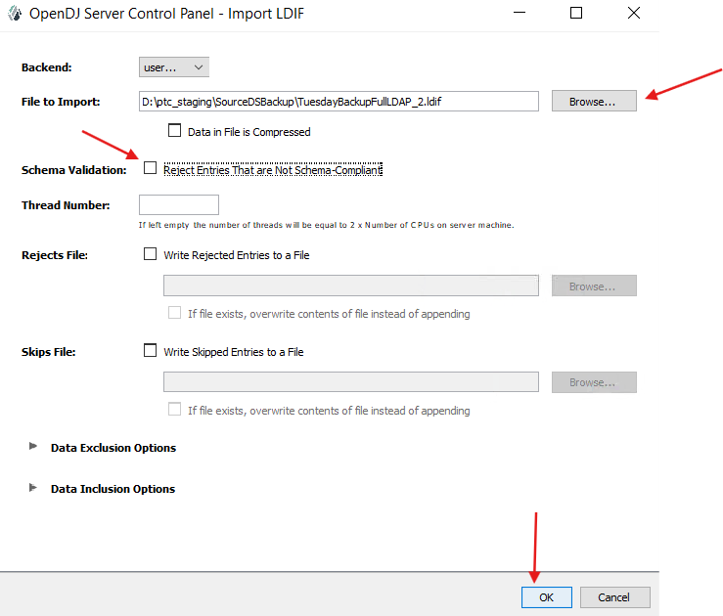

23. Click on Close once the import completed successfully.

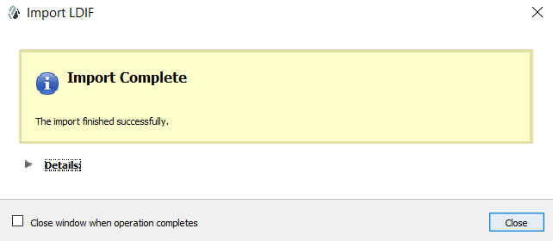

# Prerequisites Before Running Upgrade Manager

1. Below is the prerequisite mentioned in Upgrade document at Page: 37.

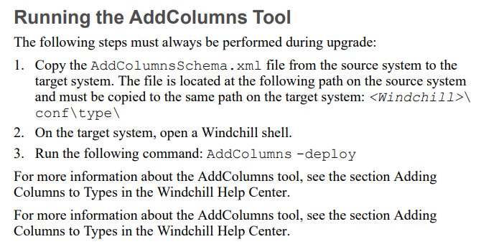

2. Copy the AddColumnsSchema.xml file from the source system to the target system. The file is located at the following path on the source system and must be copied to the same path on the target system: <Windchill>\conf\type\

3. Run the following command from windchill shell as an admin.

AddColumns -deploy

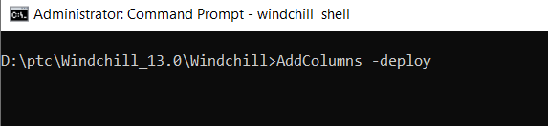

4. Ensure the Add Columns deployed successfully.

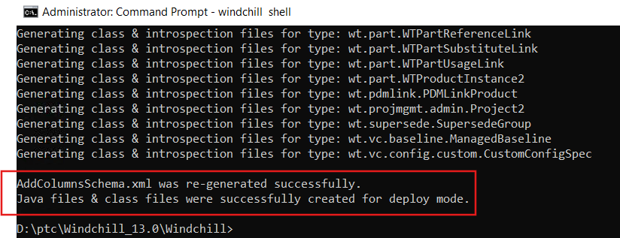

# Run Upgrade Manager

1. Before running upgrade manager uninstall Windchill, DS and Apache as services.
2. Make sure Windchill DS and Apache are running.
3. Launch Windchill Shell as an administrator and execute the below command to run Upgrade Manager.



4. Click on Ok.

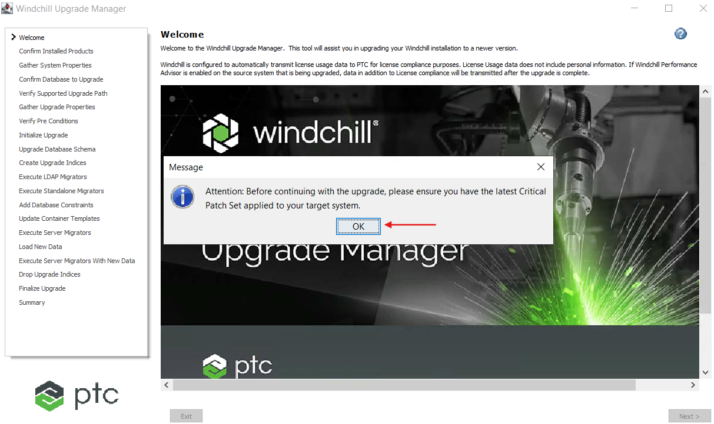

5. Click on Next.

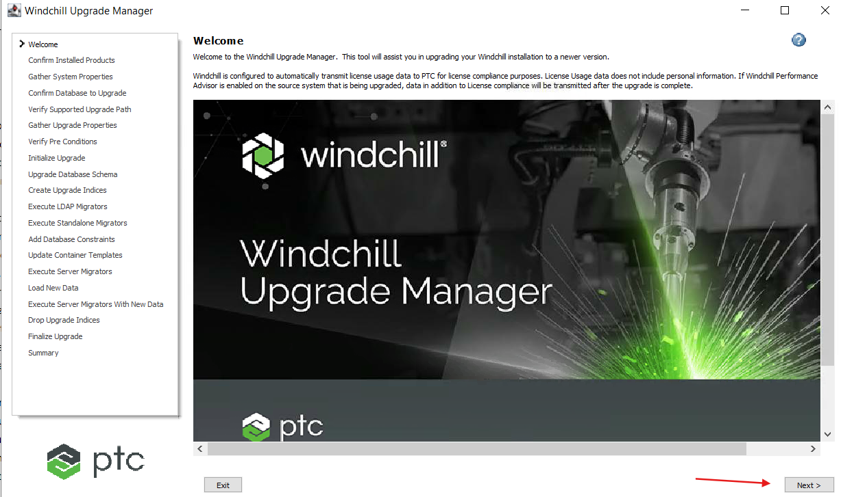

6. Click Next.

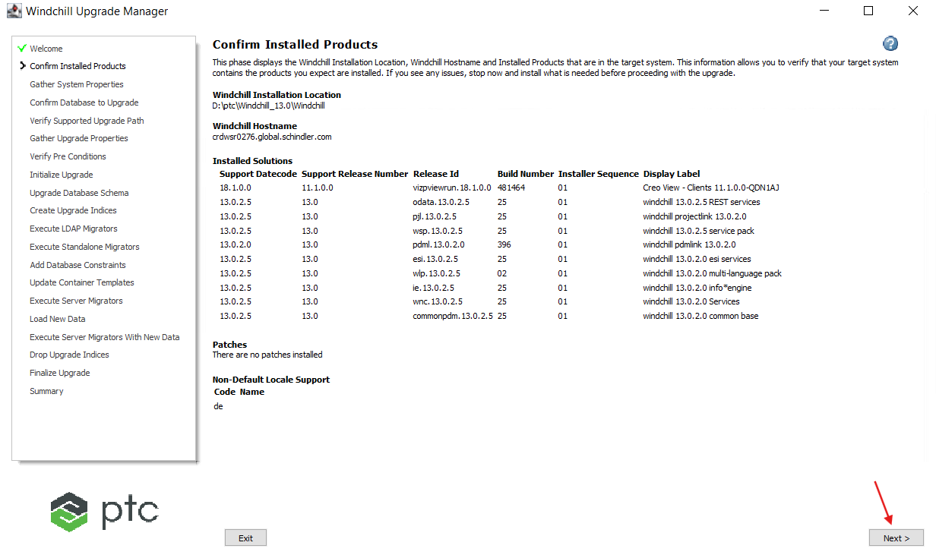

7. Provide the details as shown below and click on Advanced Database section as shown below.

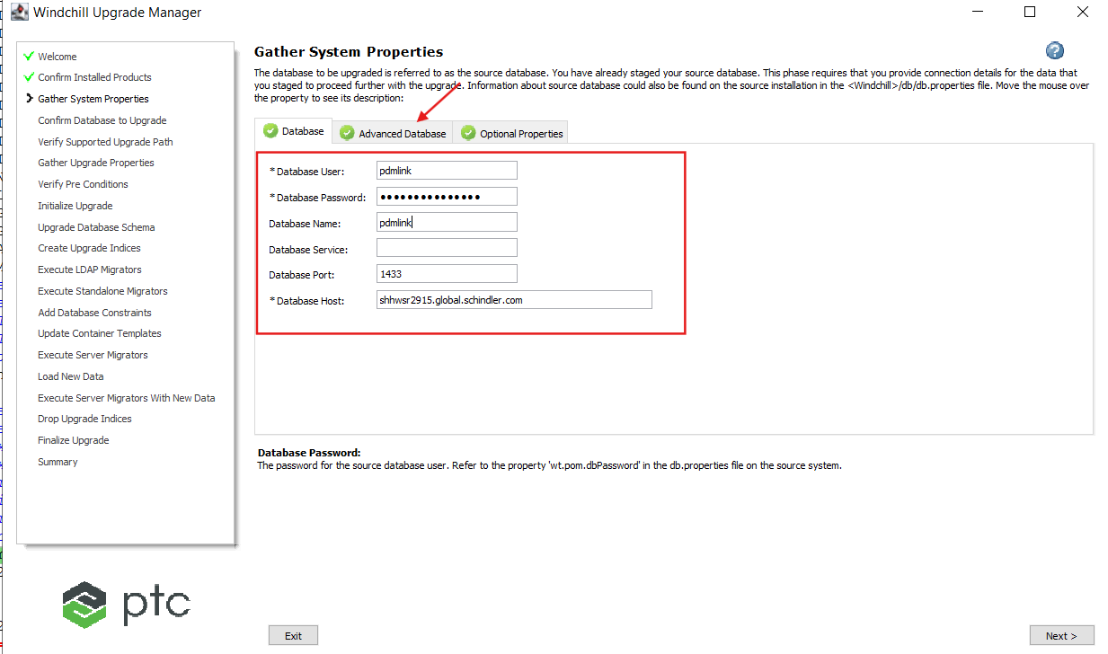

8. Leave 'Advanced Database' section blank and click on next tab as shown below.

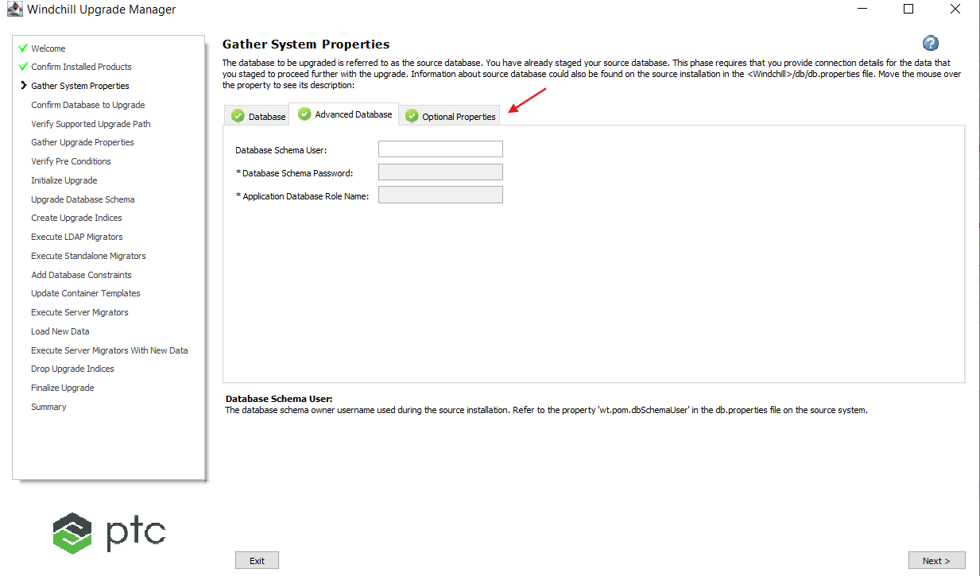

9. Leave 'Optional Properties' section as is and click on Next.

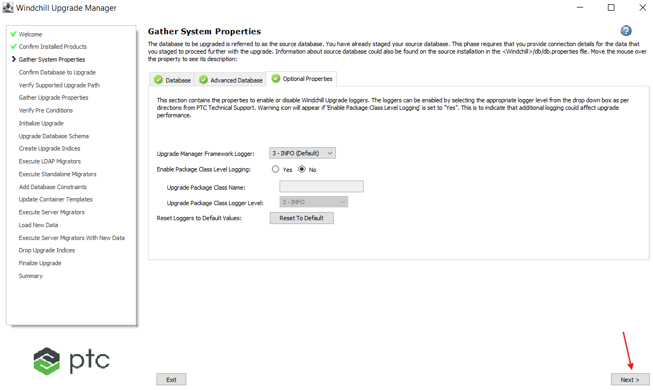

10. Verify the details and click on Next.

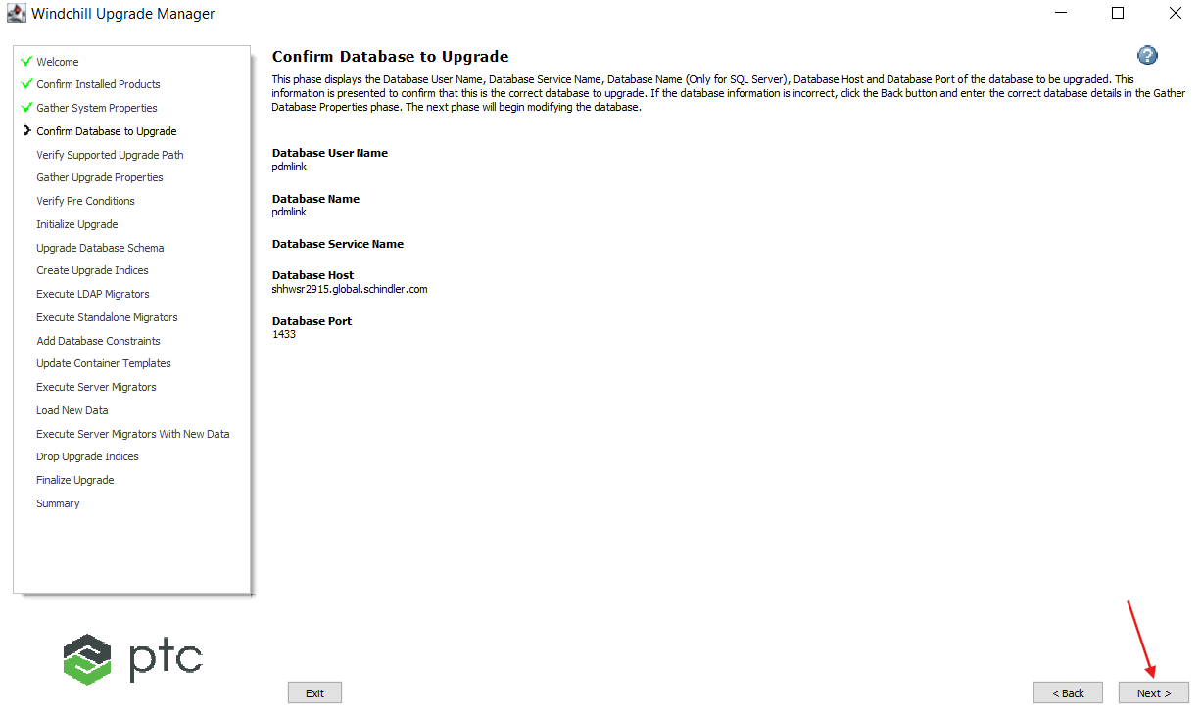

11. Click on Next.

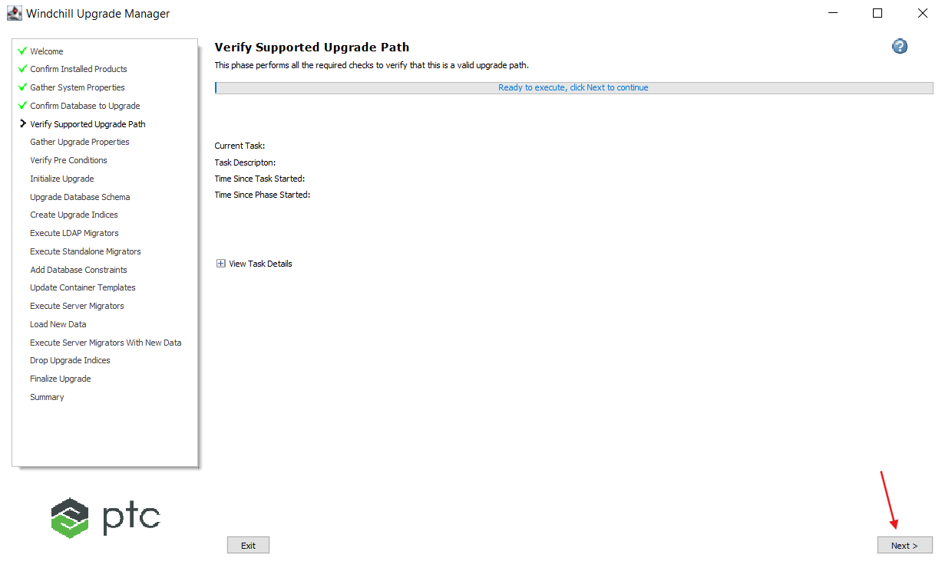

12. **Upgrade manager failed at the below step.**

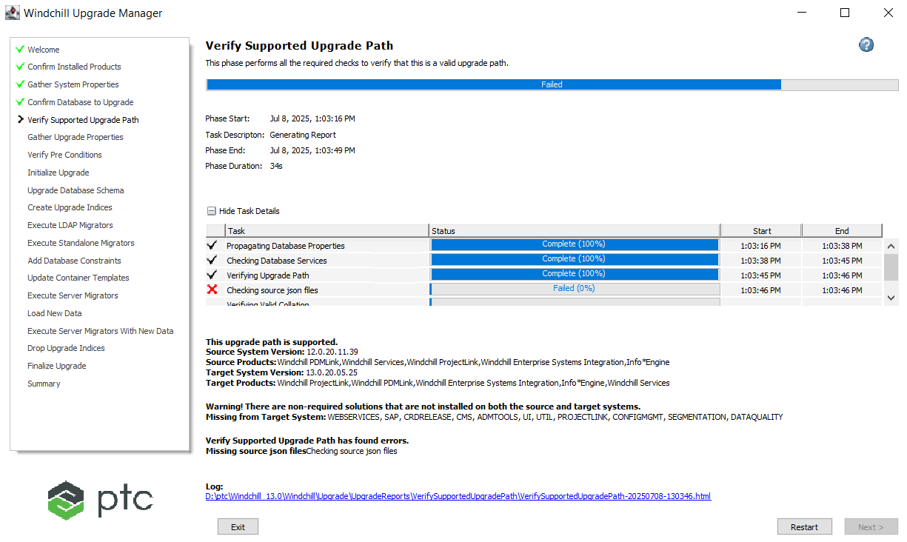

13. Implemented the resolution as per the following article: [Article - CS389647 - UpgradeManager task failure at Checking source json files from Windchill PDMLink 12.0.1+](https://www.ptc.com/en/support/article/CS389647?source=search)

14. Re-run the Upgrade Manager.

15. Click Next.

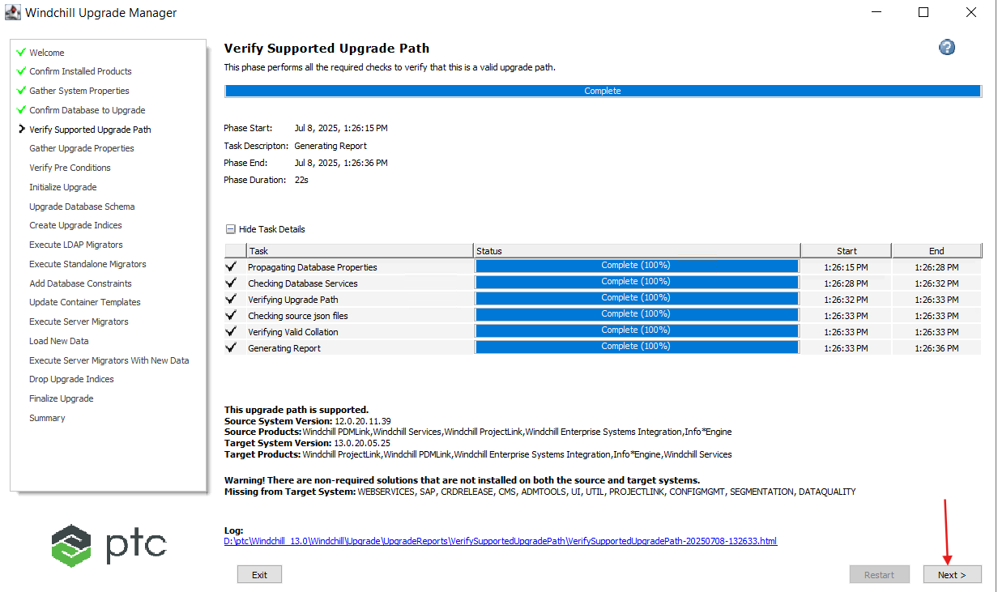

16. Provide the details as shown in the below screenshot and click on next tab.

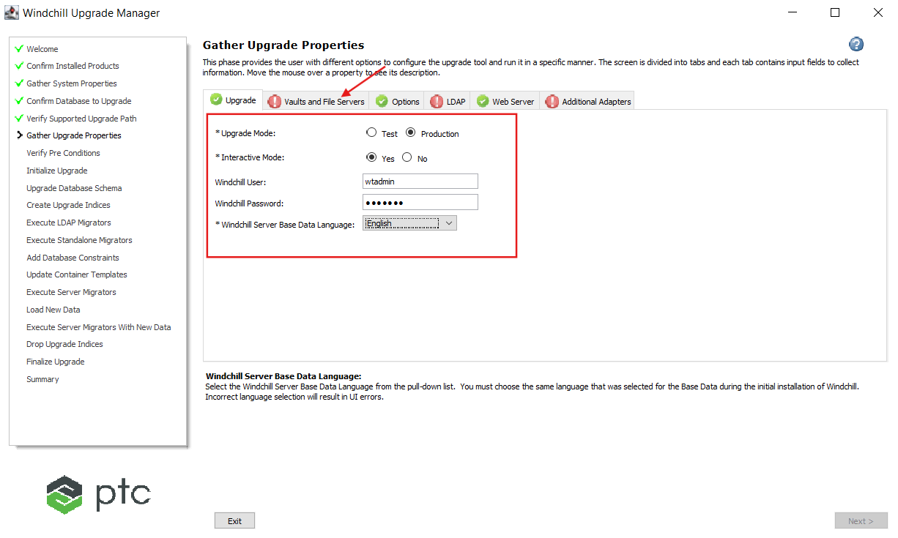

17. Provide the value as shown below and click on next tab.

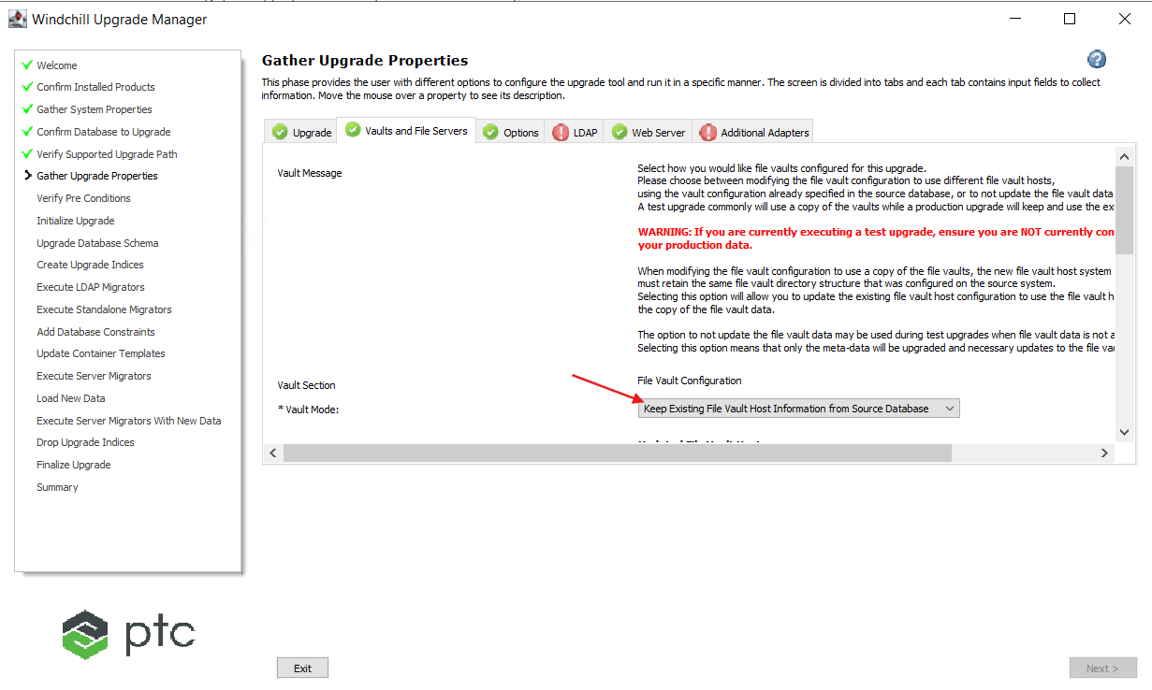

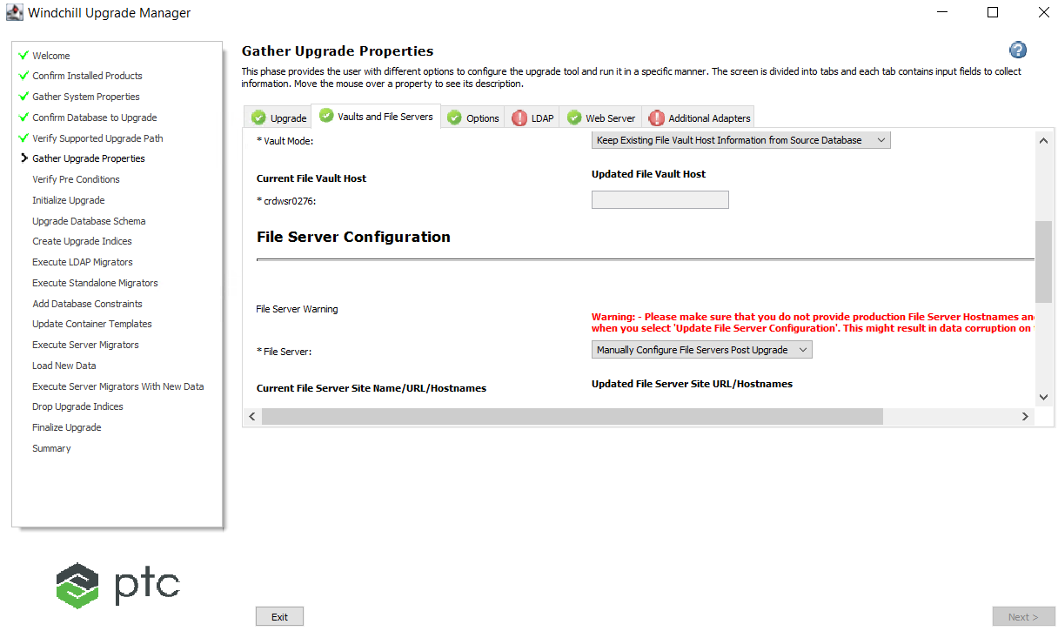

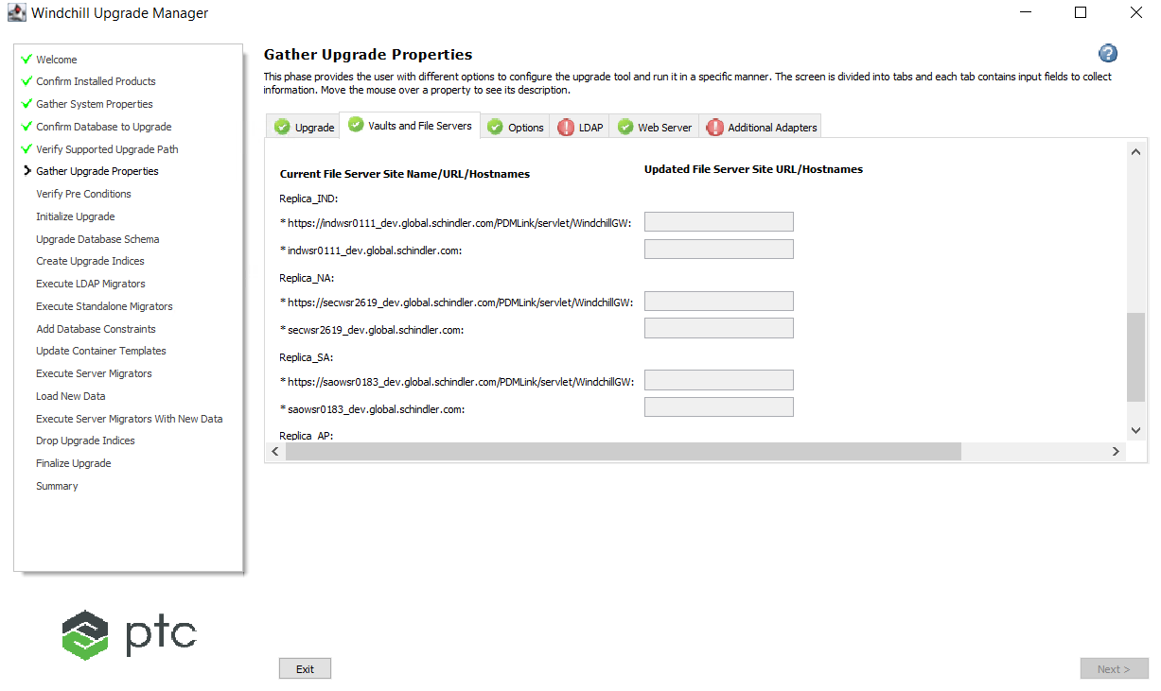

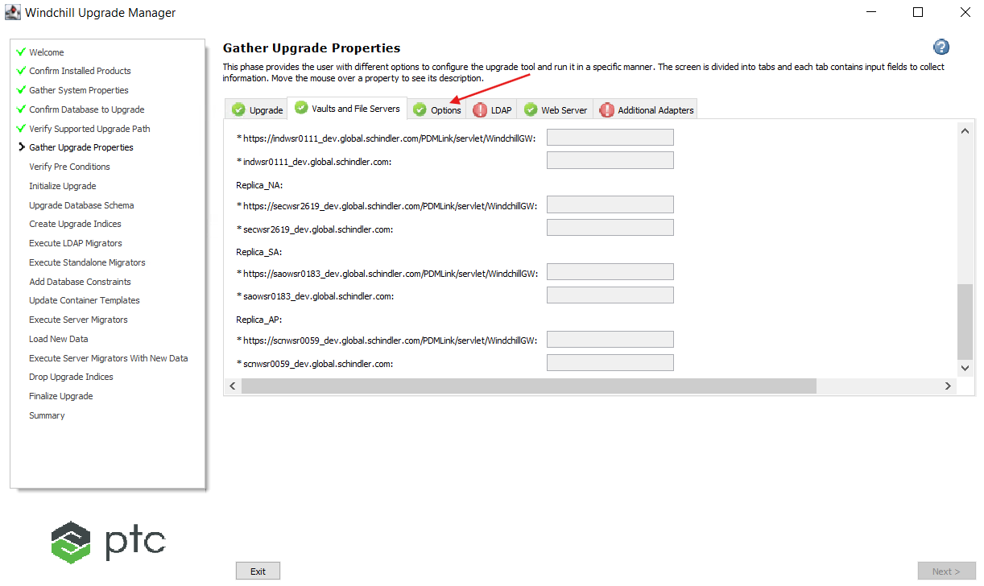

18. Leave 'Options' tab as is and click on next tab.

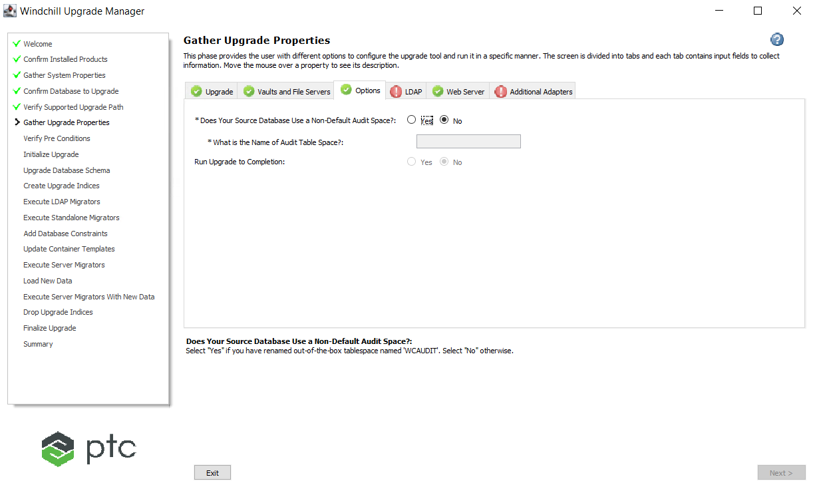

19. Make sure the Source LDAP is running (Page 62 of Upgrade Guide).

20. Provide the details as shown below and click on next tab.

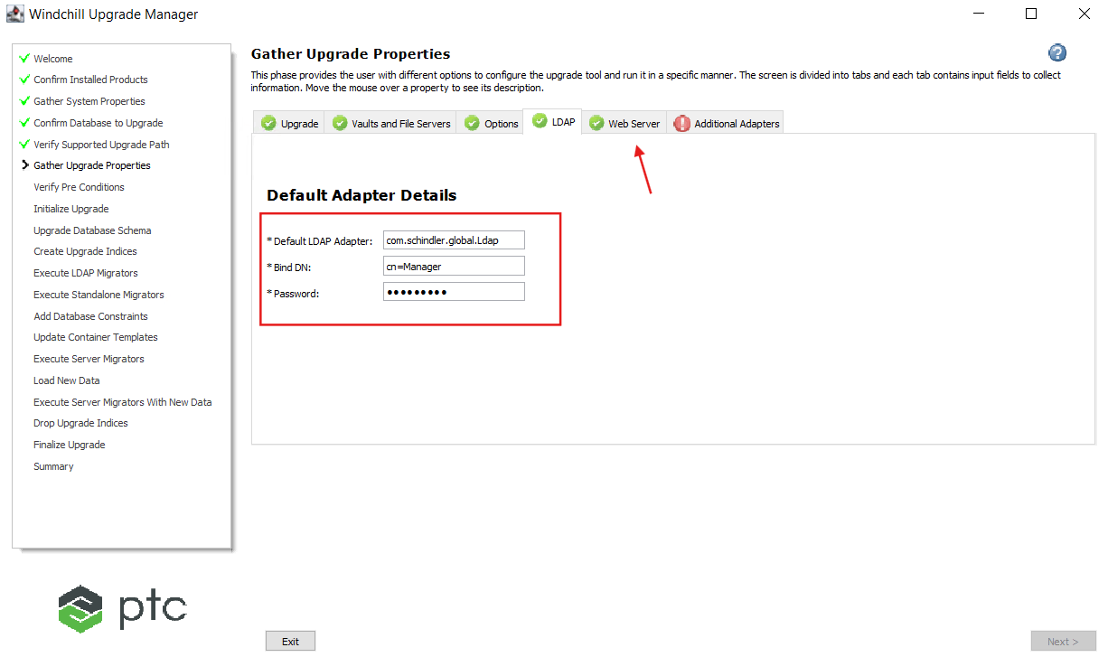

21. Leave 'Web Server' section as is and click on next tab.

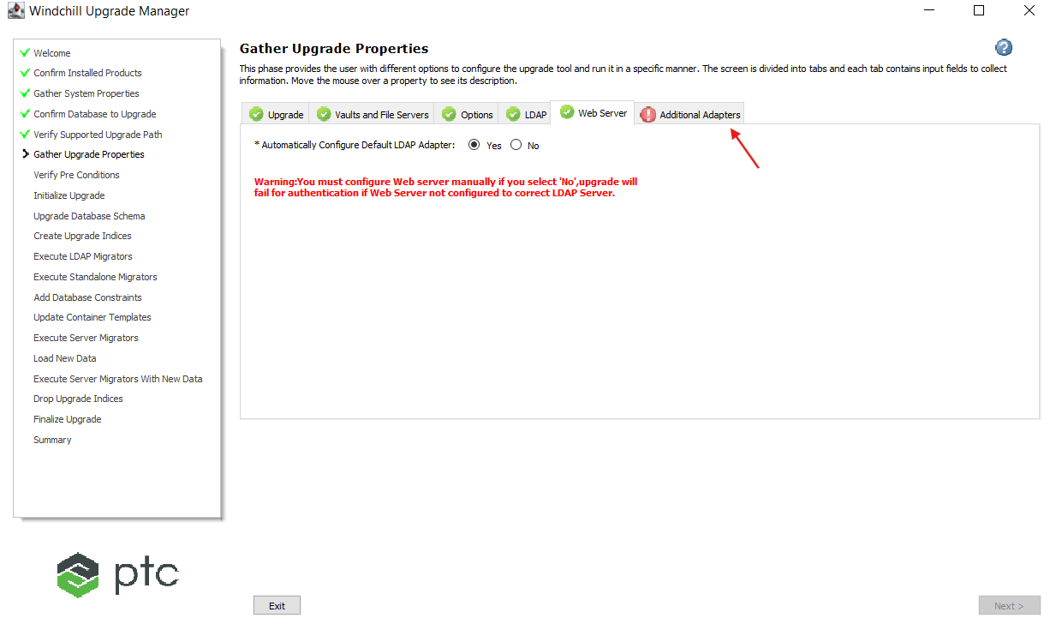

22. Select 'Copy to Target System' value as No (because we already created the adapter manually as a part of AD configuration) and click on Next.

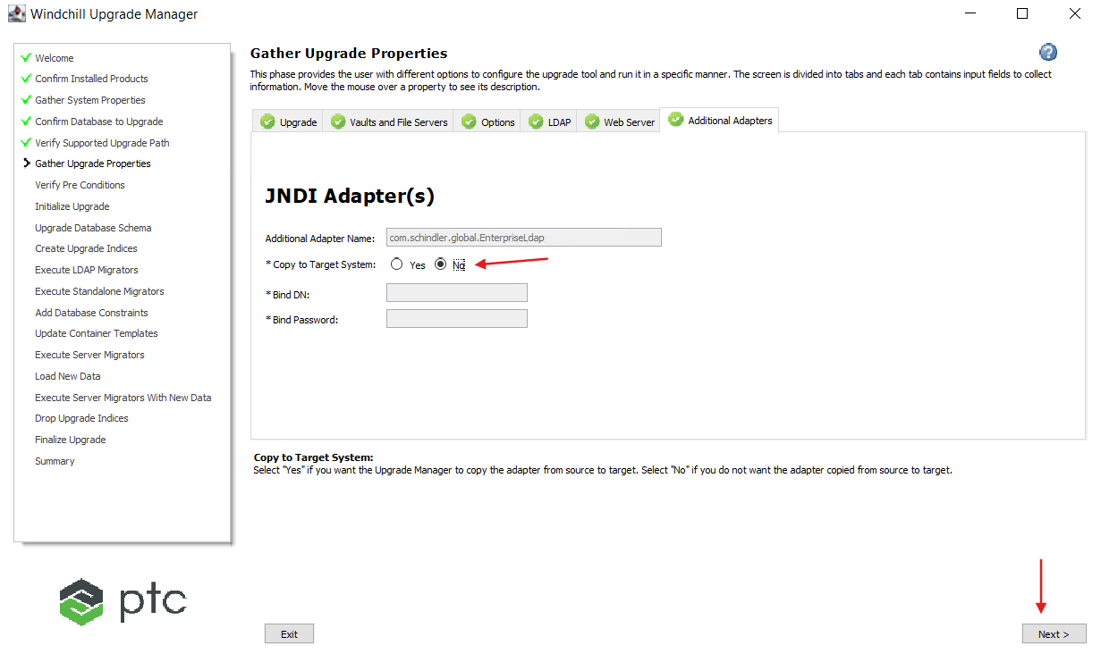

23. Click Next.

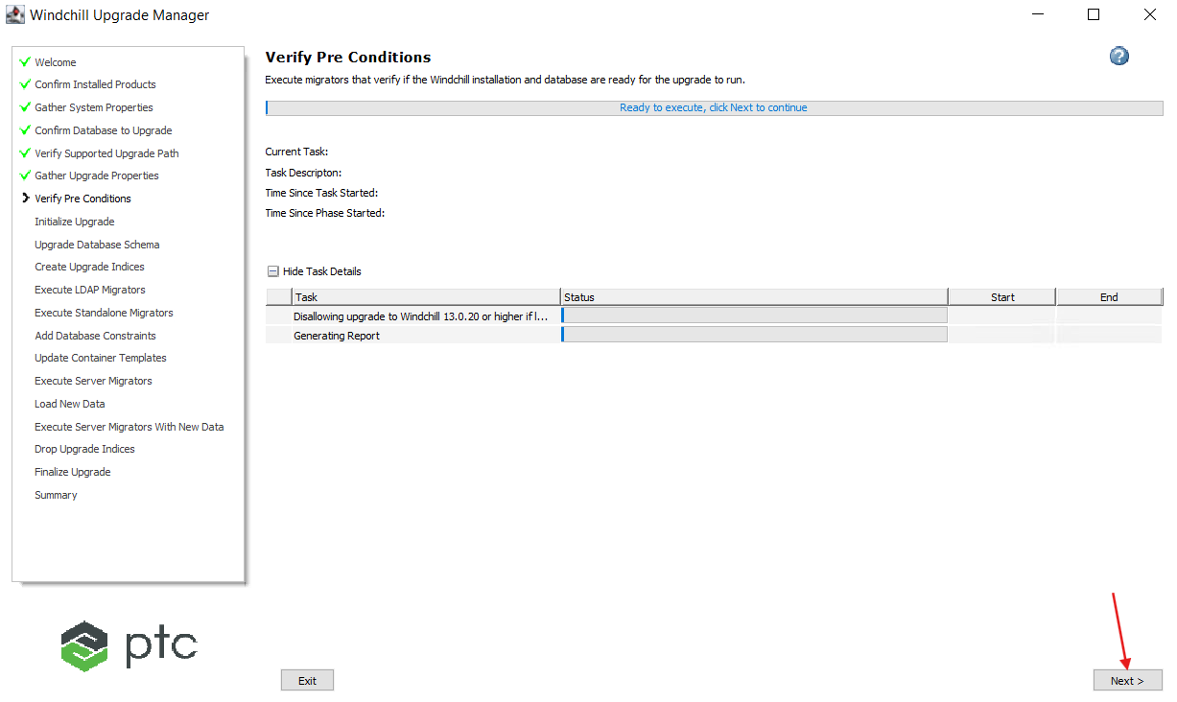

24. Click Next.

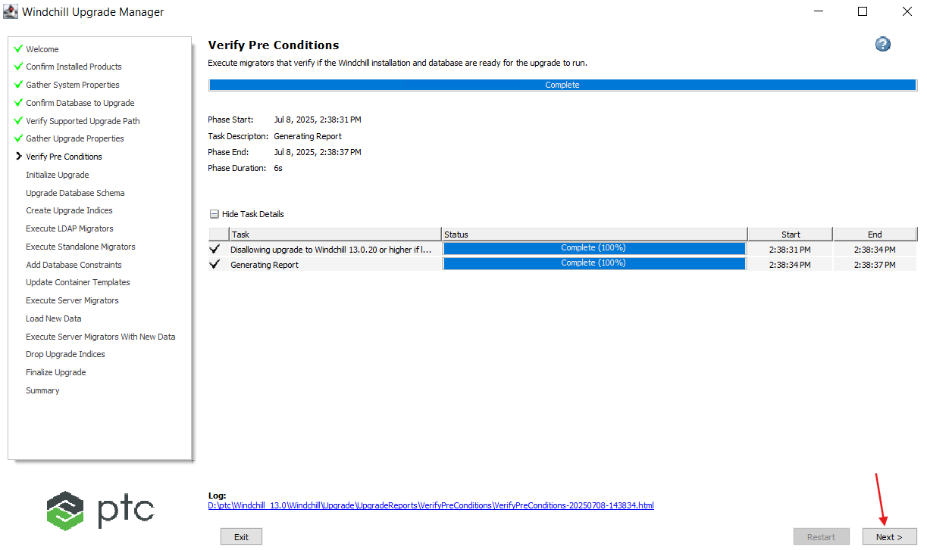

25. Click Next.

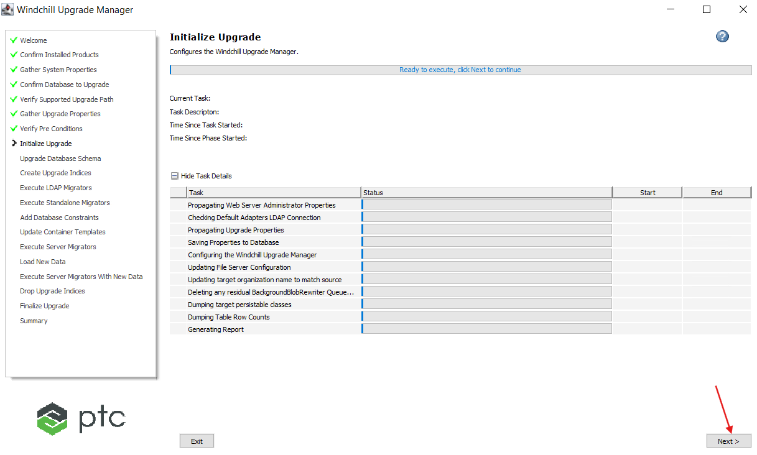

26. Restart Apache and click on Ok.

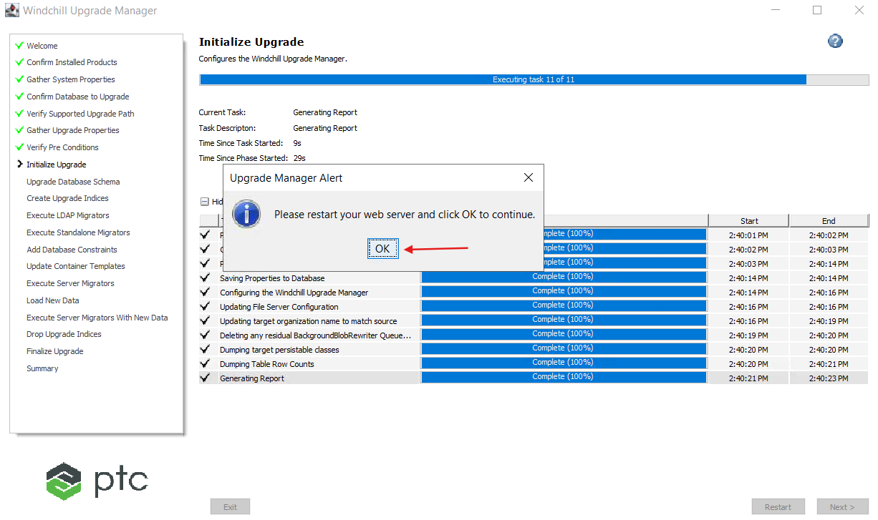

27. Click Next.

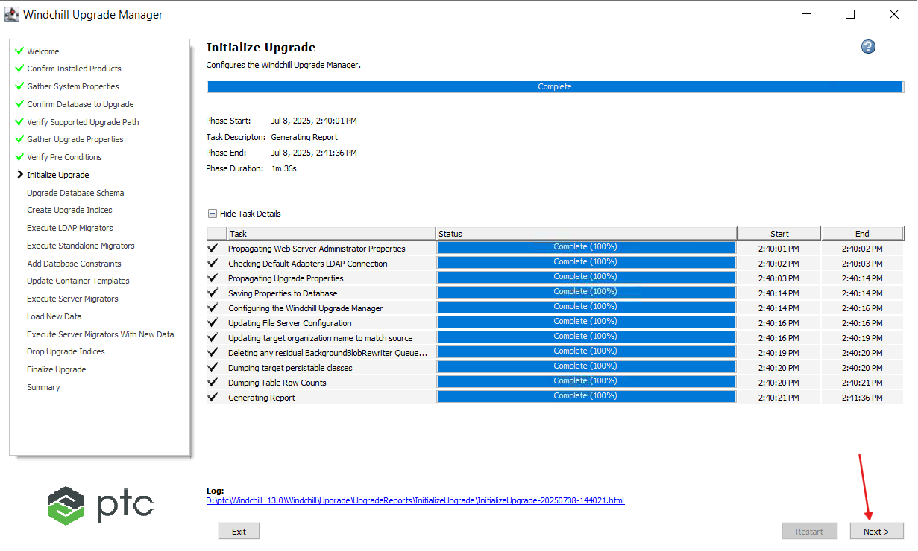

28. Click Next.

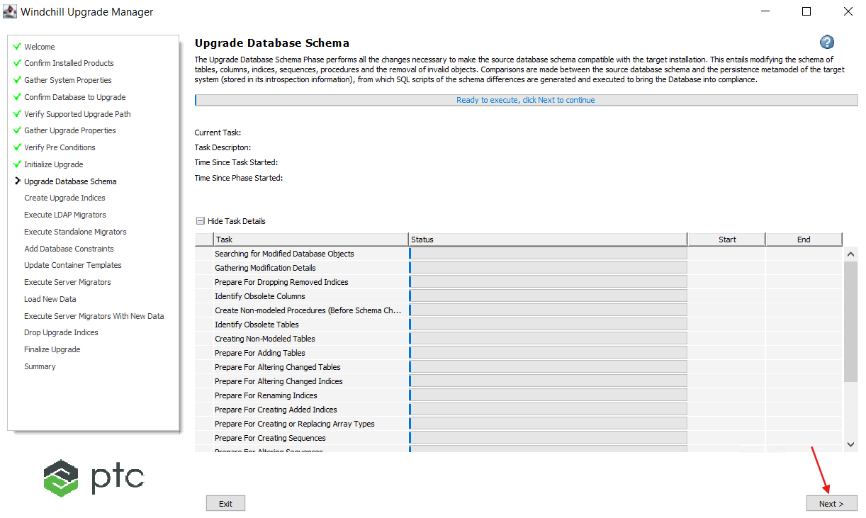

29. Click Next.

Note: This is the expected behaviour of upgrade manager to skip non-modeled Procedures. Please refer below article for reference.

[Article - CS439143 - Task Create Non-modeled Procedures (After Schema Changes) under Upgrade Database Schema is skipped when executing UpgradeManager in Windchill PDMLink](https://www.ptc.com/en/support/article/CS439143?source=search)

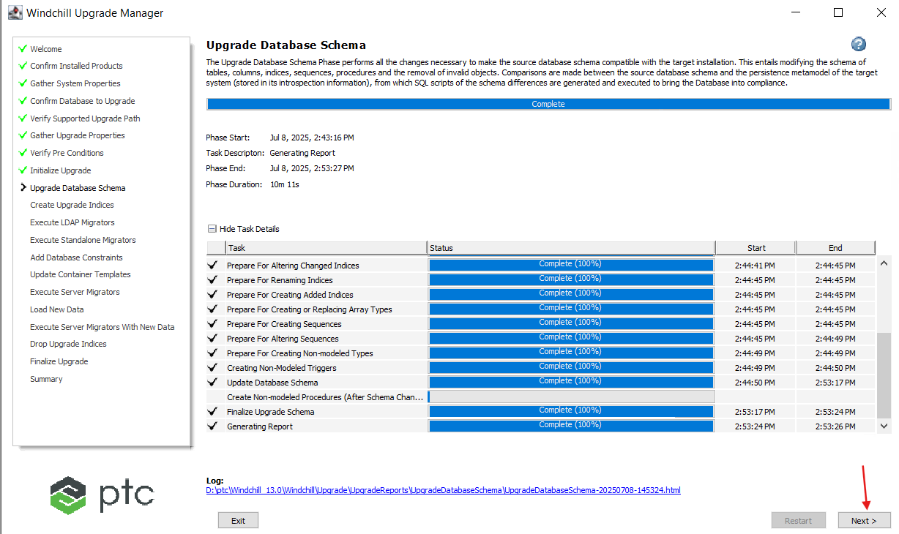

30. Click Next.

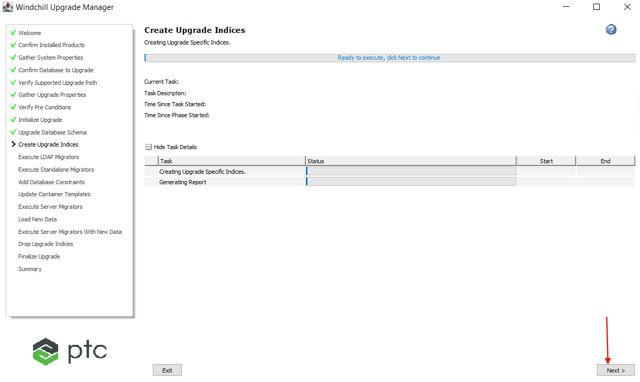

31. Click Next.

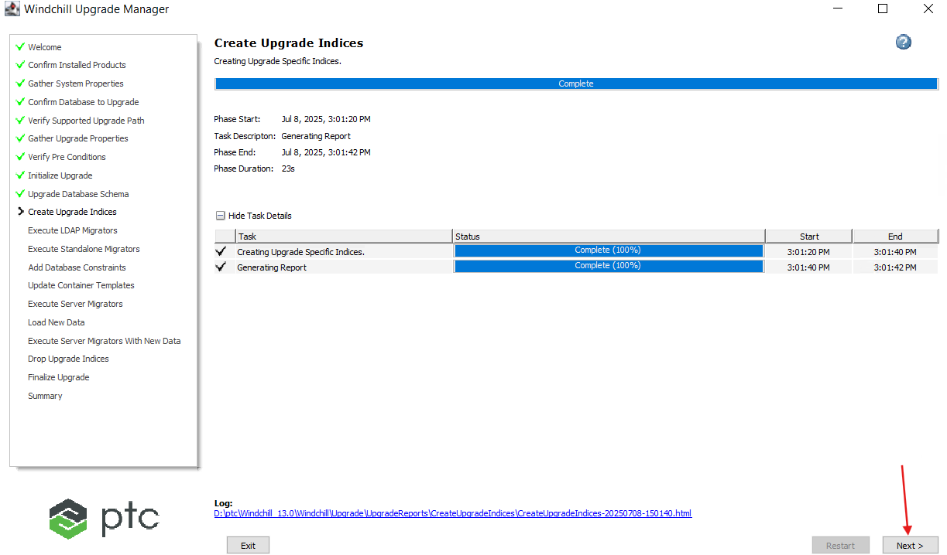

32. Click Next.

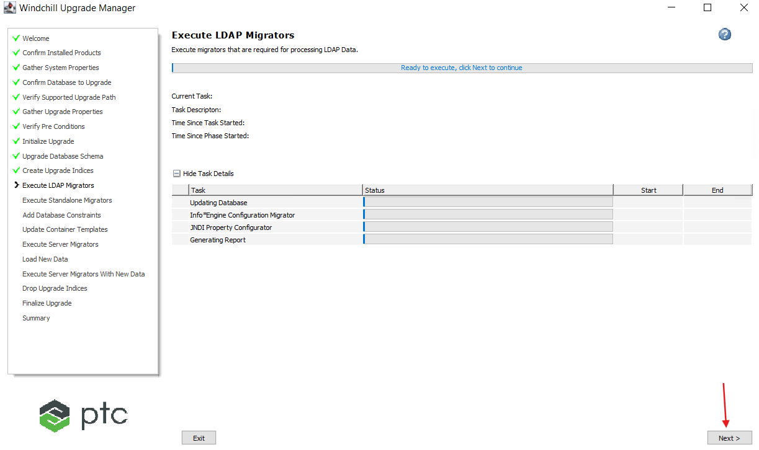

33. Click Next.

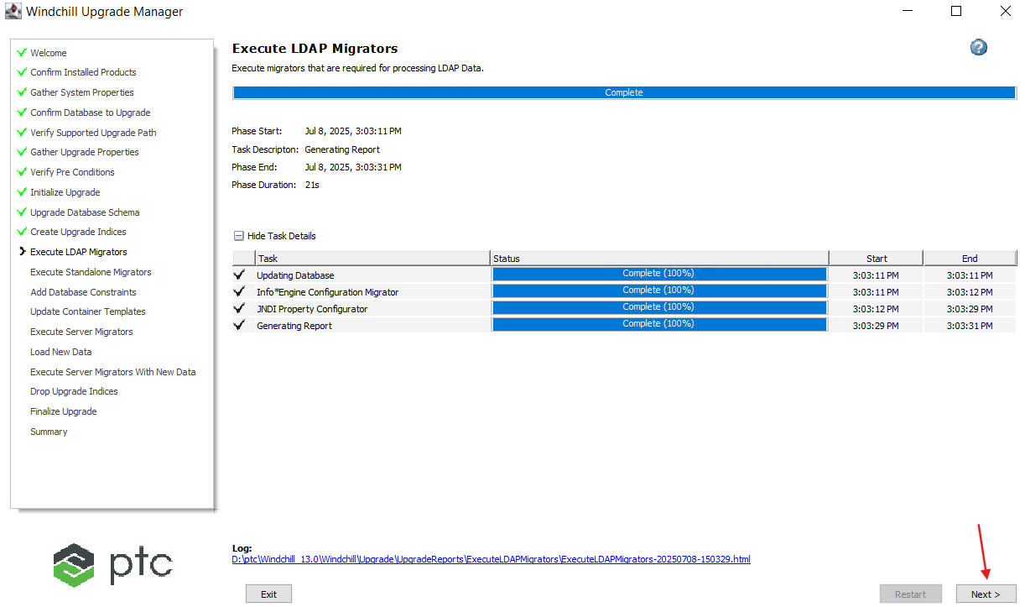

34. Click Next.

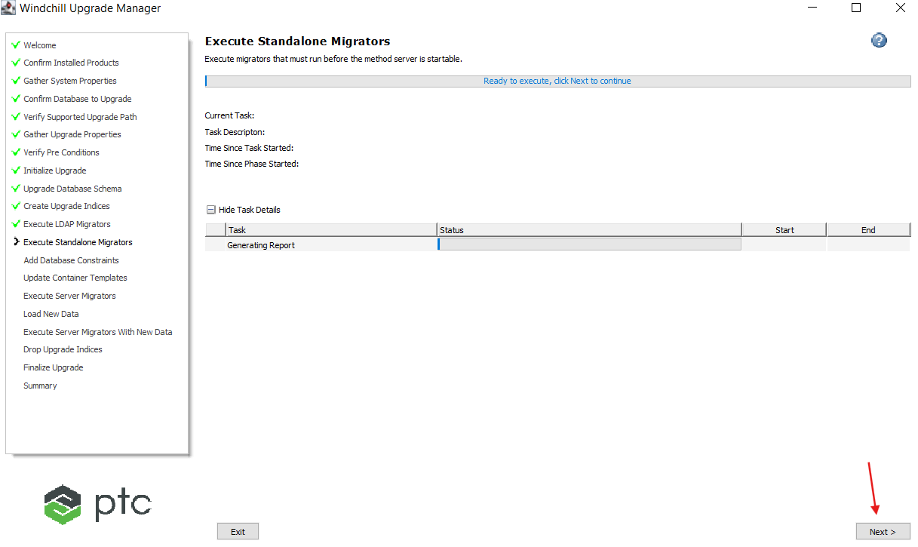

35. Click Next.

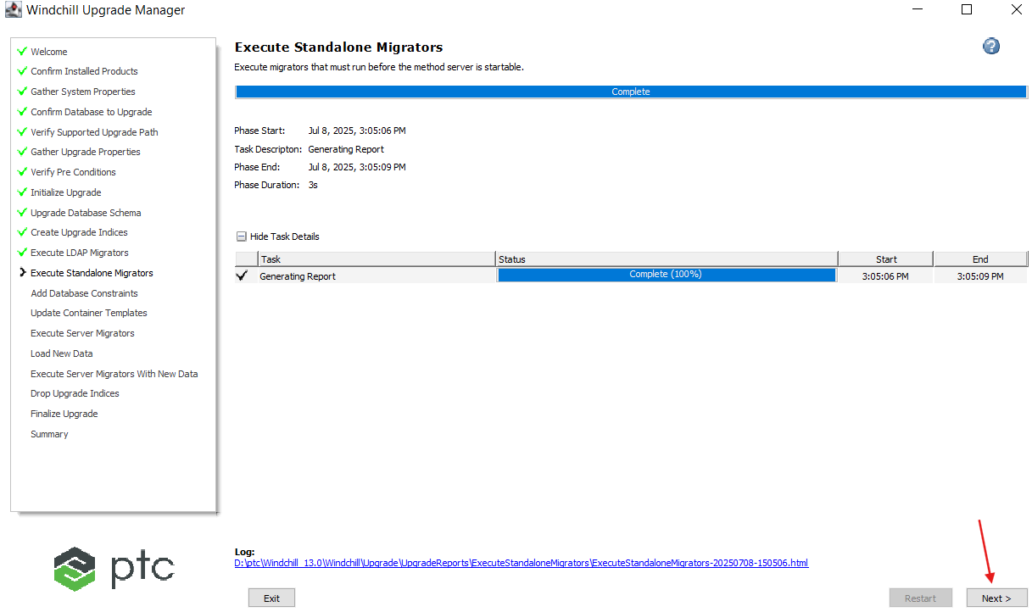

36. Click Next.

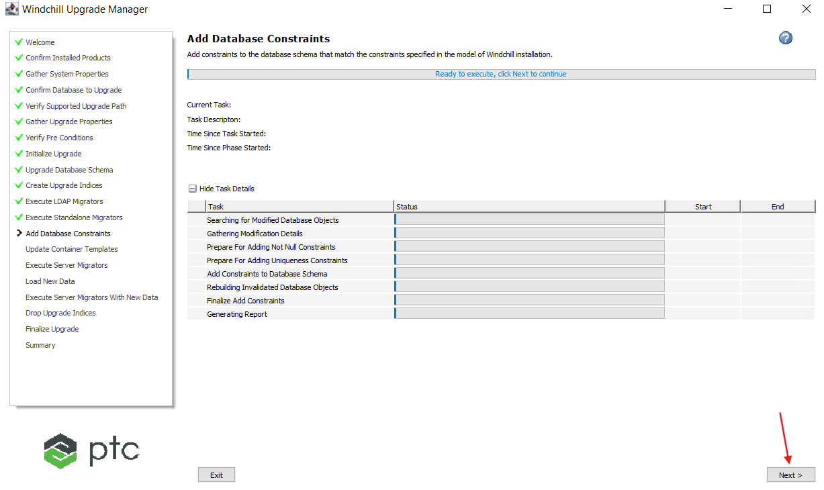

37. Click on Next.

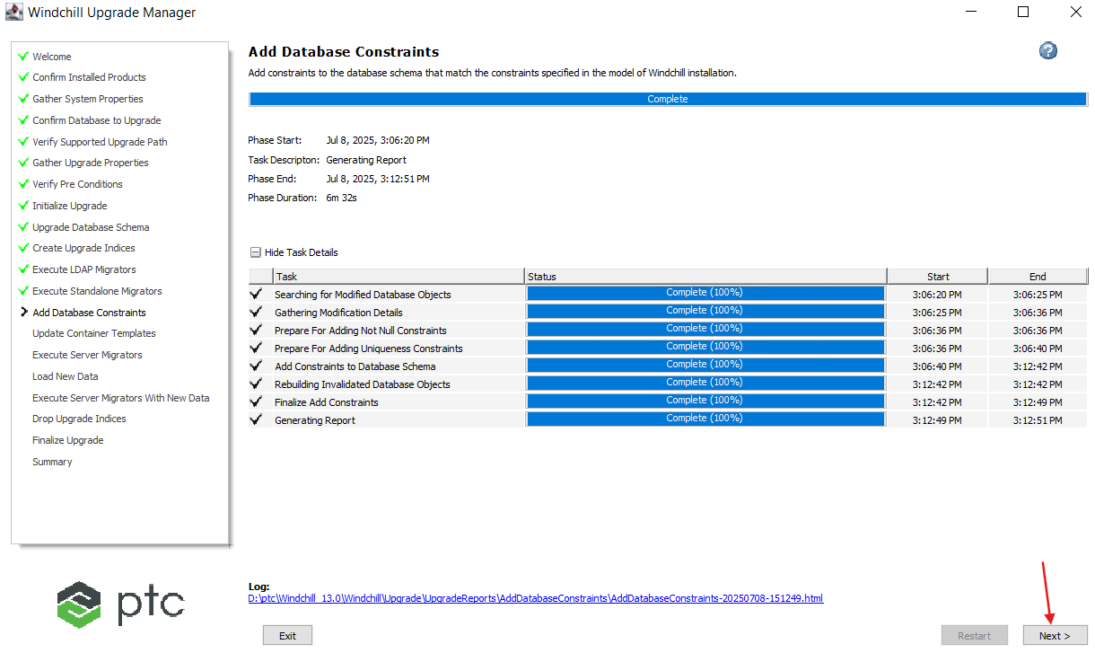

38. Click Next.

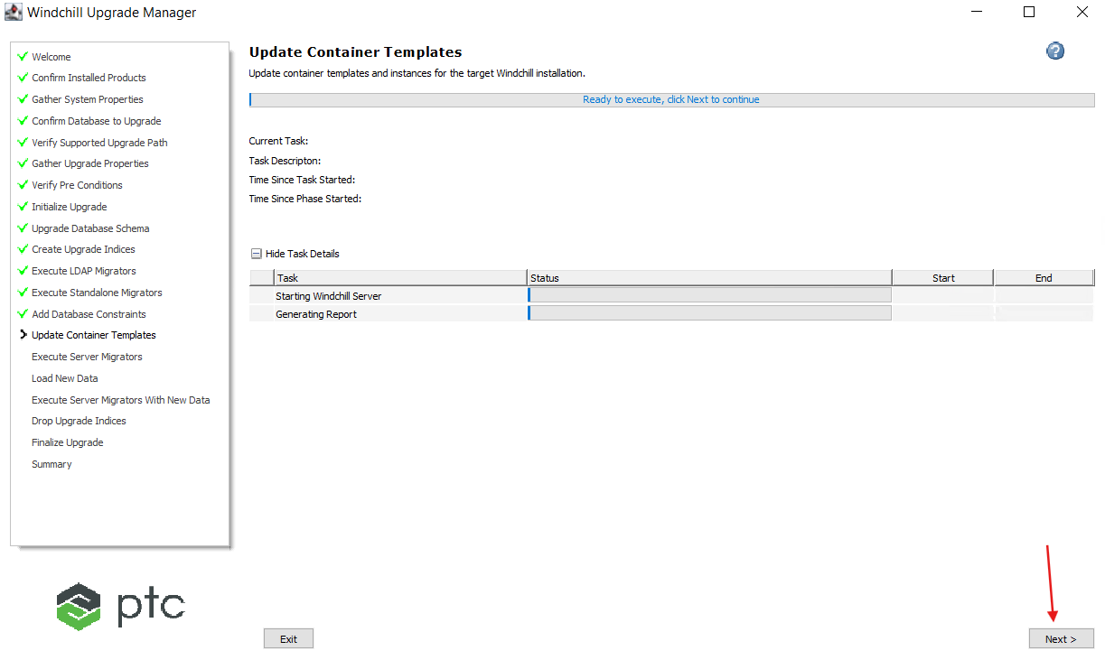

39. Click Next.

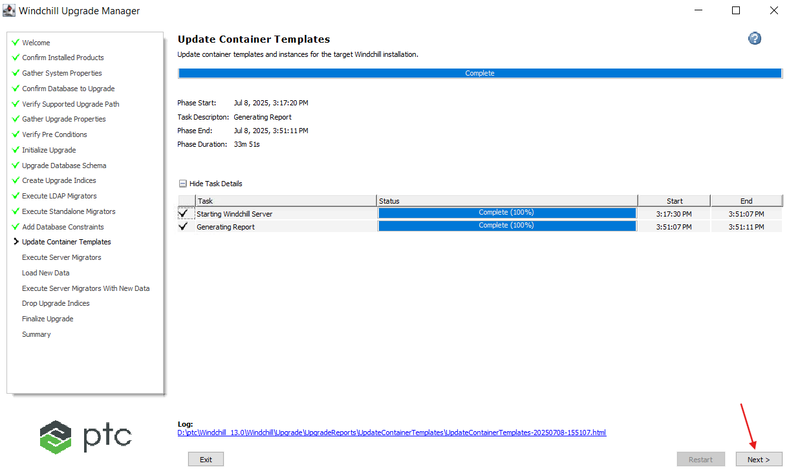

40. Click Next.

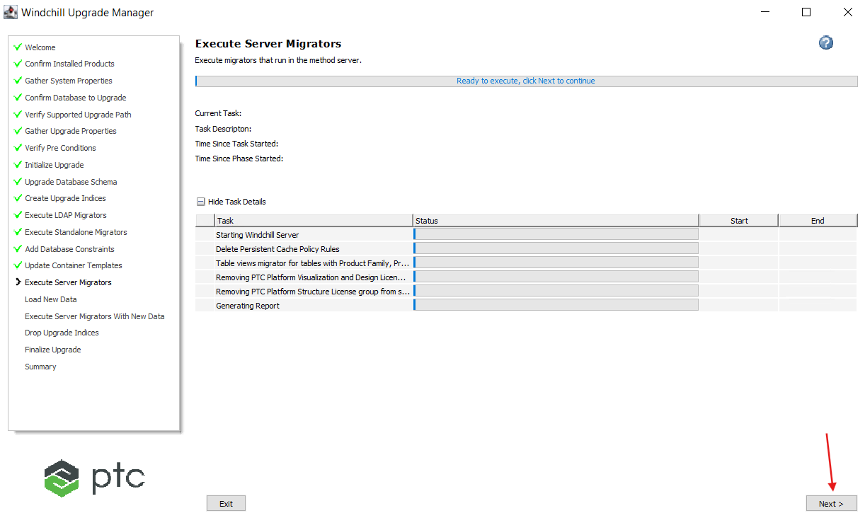

41. Click Next.

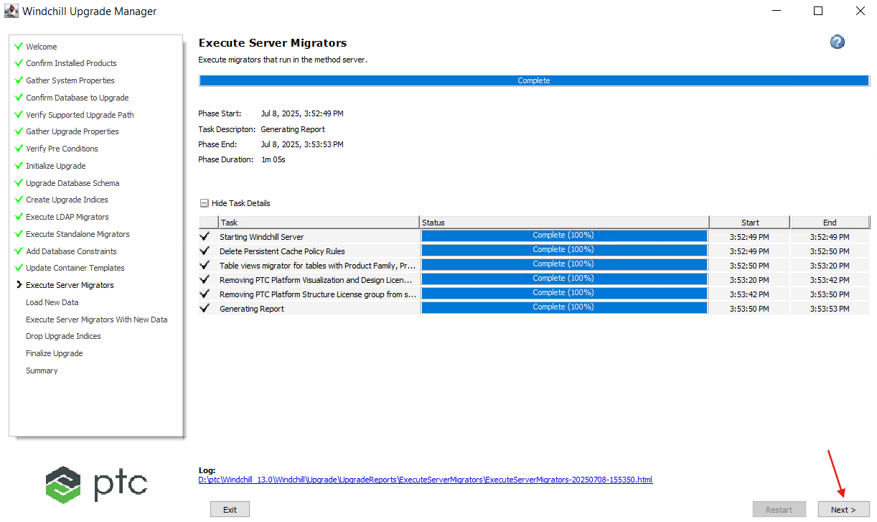

42. Click Next.

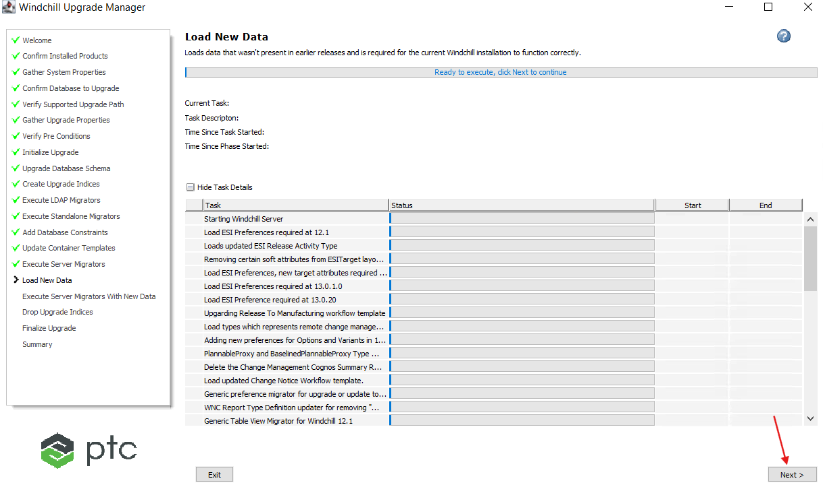

43. Upgrade Manager failed at Load New Data.

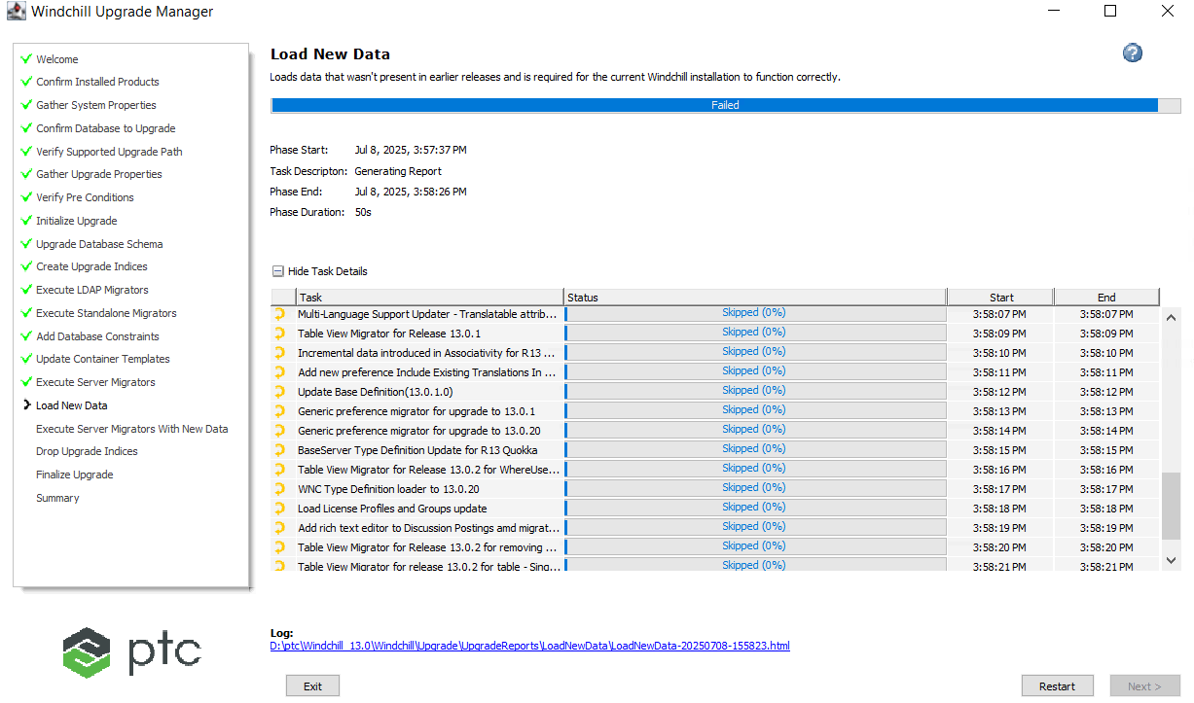

44. Below is the error observed in Method Server Log file.

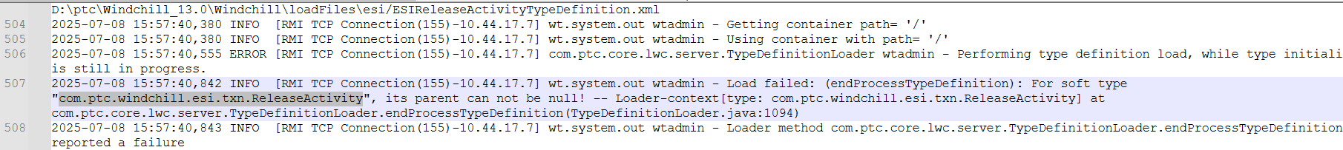

45. Verified the properties as per the following article and observed that everything is good.

[Article - CS240381 - Load New Data > Type Data Loader returns For soft type <type name>, its parent can not be null! during upgrade of Windchill PDMLink](https://www.ptc.com/en/support/article/CS240381?source=search)

46. Restarted entire server and re executed upgrade manager as per the above article.

47. This time it passed the issue.

48. Click Next.

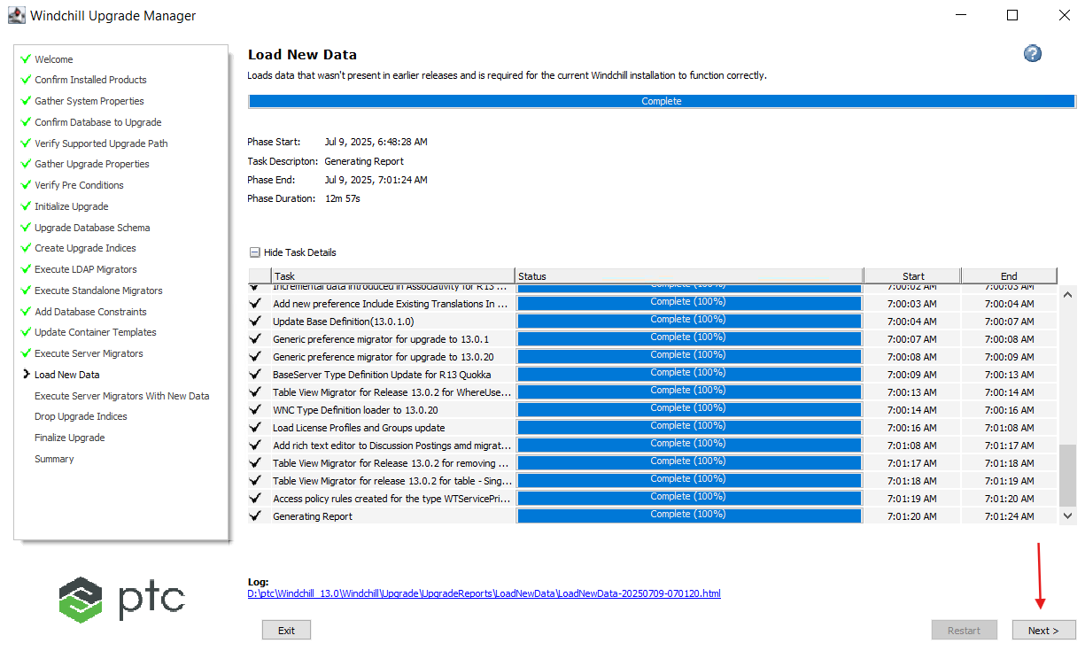

49. Click Next.

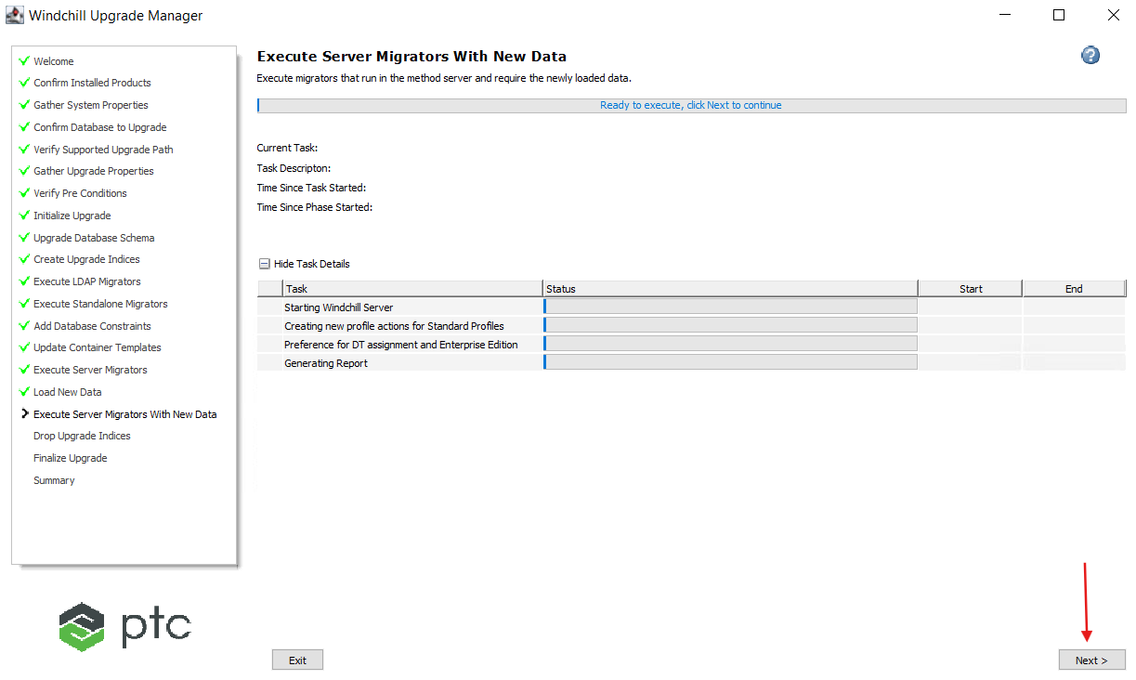

50. Click Next.

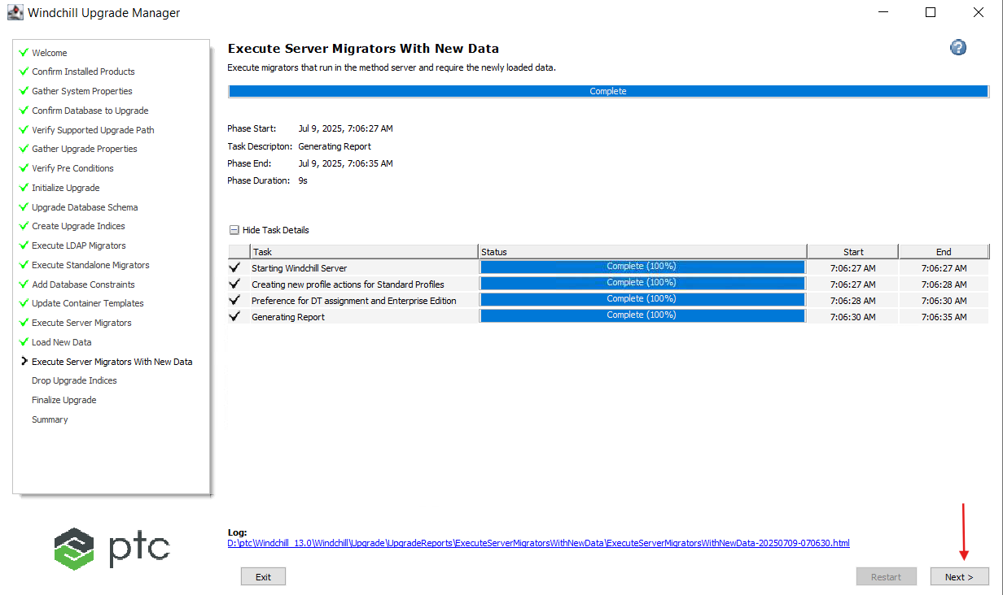

51. Click Next.

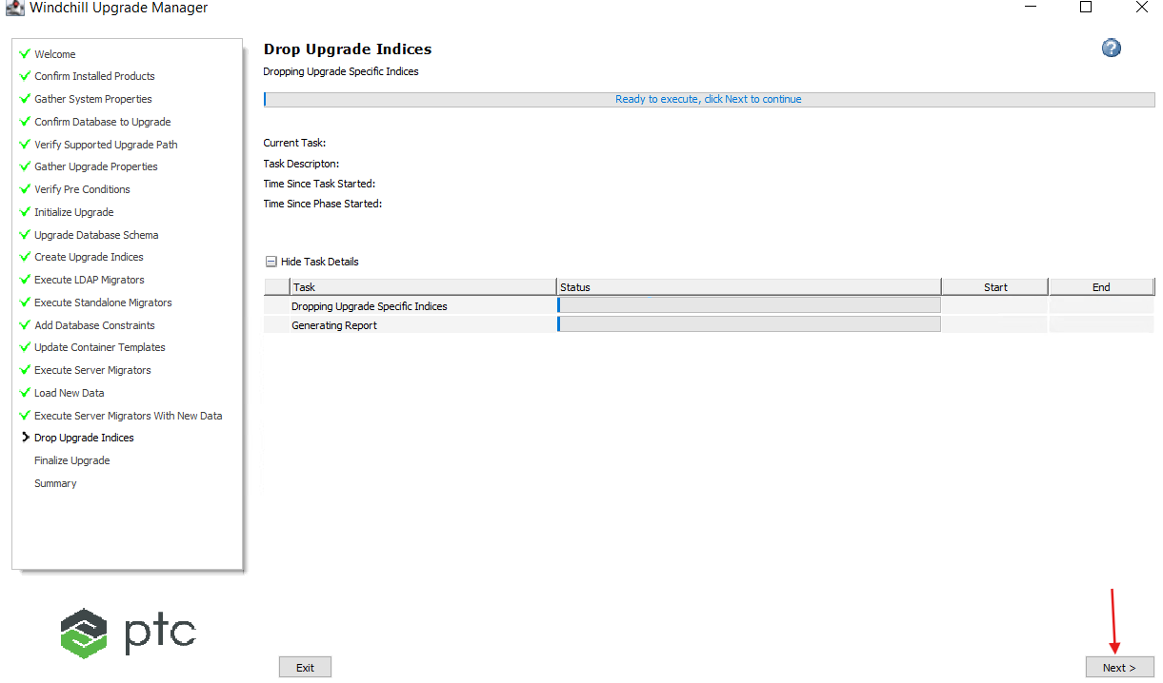

52. Click Next.

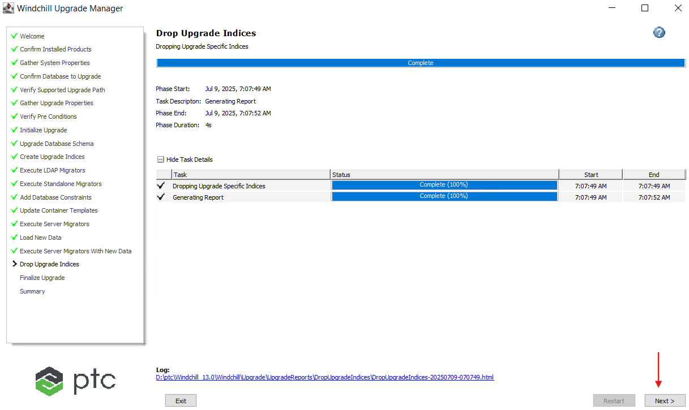

53. Click Next.

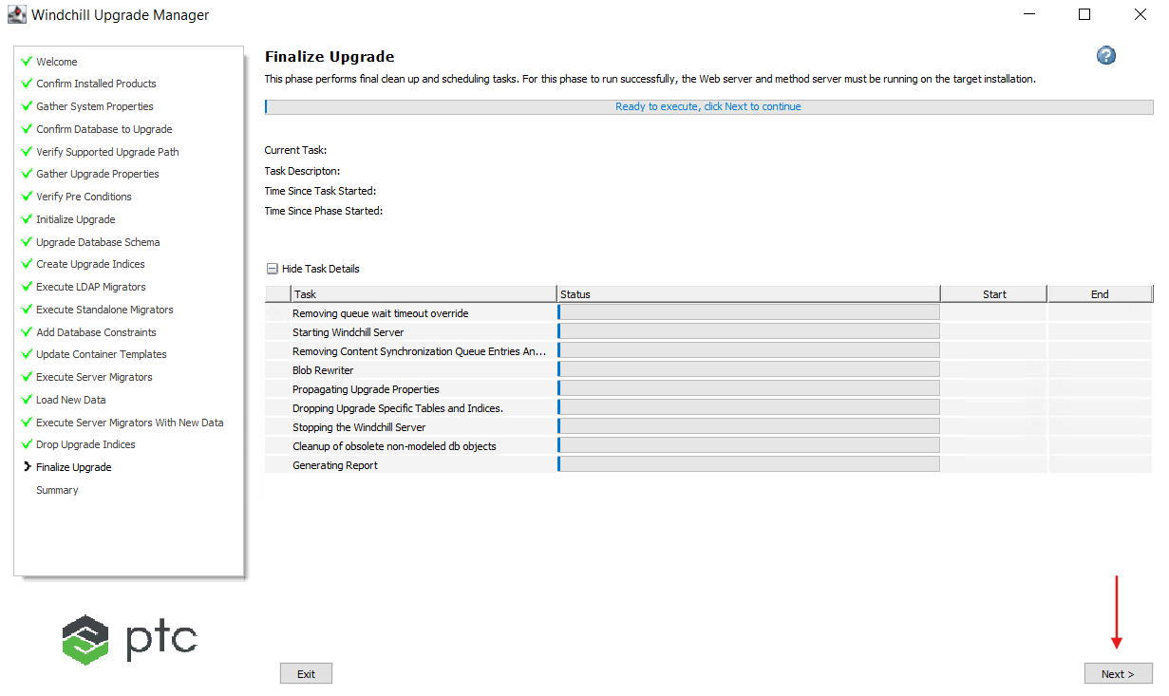

54. Click Next.

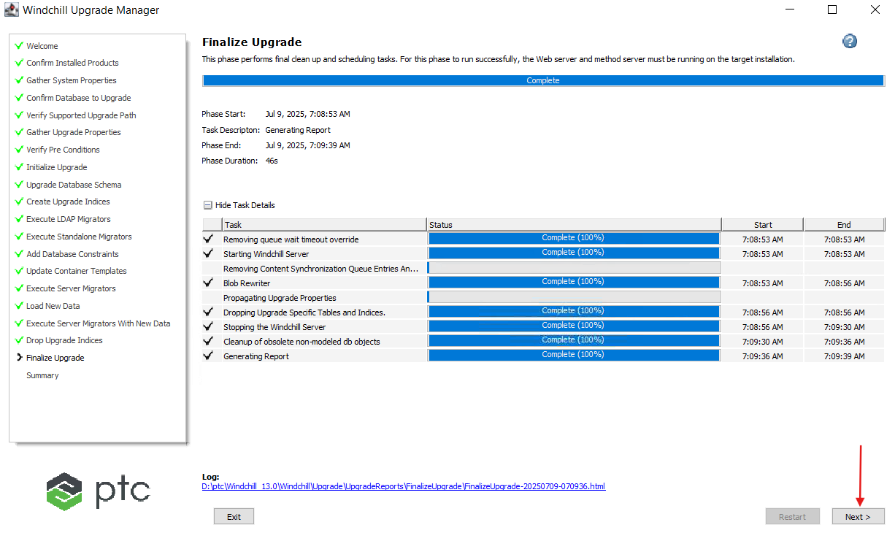

55. Click on Exit.

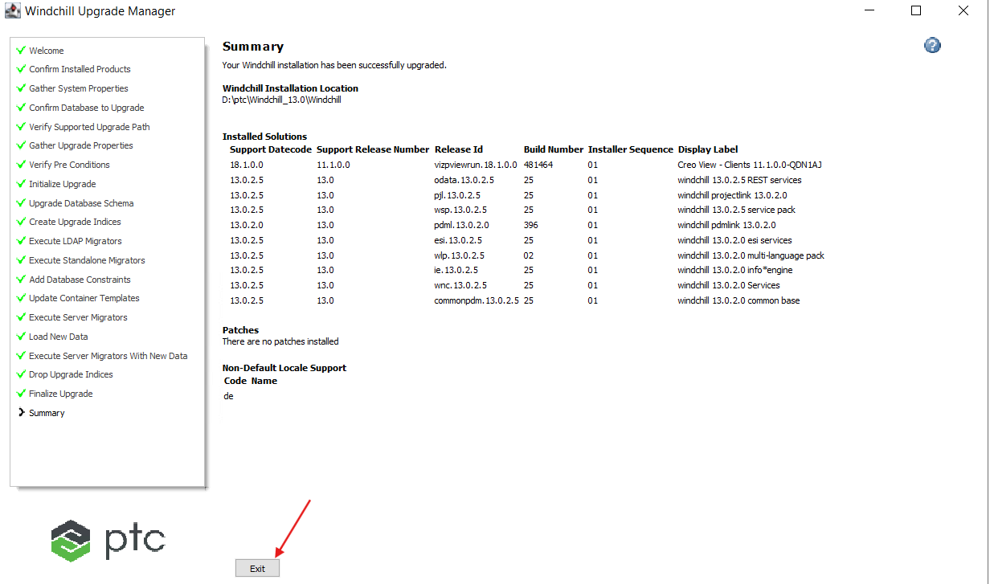

56. Click on Yes.

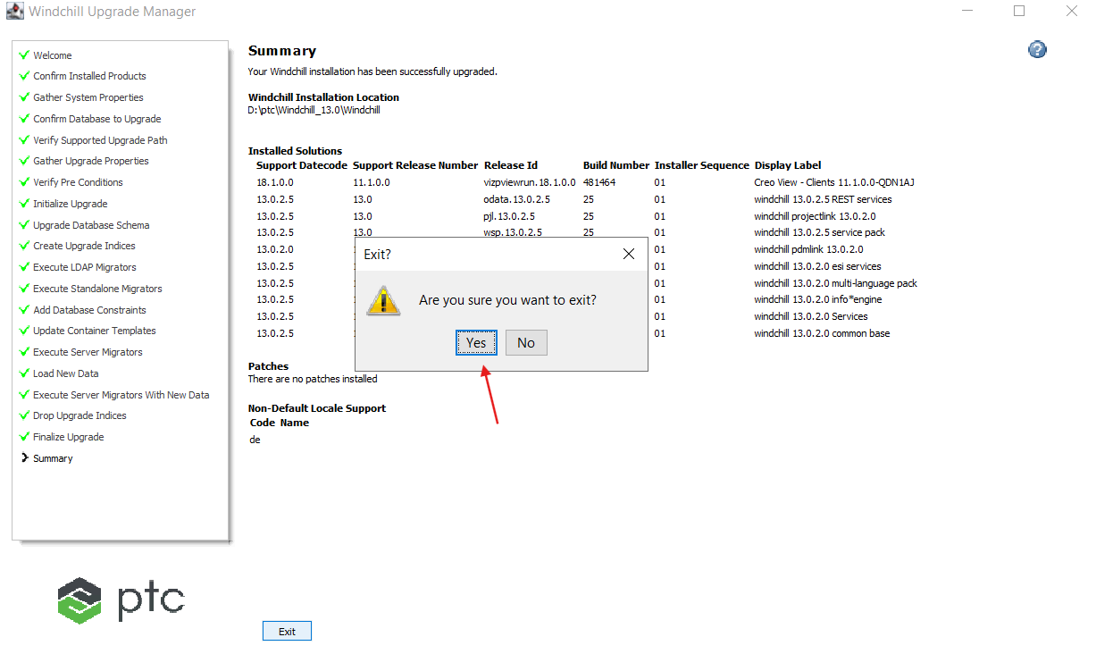

# Enable SSL Configuration

1. Please follow the below documentation and perform SSL configuration.

URL: [SSL/HTTPS Configuration - Schindler CRD Applications - CRD Confluence](https://confluence.schindler.com/spaces/SCA/pages/610404954/SSL+HTTPS+Configuration)

# Windchill Starting Issue:

1. After SSL configuration when we are trying to launch Windchill it is failing with below error in Method Server. Stop Windchill, DS and Apache.



2. Verified in PTC and found the following article.

[Article - CS414753 - Post rehost MethodServer failed to start with error wt.org.OrganizationServicesIEException: javax.naming.CommunicationException in Windchill PDMLink](https://www.ptc.com/en/support/article/CS414753?source=search)

3. Updated the properties in the below file as shown below.

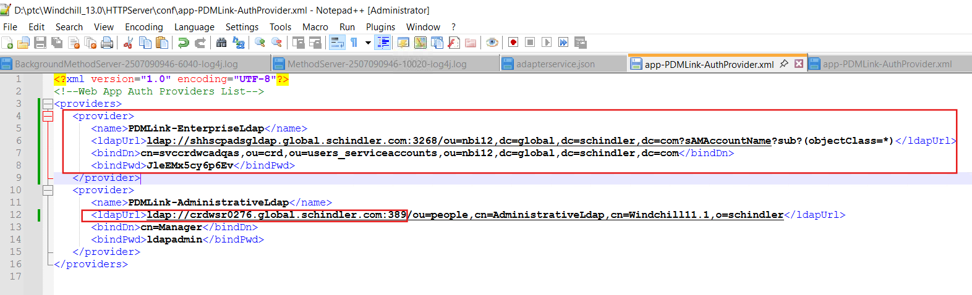

4. Update the property as shown below and save changes.

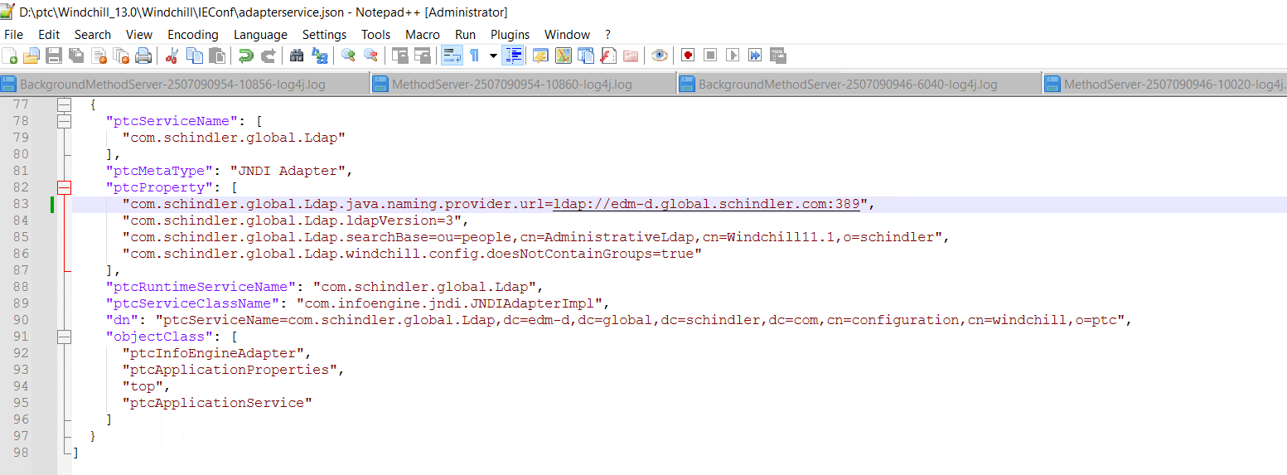

5. Open Windchill Shell as an Administrator and navigate to HTTPServer directory and execute the below command.

**ant -f webAppConfig.xml regenWebAppConf -DappName=PDMLink**

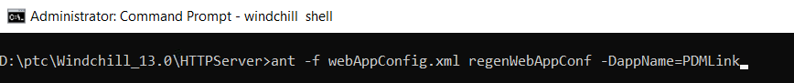

6. Make sure the build is successful.

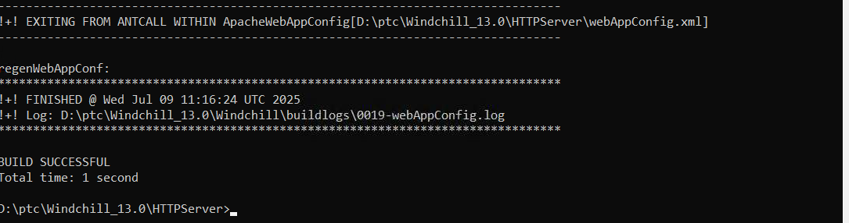

7. Make sure the below properties are in site.xconf file.

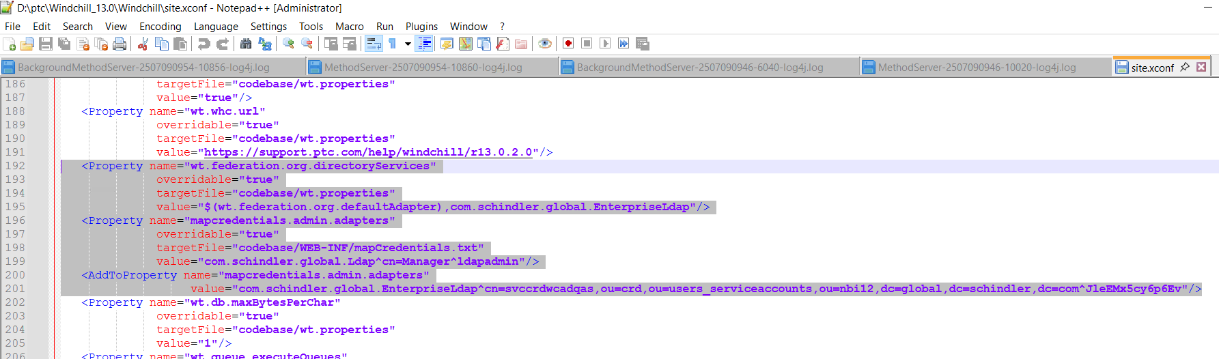

8. Restart server, clean cache and start Windchill.

9. Windchill started sucessfully.

# Importing License

1. Even though the Windchill started successfully wtadmin was unable to see the Advanced Search tab, Product, Libraries, Projects, Changes tabs.
2. We requested Schindler team to provide the license file to import.
3. Schindler team (Sandip Kute) imported the license on 10th July 2025.
4. After the license import wtadmin issue (point-1) is resolved.

# Recheck AD Configuration

1. After the running the upgrade manager observed that couple of AD configurations are wiped out.
2. Please follow the below document to make sure everything is available as per the configuration. If anything is missing, please add it.

URL: [Active Directory Configuration - Schindler CRD Applications - CRD Confluence](https://confluence.schindler.com/spaces/SCA/pages/613188727/Active+Directory+Configuration)

# Vault Configuration

1. Clean cache and start Windchill if it down.
2. Log into Windchill as Administrator and navigate to Site → Utilities → File Server Administration.

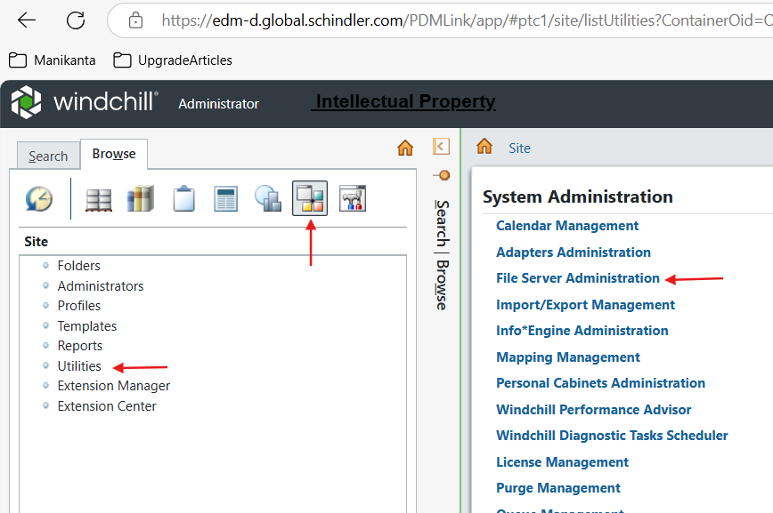

3. Click on Vault Configuration.

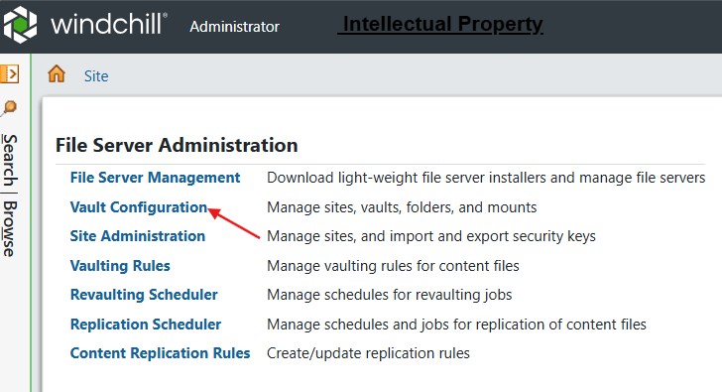

4. Expand Site → main → Hosts → select server hostname → click on Object as shown below.

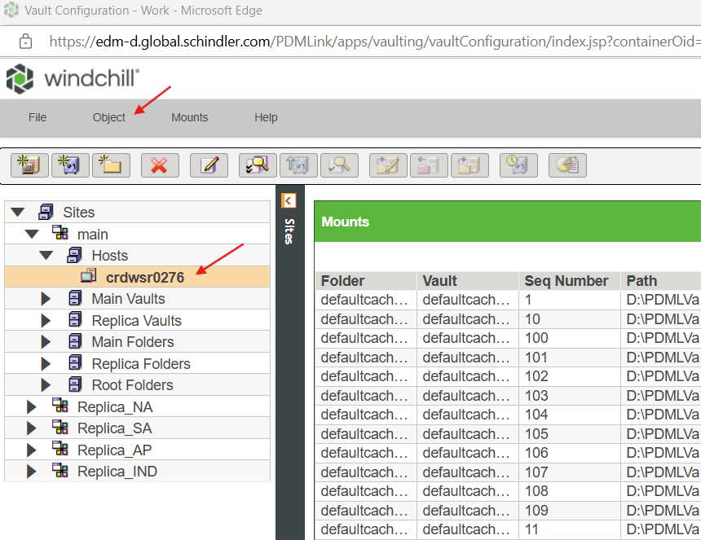

5. Click on Validate.

6. It resulted the below error.

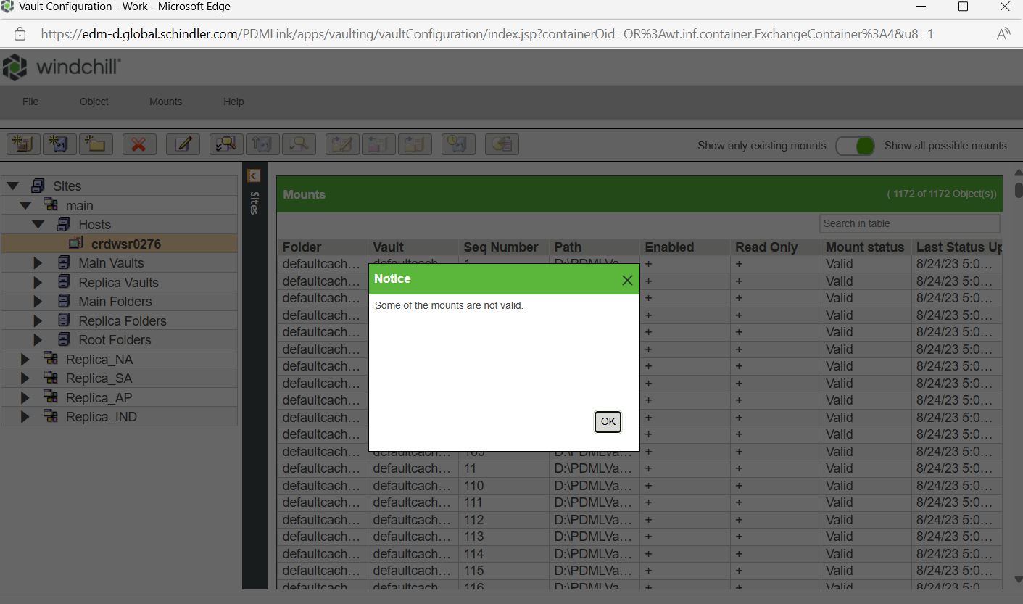

7. Click on Ok.

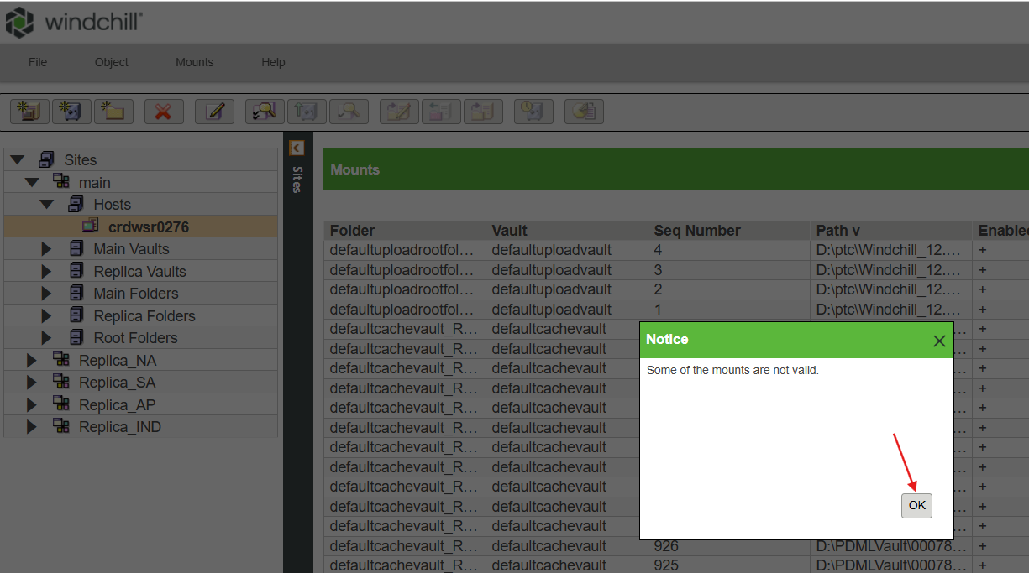

8. Sorted by Mount Status and observed couple of entries that does not exist.

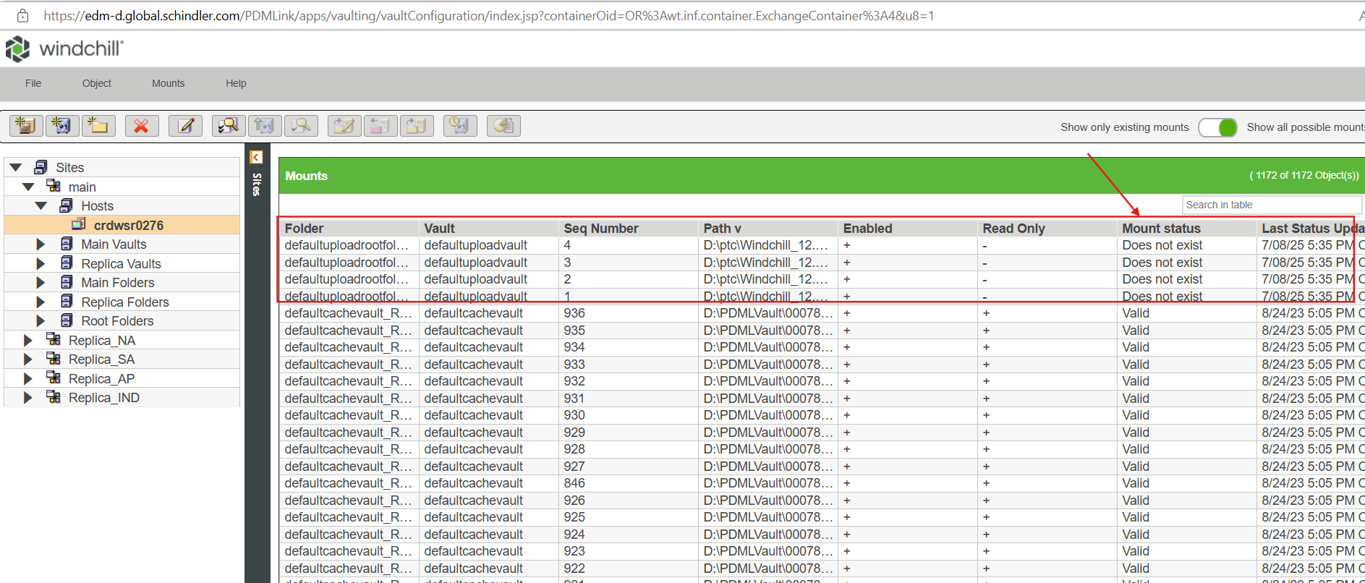

9. Log into database as pdmlink and execute the below query.

select * from pdmlink.pdmlink.FvMount ORDER BY path DESC;

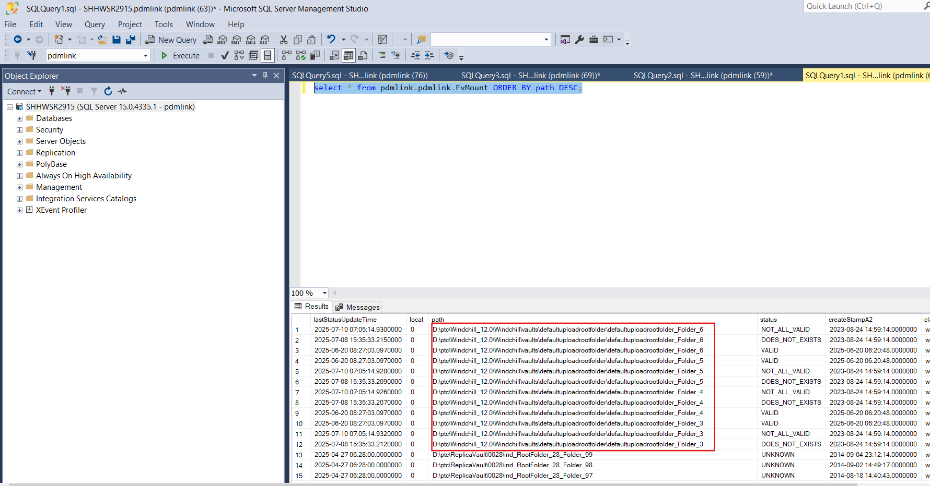

10. Observed couple of entries are pointing to wrong folder location.

11. Executed the below query to take backup of FvMount table.

select * into FvMountBeforePathUpdateToWindchill13 from FvMount;

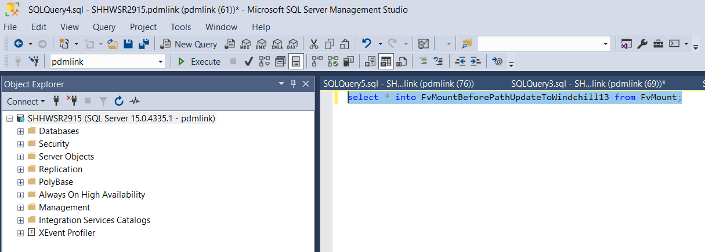

12. Prepared below SQL queries to update the locations.

Update pdmlink.pdmlink.FvMount SET path='D:\ptc\Windchill_13.0\Windchill\vaults\defaultuploadrootfolder\defaultuploadrootfolder_Folder_6' where idA2A2=14481439217  
Update pdmlink.pdmlink.FvMount SET path='D:\ptc\Windchill_13.0\Windchill\vaults\defaultuploadrootfolder\defaultuploadrootfolder_Folder_6' where idA2A2=14481439219  
Update pdmlink.pdmlink.FvMount SET path='D:\ptc\Windchill_13.0\Windchill\vaults\defaultuploadrootfolder\defaultuploadrootfolder_Folder_6' where idA2A2=23920446518  
Update pdmlink.pdmlink.FvMount SET path='D:\ptc\Windchill_13.0\Windchill\vaults\defaultuploadrootfolder\defaultuploadrootfolder_Folder_5' where idA2A2=23920446516  
Update pdmlink.pdmlink.FvMount SET path='D:\ptc\Windchill_13.0\Windchill\vaults\defaultuploadrootfolder\defaultuploadrootfolder_Folder_5' where idA2A2=14481439213  
Update pdmlink.pdmlink.FvMount SET path='D:\ptc\Windchill_13.0\Windchill\vaults\defaultuploadrootfolder\defaultuploadrootfolder_Folder_5' where idA2A2=14481439215  
Update pdmlink.pdmlink.FvMount SET path='D:\ptc\Windchill_13.0\Windchill\vaults\defaultuploadrootfolder\defaultuploadrootfolder_Folder_4' where idA2A2=14481439209  
Update pdmlink.pdmlink.FvMount SET path='D:\ptc\Windchill_13.0\Windchill\vaults\defaultuploadrootfolder\defaultuploadrootfolder_Folder_4' where idA2A2=14481439211  
Update pdmlink.pdmlink.FvMount SET path='D:\ptc\Windchill_13.0\Windchill\vaults\defaultuploadrootfolder\defaultuploadrootfolder_Folder_4' where idA2A2=23920446514  
Update pdmlink.pdmlink.FvMount SET path='D:\ptc\Windchill_13.0\Windchill\vaults\defaultuploadrootfolder\defaultuploadrootfolder_Folder_3' where idA2A2=23920446512  
Update pdmlink.pdmlink.FvMount SET path='D:\ptc\Windchill_13.0\Windchill\vaults\defaultuploadrootfolder\defaultuploadrootfolder_Folder_3' where idA2A2=14481439205  
Update pdmlink.pdmlink.FvMount SET path='D:\ptc\Windchill_13.0\Windchill\vaults\defaultuploadrootfolder\defaultuploadrootfolder_Folder_3' where idA2A2=14481439207

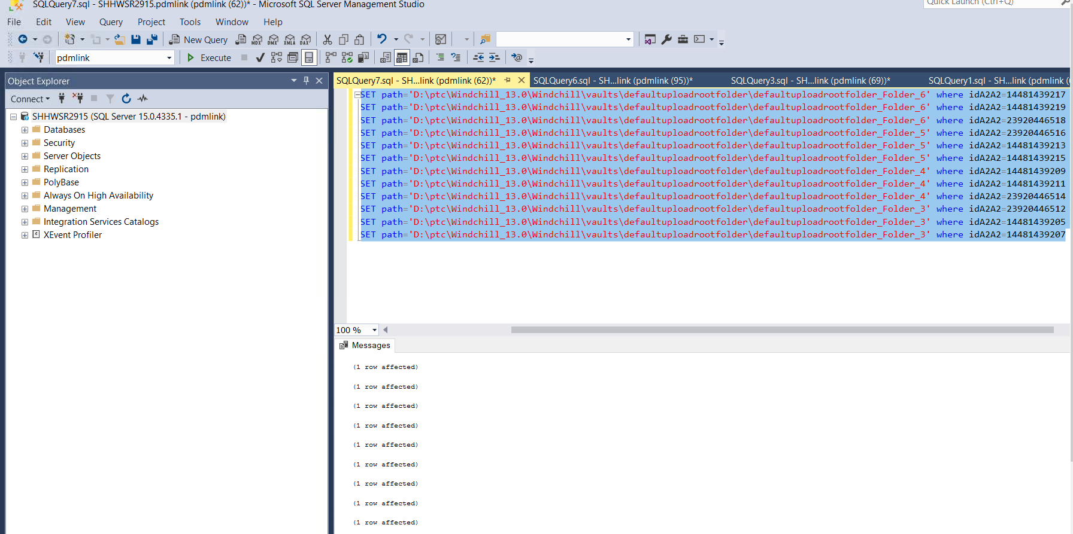

13. Execute the below query to make sure the values got updated successfully.

select * from pdmlink.pdmlink.FvMount ORDER BY path DESC;

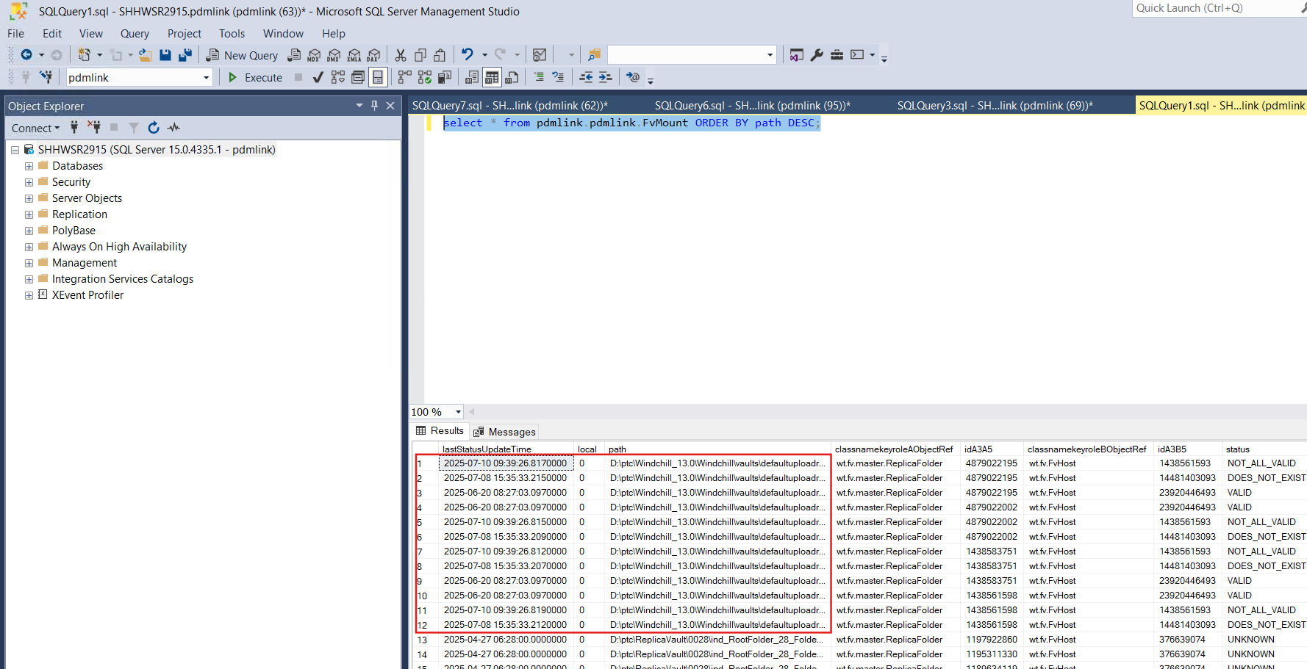

14. Copy the below folders from Source to Target.

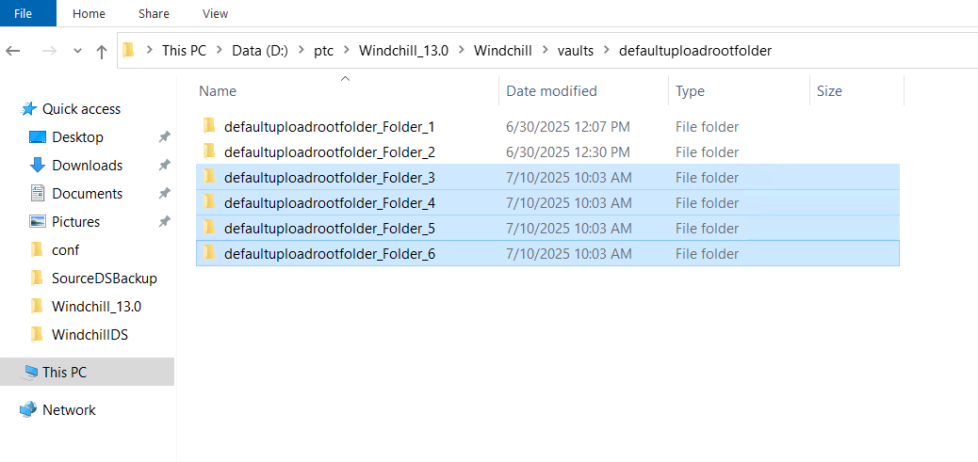

15. Stop Windchill, clean cache and start Windchill.

16. Now the status is showing as valid as shown below.

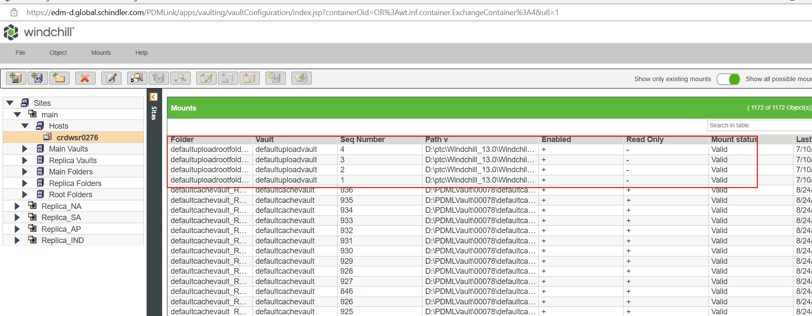

17. Now validated the mounts and it completed successfully as shown below. Click on Ok.

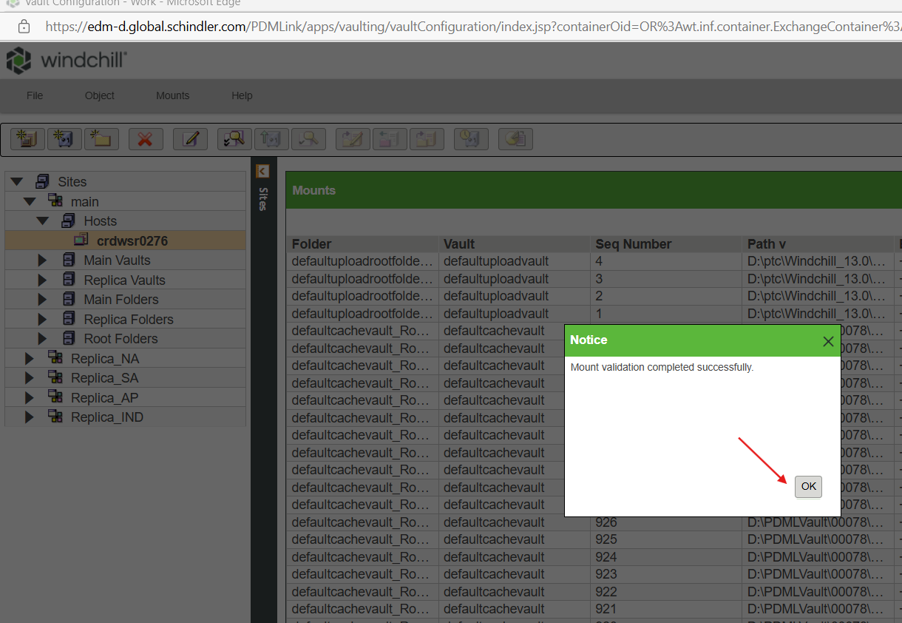

# Clean Unreferenced Vault Files

1. Log into Windchill as Administrator.
2. Navigate to Site → Utilities → File Server Administration.



3. Click on Vault Configuration.



4. Expand Sites → main → Main Vaults → select the entry under Main Vaults → click on Object → click on Remove unreferenced files.

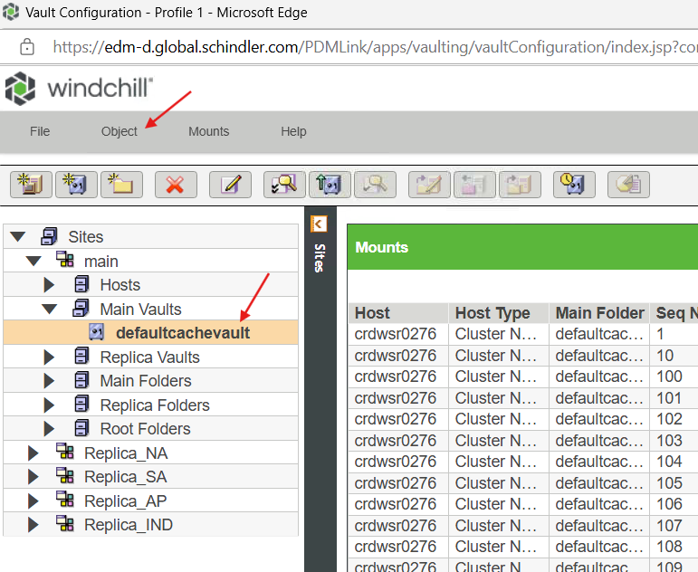

5. Select Move Files Instead of Deleting and click on Ok.

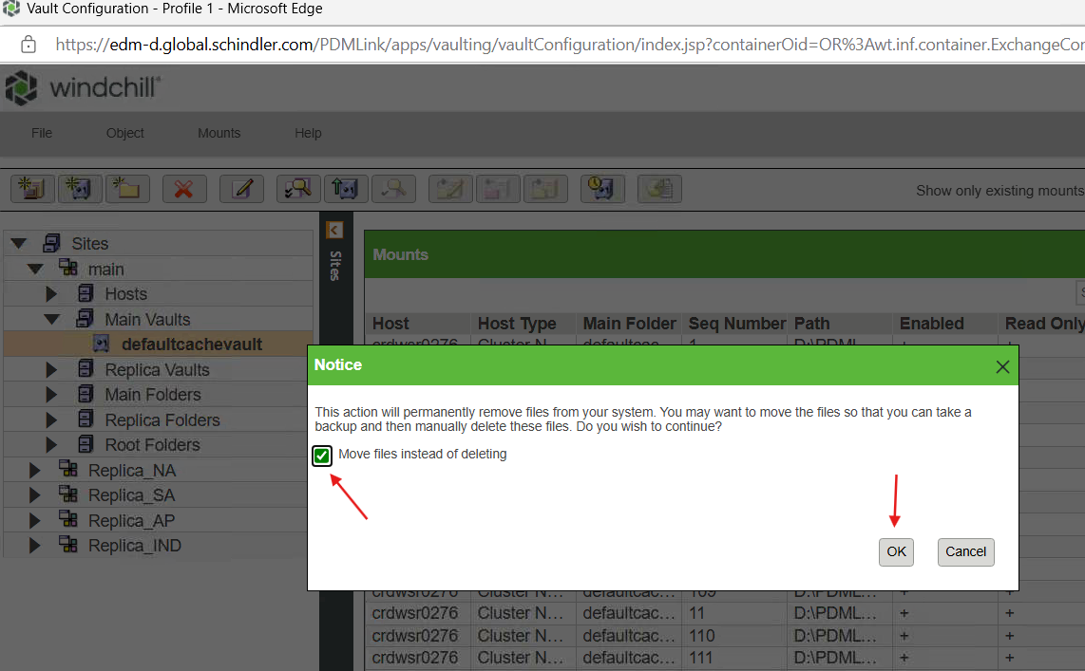

6. Job will be initiated to run in the background.

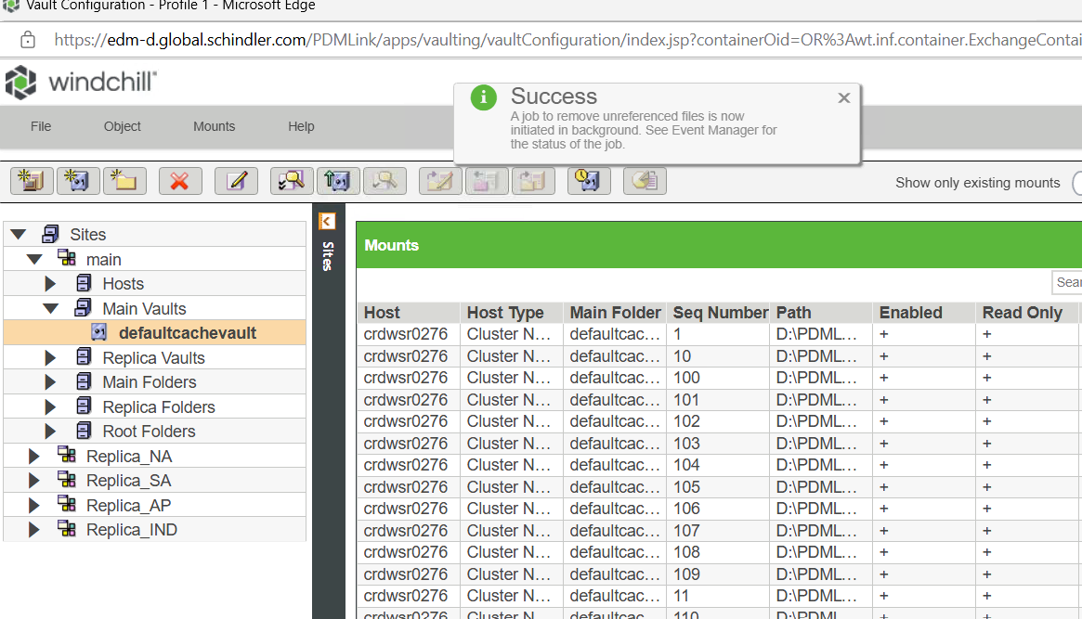

7. Navigate to Windchill Home Page → Quick Links → and click on Event Management as shown below.

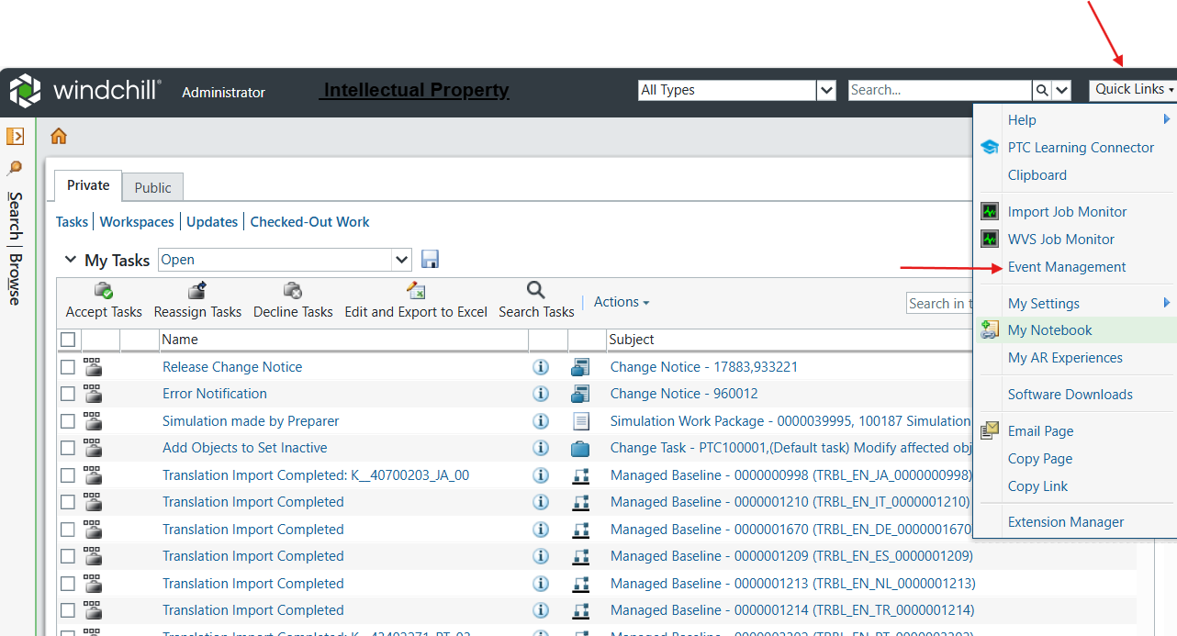

8. Check the status and click on Close.

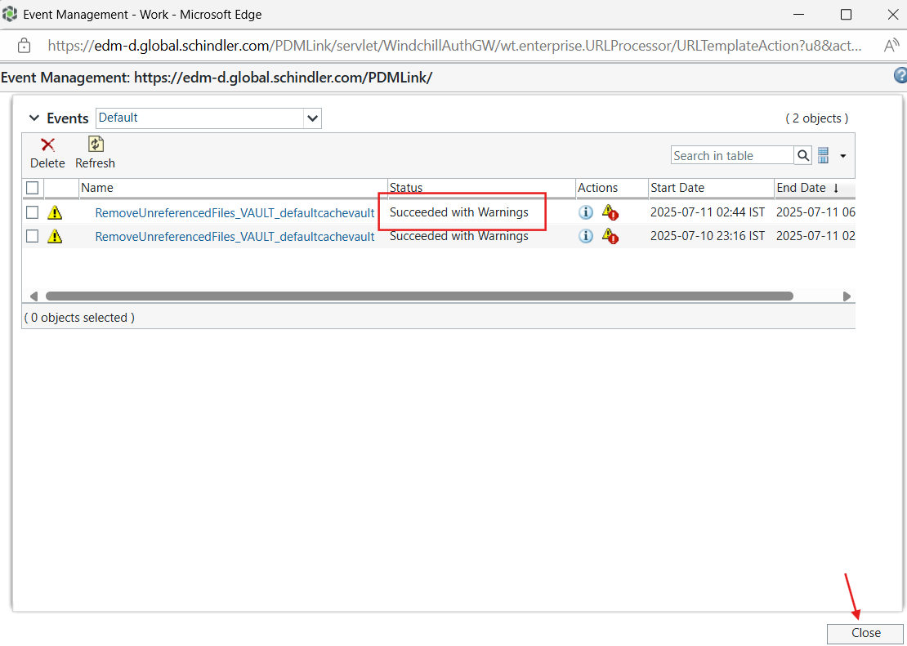

# Index Search Installation and Configuration

1. Please follow the below documentation to complete index search installation and configuration.

URL: [Index Search Installation & Configuration on Windchill 13.0 - Schindler CRD Applications - CRD Confluence](https://confluence.schindler.com/spaces/SCA/pages/617972524/Index+Search+Installation+Configuration+on+Windchill+13.0)

# Post Upgrade WinDU

1. Make sure Windchill is up & running.
2. Launch Windchill Shell as an admin and execute the below command to run WinDU.

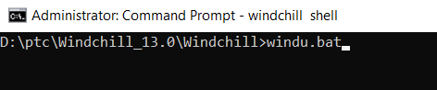

3. Unselect everything and select 'Verification Suite' as shown below and click on Run.

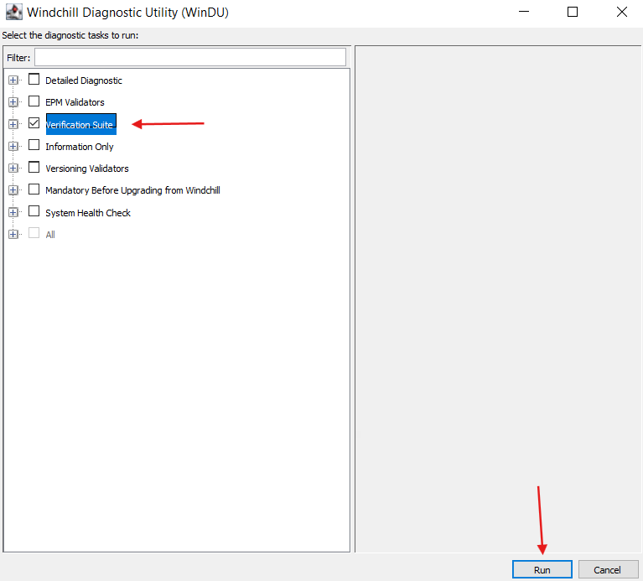

4. Provide Windchill admin credentials and click on Yes.

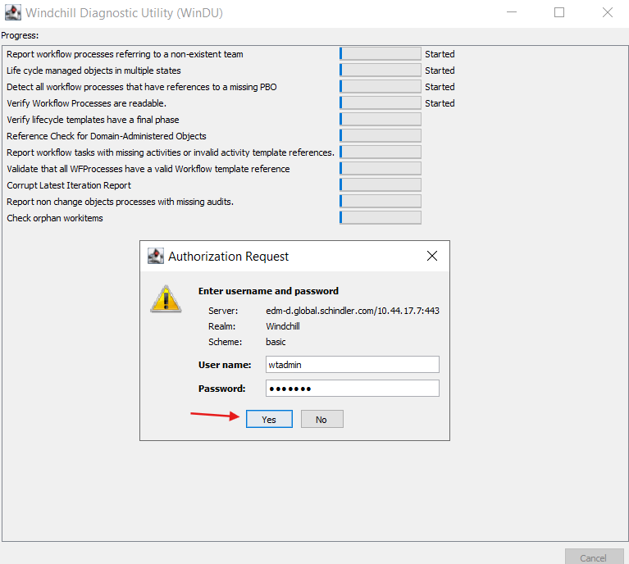

5. WinDU executed successfully and reported 3 potential problems.

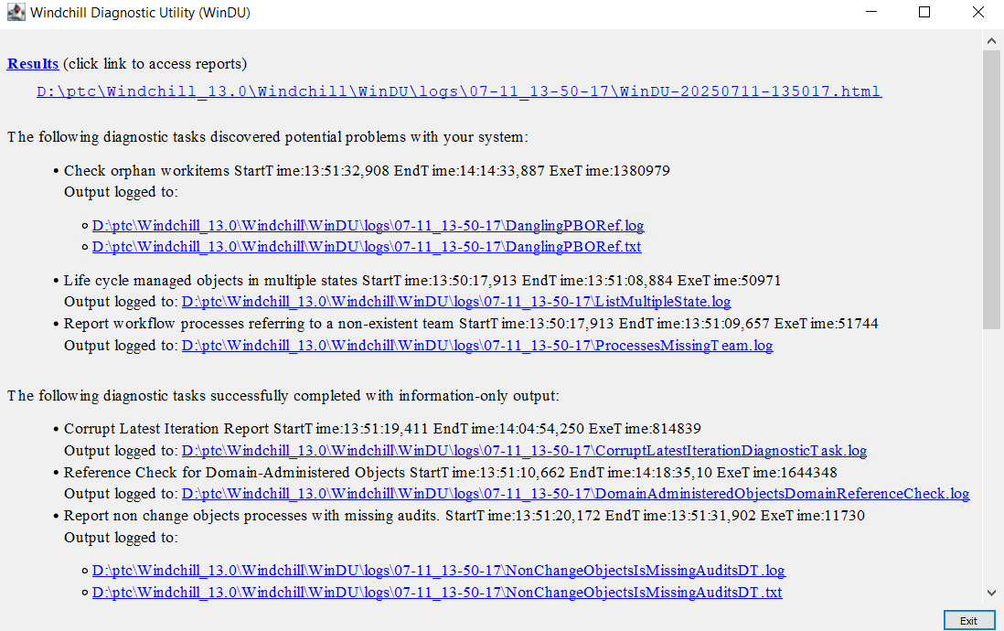

## WinDU Potential Problem-1: Processes Missing Team



1. Open ProcessesMissingTeam.log



2. All the reported items are at CLOSED_TERMINATED or CLOSED_COMPLETED_EXECUTED except the below highlighted 3 entries.

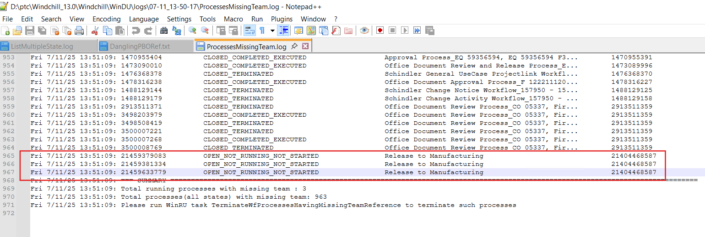

3. As per the [Article - CS40260 - WinDU task Report workflow processes referring to a non-existent team reports findings for Windchill](https://www.ptc.com/en/support/article/CS40260?source=search) we can ignore the entries which are at CLOSED_TERMINATED or CLOSED_COMPLETED_EXECUTED.

4. Followed the 'Manual Healing Process' section to resolve the issue.

5. Go to **Search > Advanced Search.**

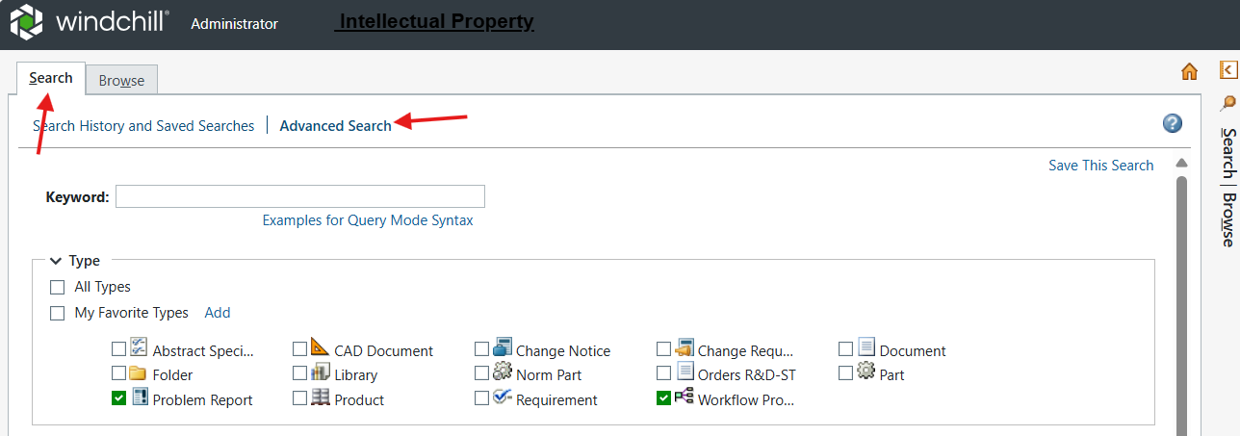

6. Under **Type**, click **Add.**

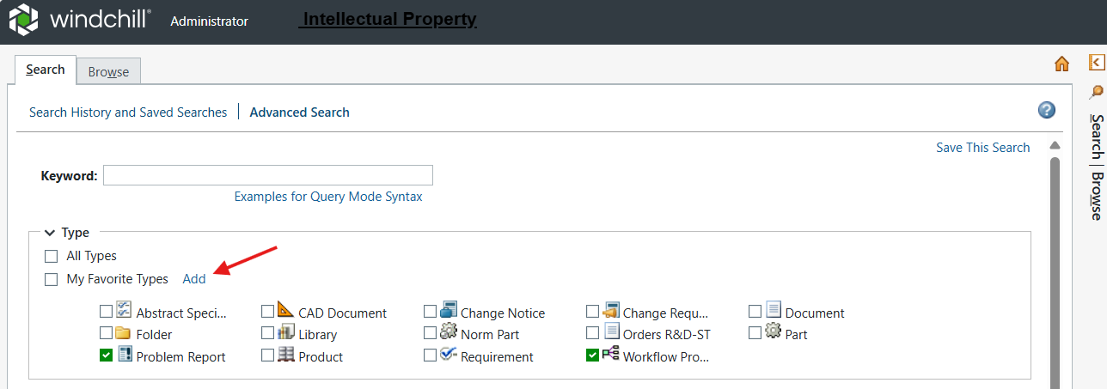

7. Select radio button for**Workflow Process** and click on Ok.

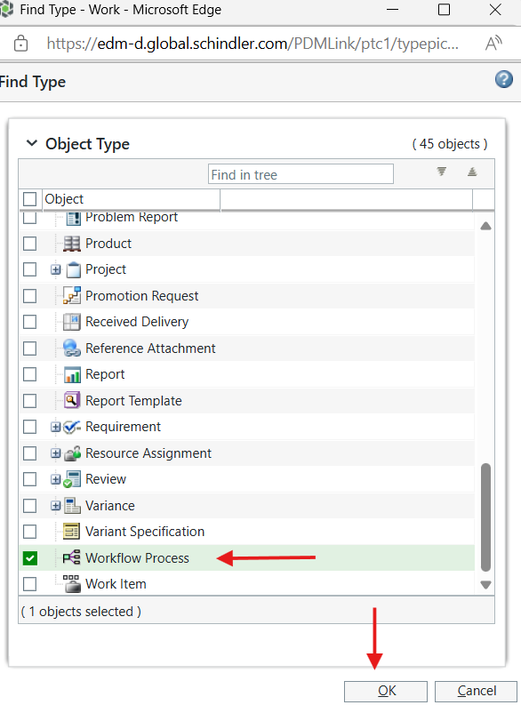

8. Make sure to unselect remaining types.

9. In the Criteria section provide the name as **Release to Manufacturing** as shown below and click on Search.

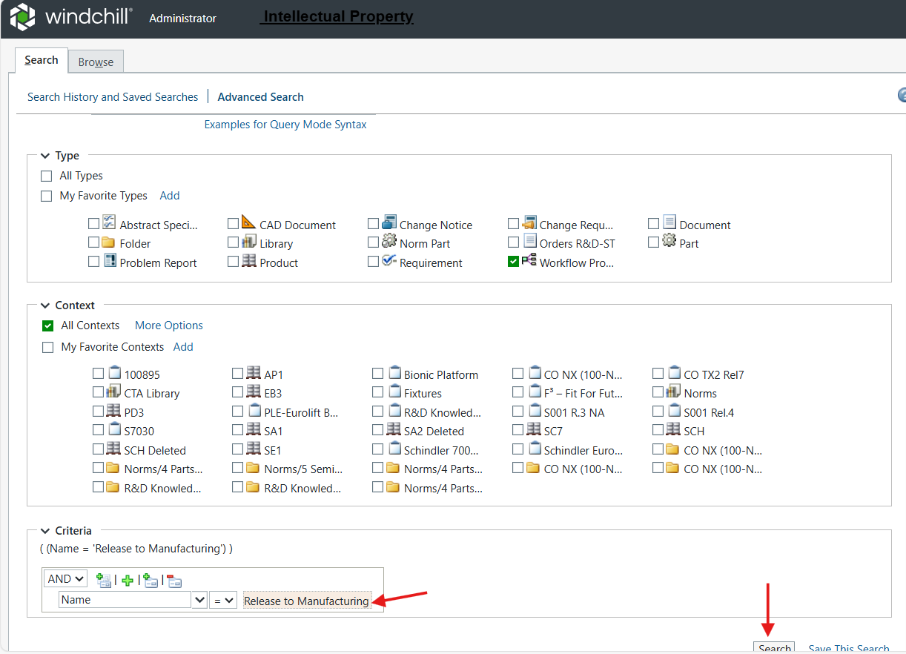

10. Verified all the 11 entries and observed that below highlighted entries are having the same idA2A2 as per the log file entries.

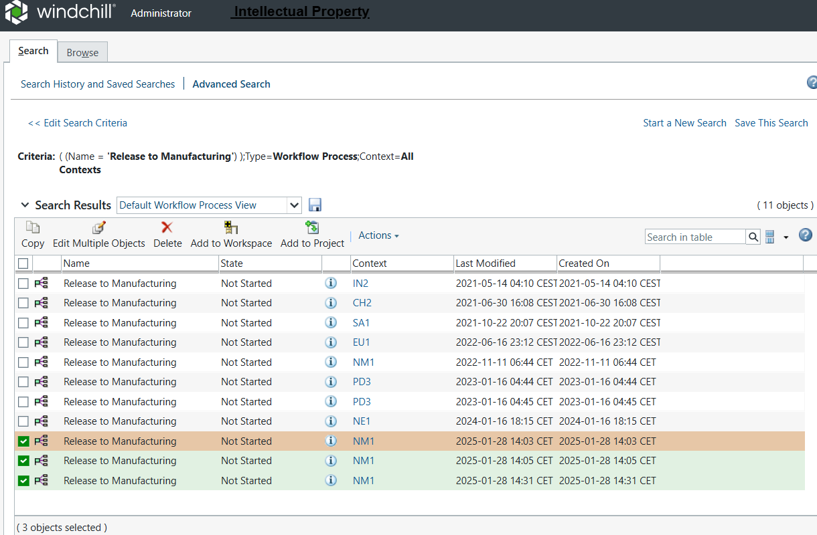

11.Below are the URL's for the above three entries.

<https://edm-d.global.schindler.com/PDMLink/app/#ptc1/tcomp/infoPage?ContainerOid=OR%3Awt.pdmlink.PDMLinkProduct%3A7065998999&oid=OR%3Awt.workflow.engine.WfProcess%3A21459379083&u8=1>

<https://edm-d.global.schindler.com/PDMLink/app/#ptc1/tcomp/infoPage?ContainerOid=OR%3Awt.pdmlink.PDMLinkProduct%3A7065998999&oid=OR%3Awt.workflow.engine.WfProcess%3A21459381334&u8=1>

<https://edm-d.global.schindler.com/PDMLink/app/#ptc1/tcomp/infoPage?ContainerOid=OR%3Awt.pdmlink.PDMLinkProduct%3A7065998999&oid=OR%3Awt.workflow.engine.WfProcess%3A21459633779&u8=1>

12. Right click and delete the three entries.

## WinDU Potential Problem-2: List Multiple State



1. Open ListMultipleState.log file.
2. Observed the below information.

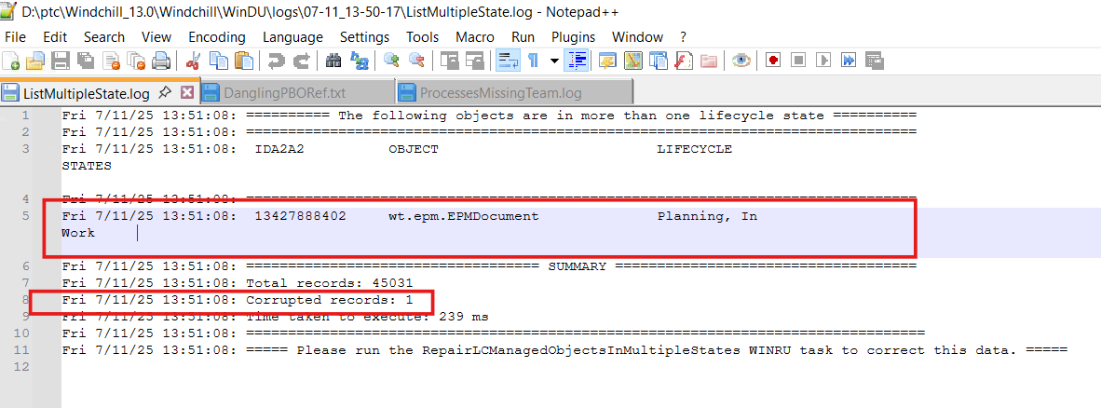

3. Based on the above idA2A2 prepared the below query to get the EPM Document Number.

Query: select epmmaster.documentNumber AS Document_Number from EPMDocument epm JOIN EPMDocumentMaster epmmaster ON epm.idA3masterReference=epmmaster.idA2A2 where epm.idA2A2=13427888402;

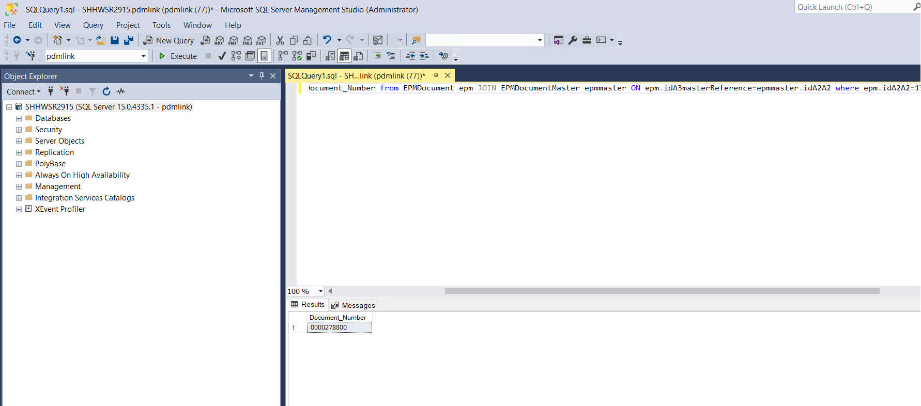

4. We verified 0000278800 via Windchill UI and suspected that this could be a test data as it was created in Test folder.

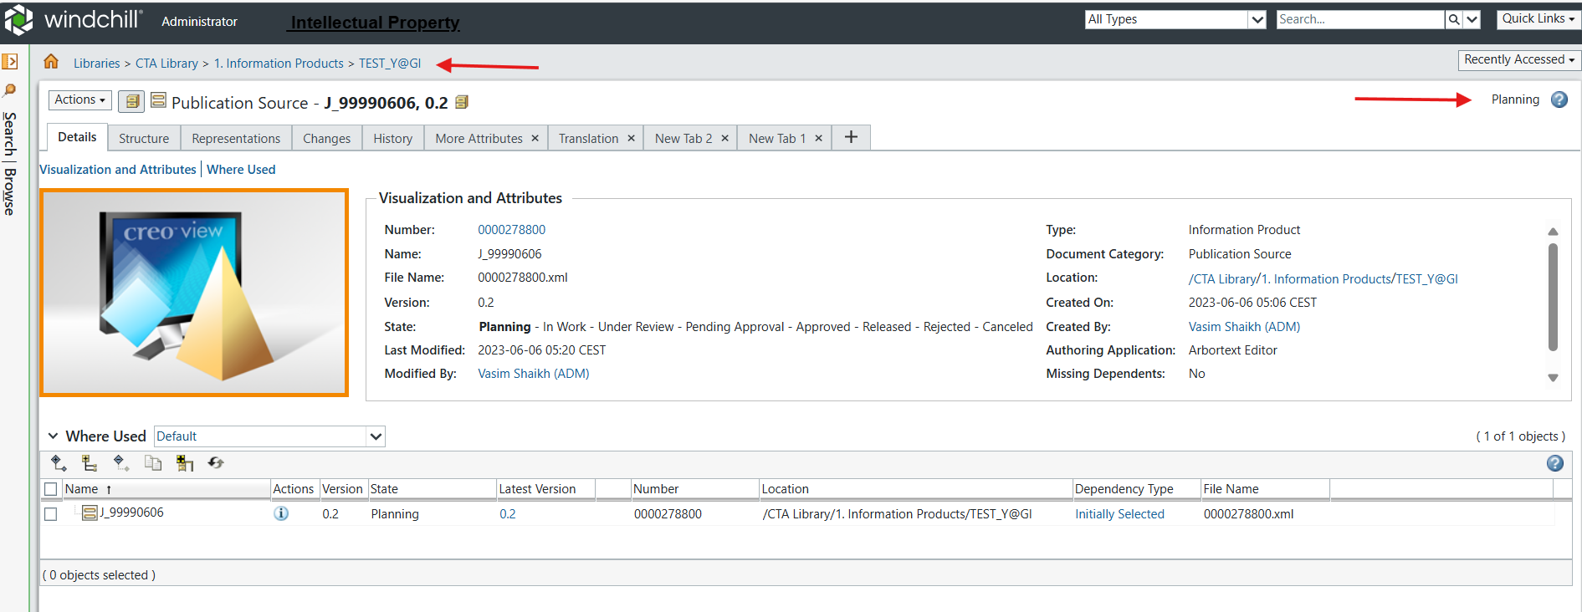

5. Schindler team (Girish and vasim) verified and provided the confirmation to delete this object as it is a test data. Also, Schindler team is going to delete the same data on QA and Prod.

6. Click on Action → Delete to delete the object.

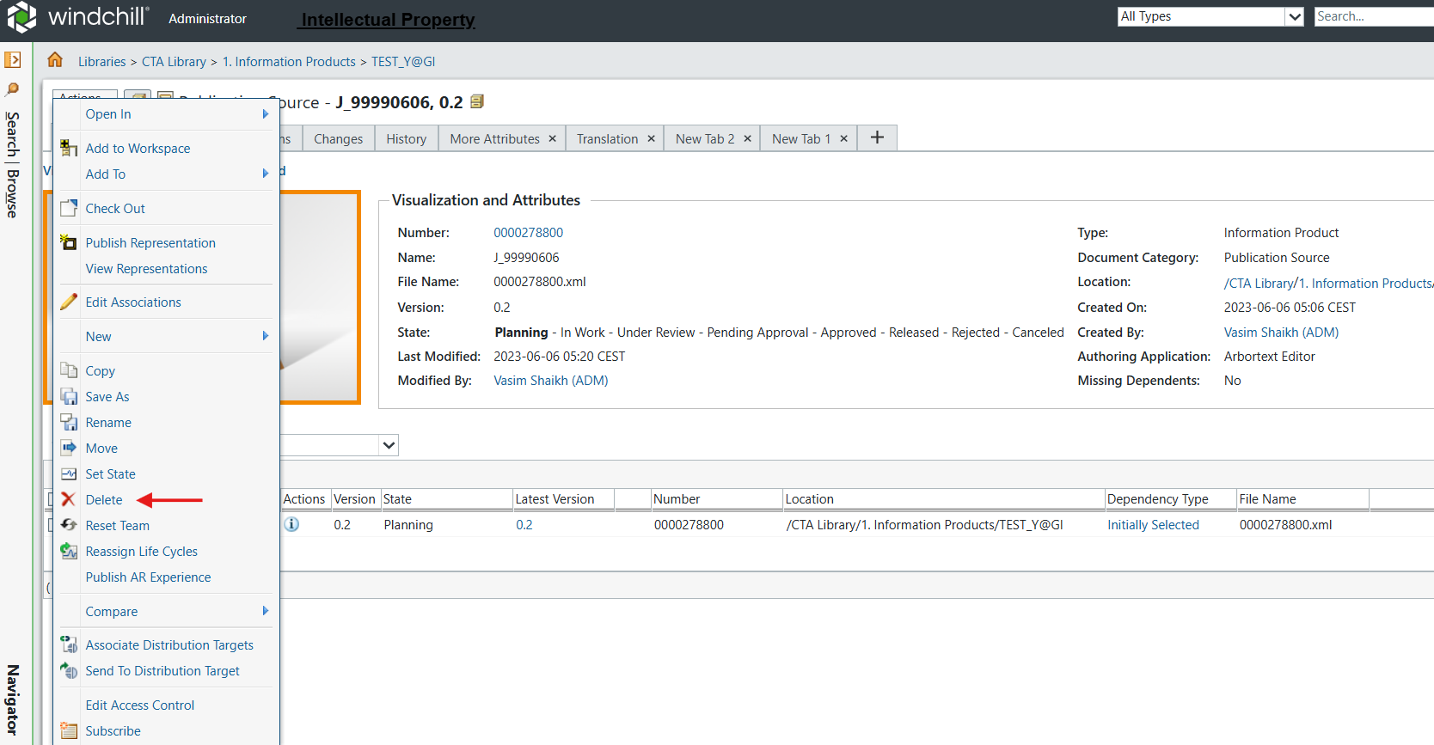

## WinDU Potential Problem-3: DanglingPBORef



1. Open DanglingPBORef.txt
2. Observed that all the entries are at Completed state except 3 entries.

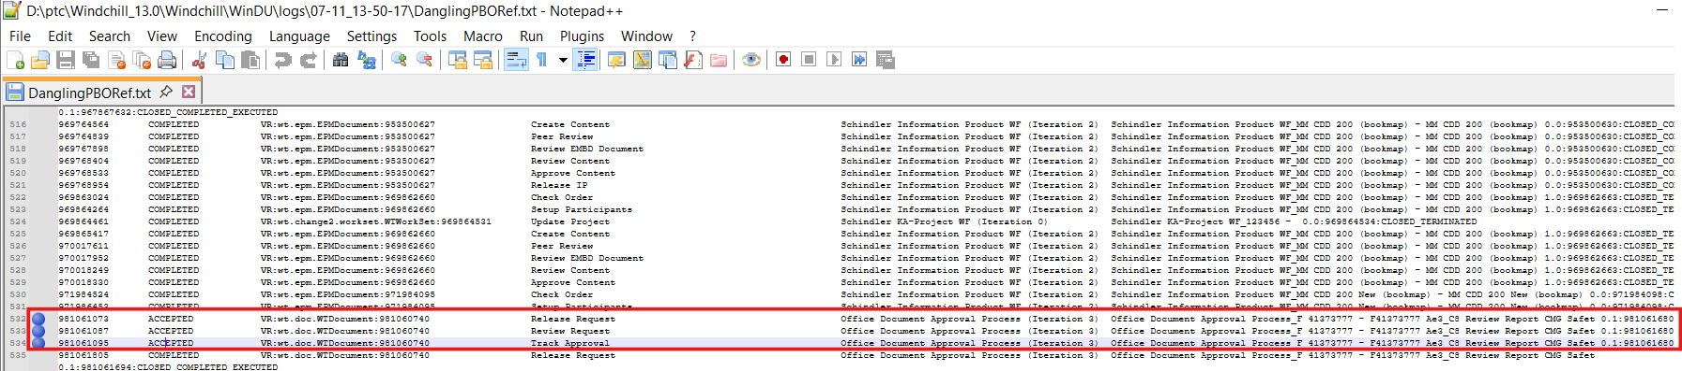

3. Reference: [Article - CS35741 - WinDU task Check Orphan Workitems reports corrupted tasks as misleading information on Windchill PDMLink](https://www.ptc.com/en/support/article/CS35741?source=search) .

4. As per the above article Work items that belong to workflow process which are not running anymore have no issue to deal with.

5. Performed the below steps to make sure the processes for the above entries are executed.

* Search → Advanced Search.
* Select the Type as 'Workflow Process'
* Under Criteria → Name provided the value as: Office Document Approval Process_F 41373777 - F41373777 Ae3_C8*
* Hit Search.

6. The reported entries are not running so as per the article we can ignore them.

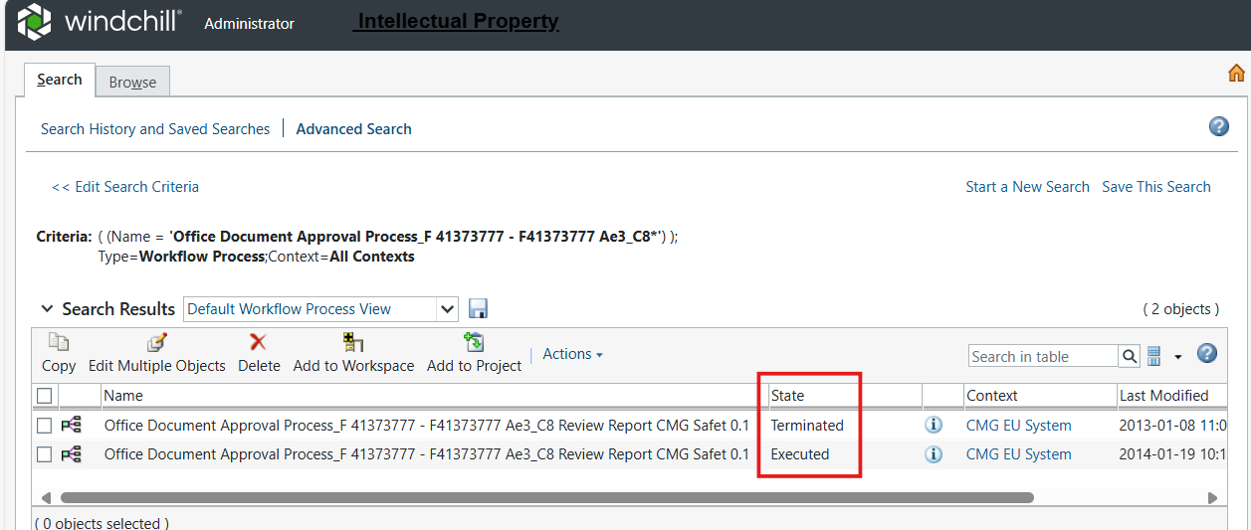

**Note:** Re-run WinDU to see if the issues got resolved.

# Windchill Configuration Assistant

1. Stop Windchill, DS and Apache.
2. Launch Windchill Shell as an admin.
3. Make load point as <WT_Home>\utilities\wca and execute the below command to start WCA.

ant -f WindchillConfigAssistant.xml configureWindchill -Dpropagate=true



4. Please compare windchillconfigurator.xconf and performance.xconf while providing the inputs to WCA.

5. Press ENTER to accept default value.

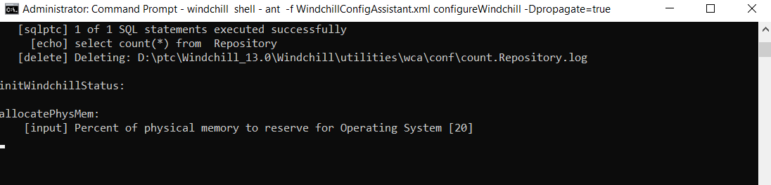

6. Press ENTER to accept default value.

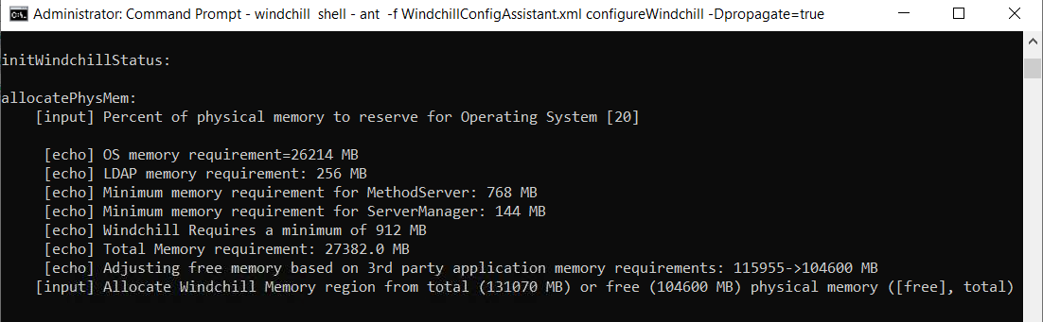

7. Press ENTER to accept default value.

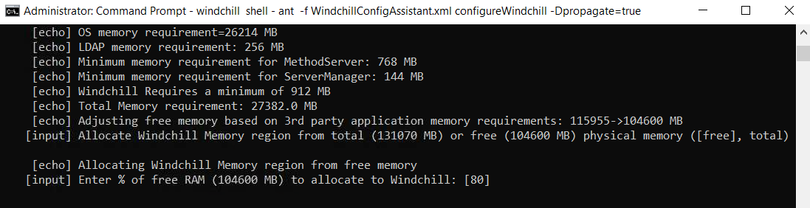

8. Press ENTER to accept default value.

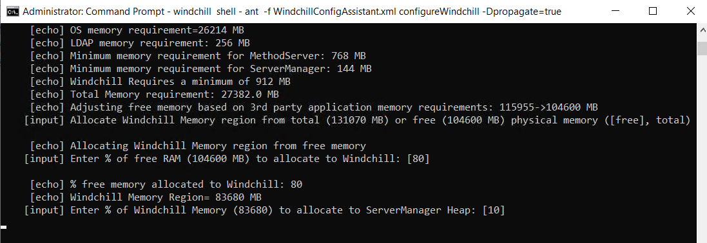

9. Press ENTER to accept default value.

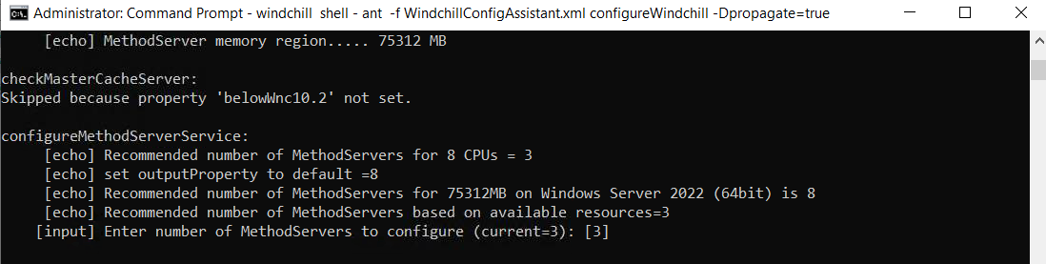

10. Press ENTER to accept default value.

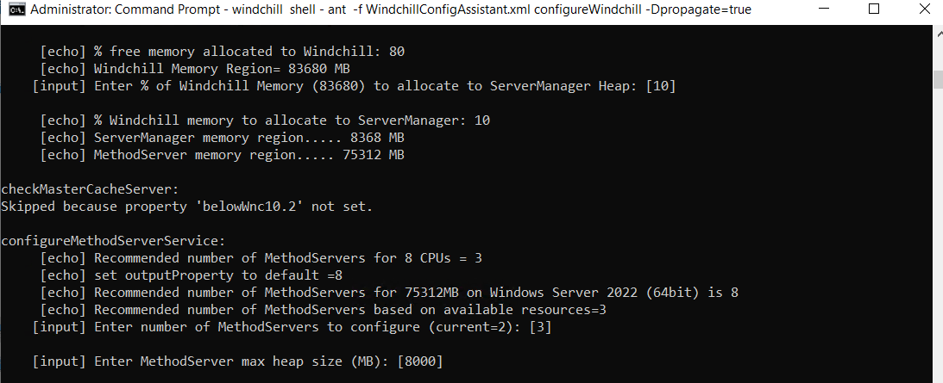

11. Press ENTER to accept default value.

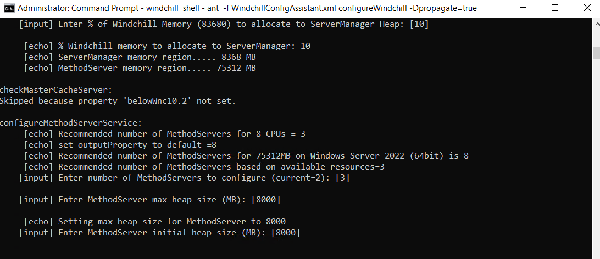

12. Press ENTER to accept default value.

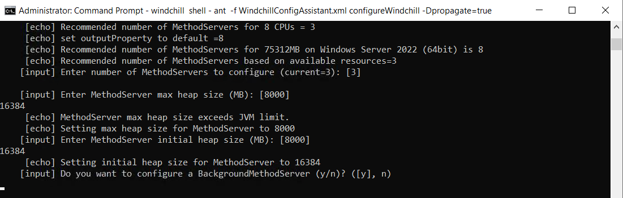

13. Press ENTER to accept default value.

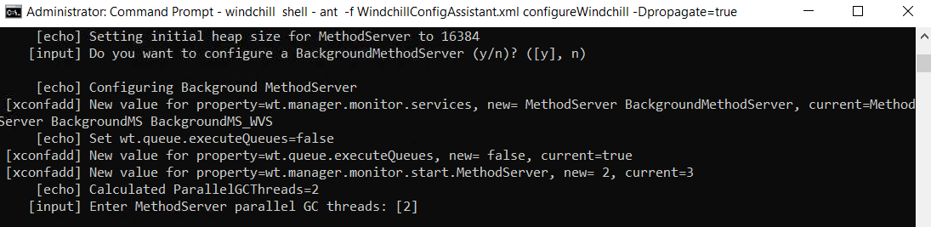

14. Press ENTER to accept default value.

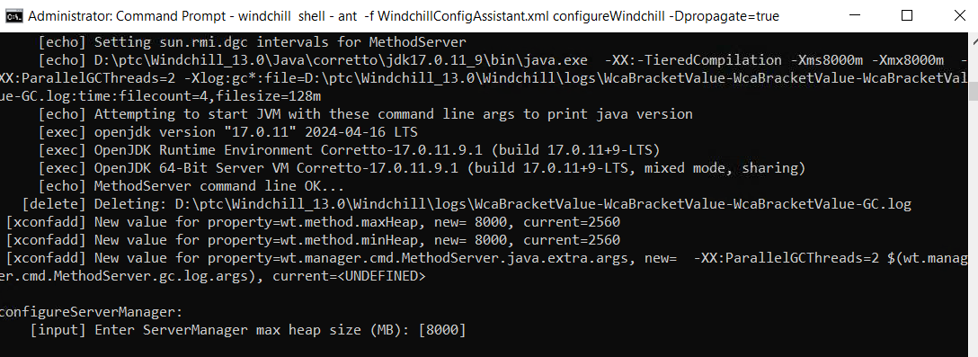

15. Press ENTER to accept default value.

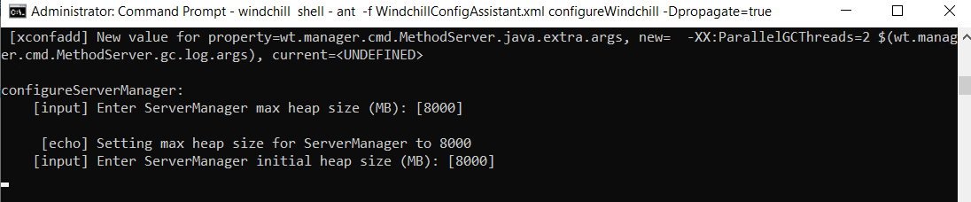

16. Press ENTER to accept default value.

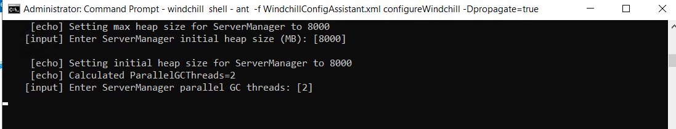

17. Press ENTER to accept default value.

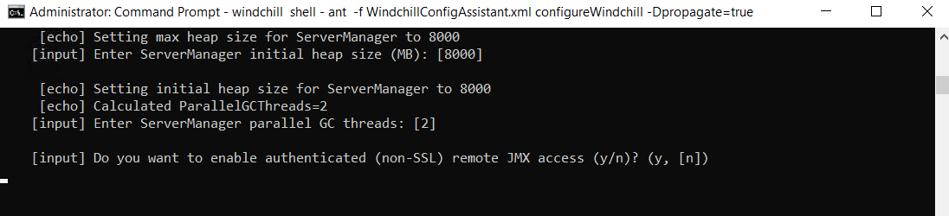

18. Press ENTER to accept default value.

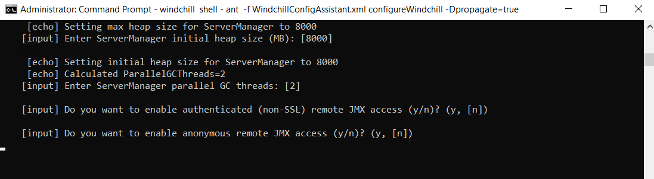

19. Press ENTER to accept default value.

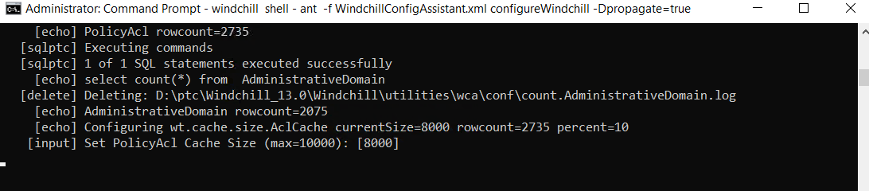

20. Press ENTER to accept default value.

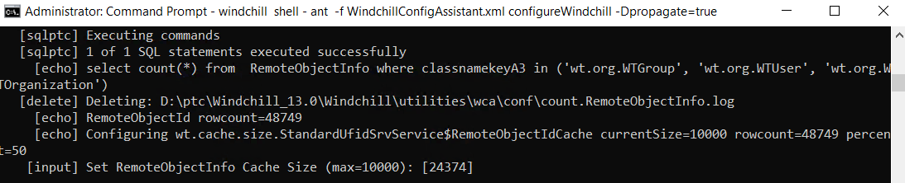

21. Press ENTER to accept default value.

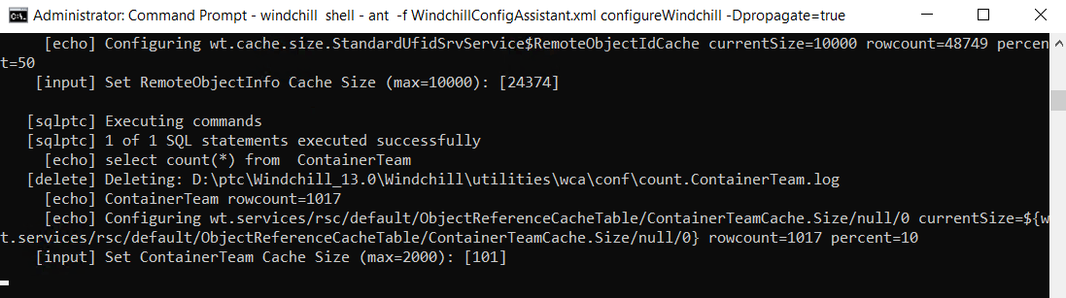

22. Press ENTER to accept default value.

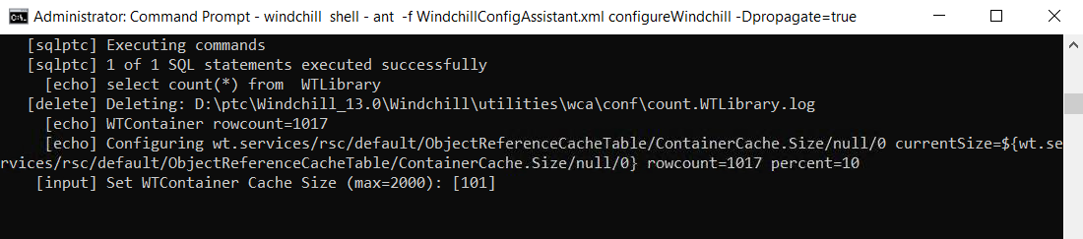

23. Press ENTER to accept default value.

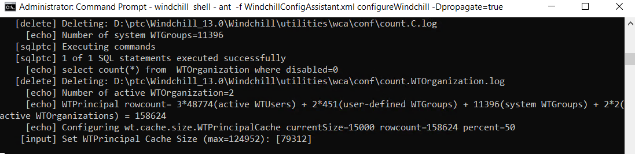

24. Provide the value as 300 and hit ENTER.

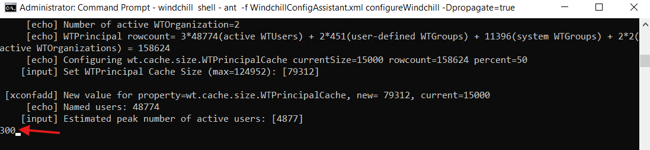

25. Press ENTER to accept default value.

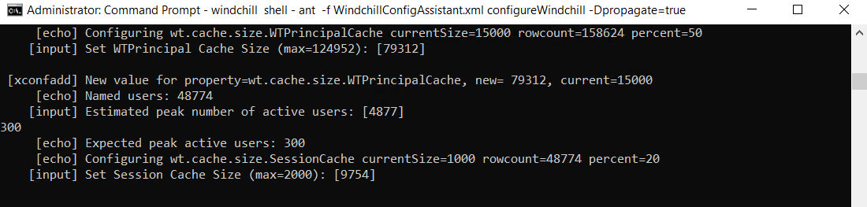

26. Press ENTER to accept default value.

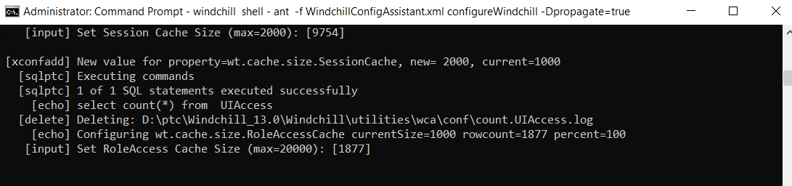

27. Press ENTER to accept default value.

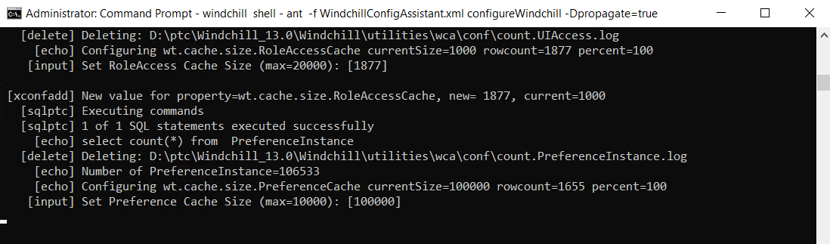

28. Press ENTER to accept default value.

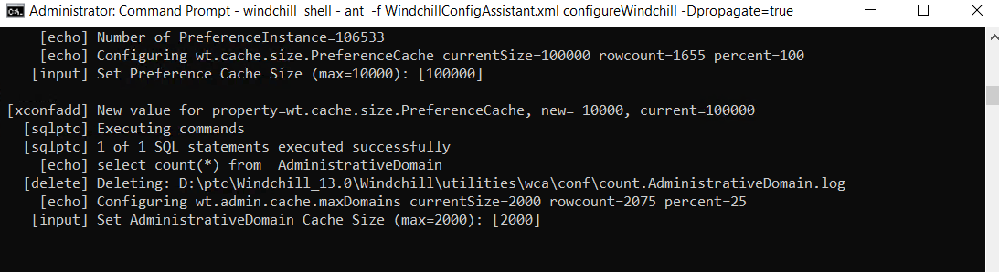

29. Press ENTER to accept default value.

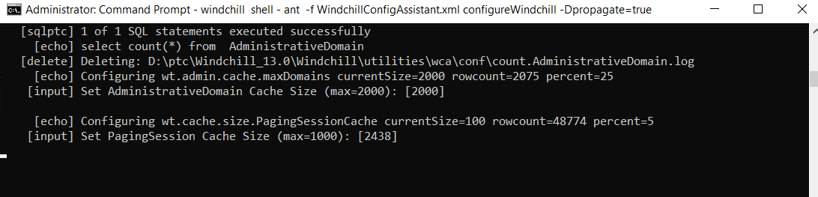

30. Press ENTER to accept default value.

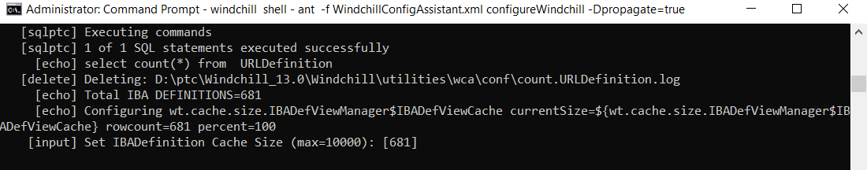

31. Press ENTER to accept default value.

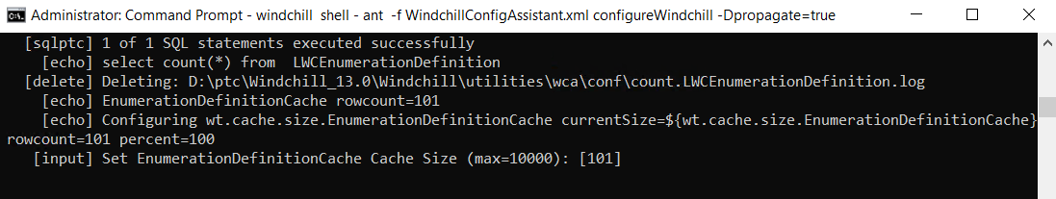

32. Press ENTER to accept default value.

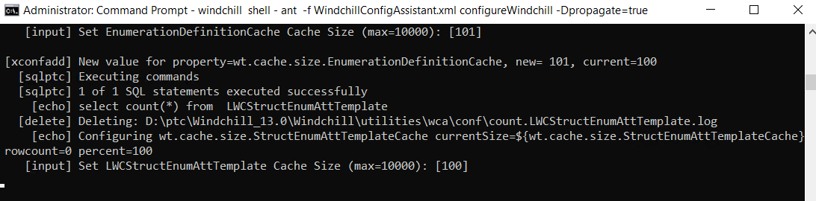

33. Press ENTER to accept default value.

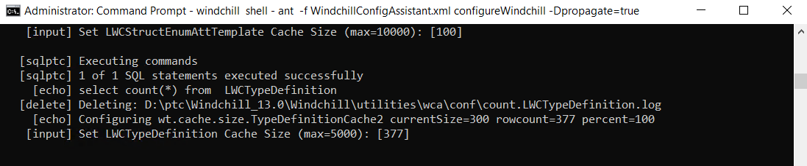

34. Press ENTER to accept default value.

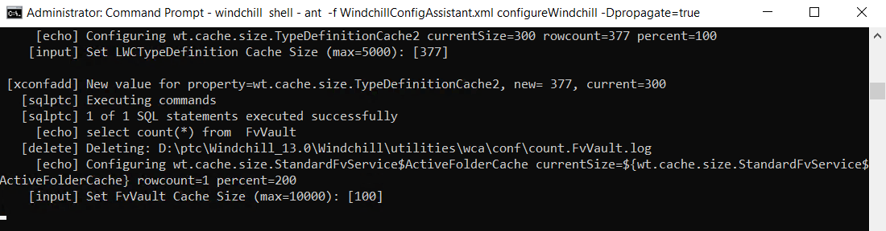

35. Press ENTER to accept default value.

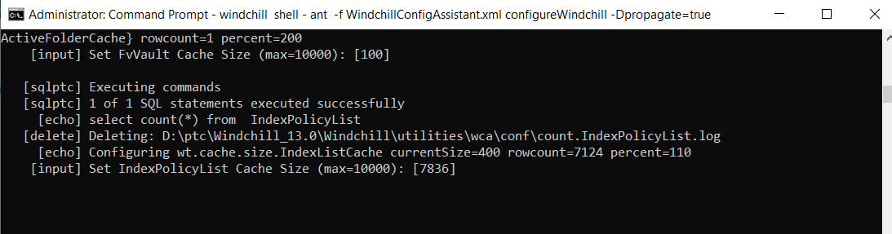

36. Press ENTER to accept default value.

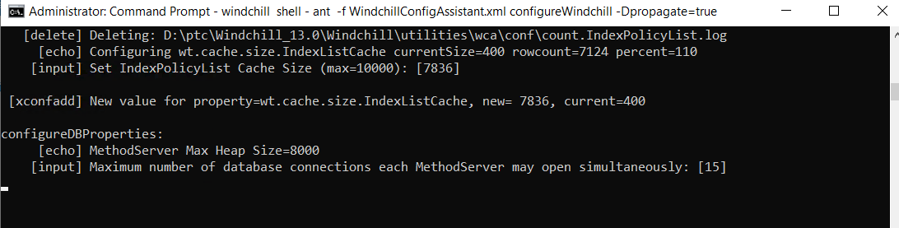

37. Press ENTER to accept default value.

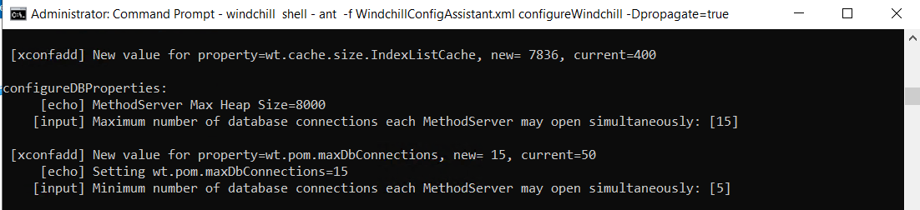

38. Press ENTER to accept default value.

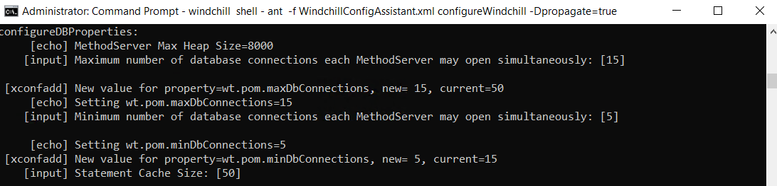

39. Press ENTER to accept default value.

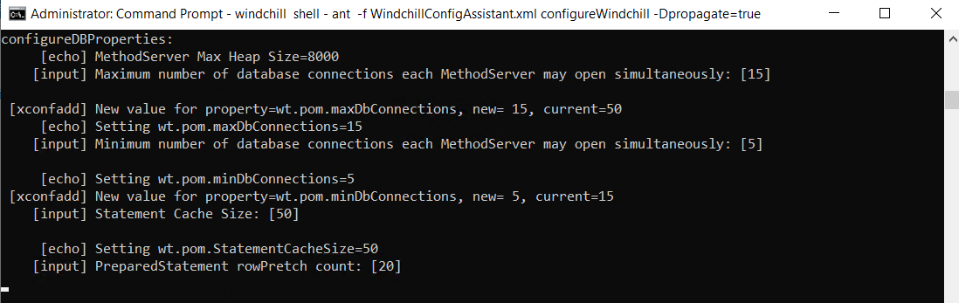

40. Press ENTER to accept default value.

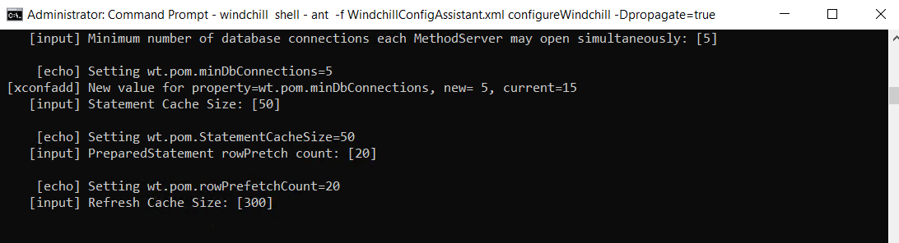

41. Press ENTER to accept default value.

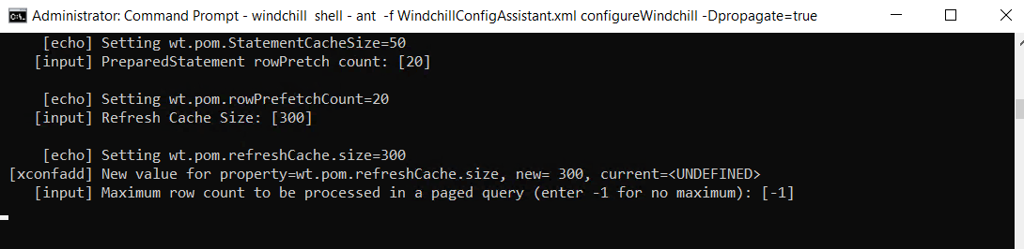

42. Press ENTER to accept default value.

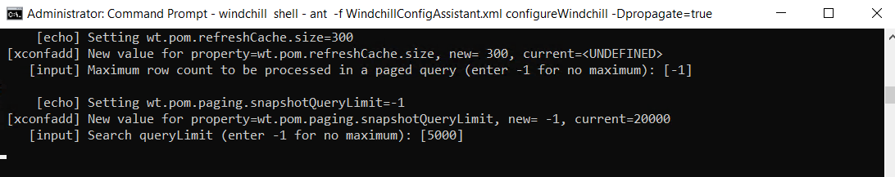

43. Press ENTER to accept default value.

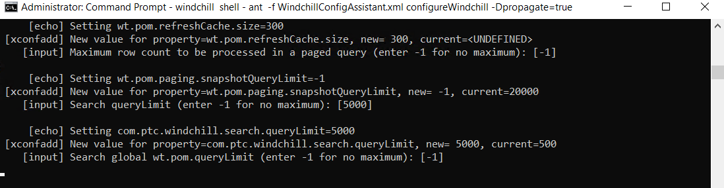

44. Press ENTER to accept default value.

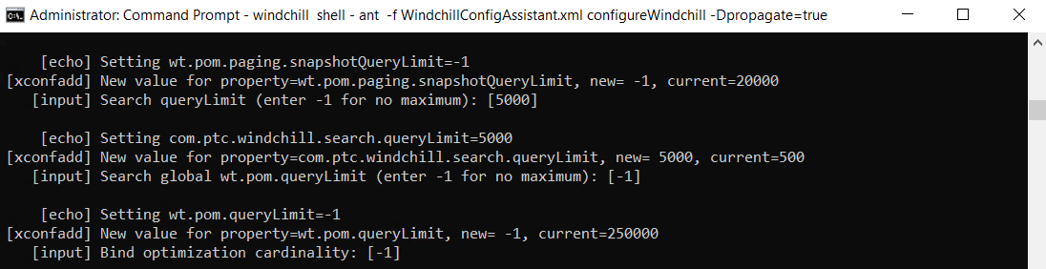

45. Press ENTER to accept default value.

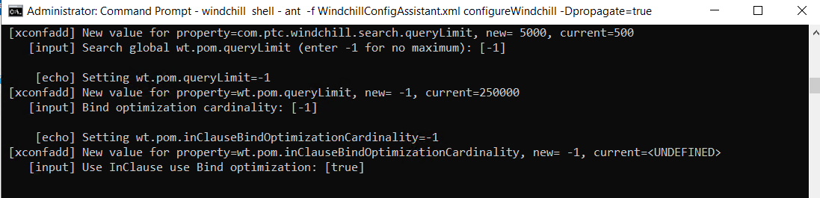

46. Press ENTER to accept default value.

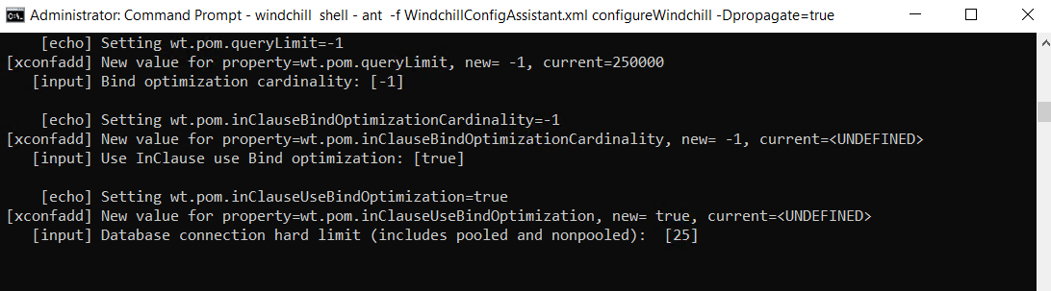

47. Press ENTER to accept default value.

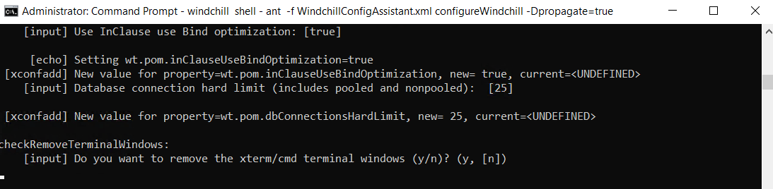

48. Press ENTER to accept default value.

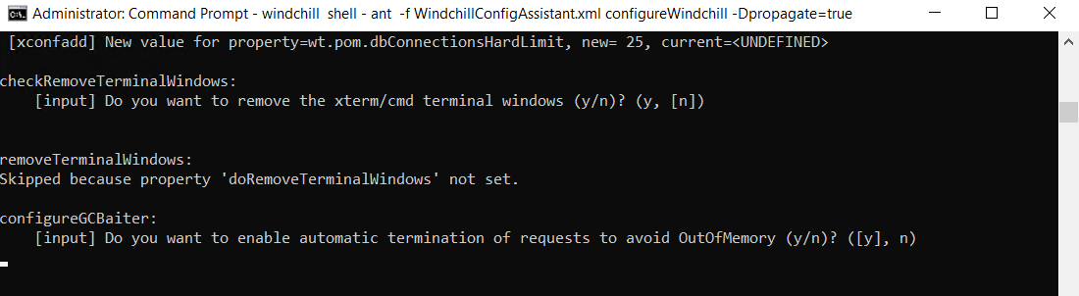

49. Press ENTER to accept default value.

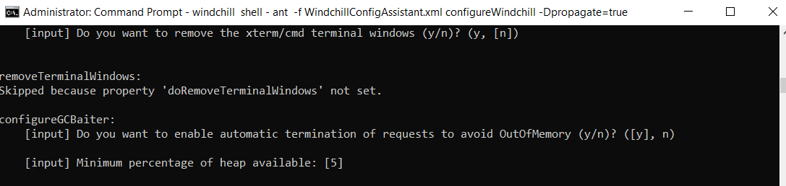

50. Provide the value as shown below and hit enter.

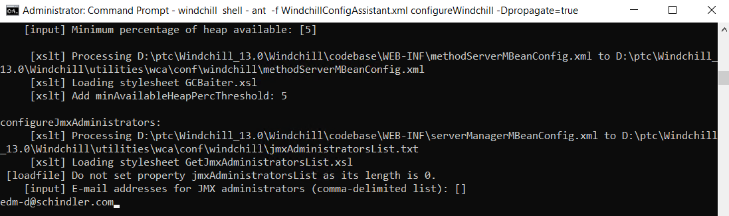

51. Ensure Build is successfull.

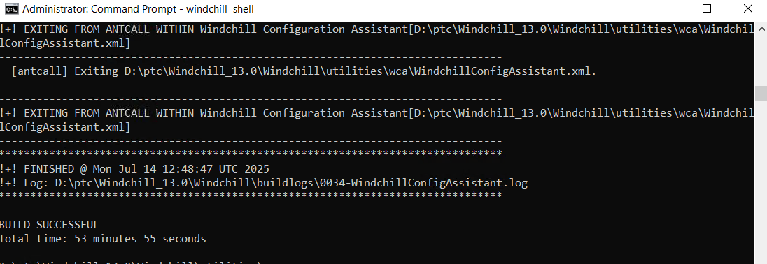

# Windchill, DS and Apache as Windows Services

## Apache:

1. Make sure all the SSL configs are in place. If not, pls update them accordingly before executing the below command.
2. Launch Windchill as an admin and navigate to HTTPServer and execute the below command.

ant -f config.xml installService -DwithSSL=true -DserviceName=PTC_Apache

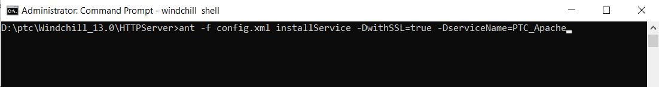

2. Ensure build is successful.

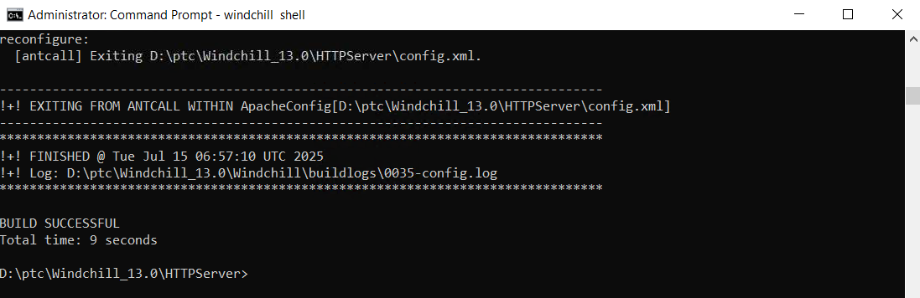

## Windchill:

1. Launch Windchill as an admin and execute the below command.

ant -buildfile D:\ptc\Windchill_13.0\Windchill\opt\ntservice\WindchillService.xml install -DserviceName=PTC_Windchill

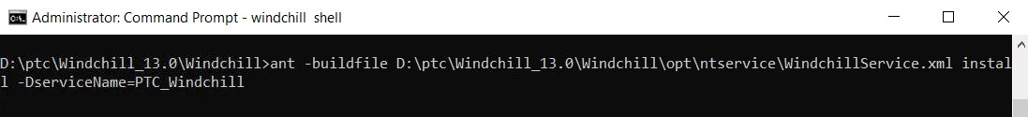

2. Make sure the build is successful.

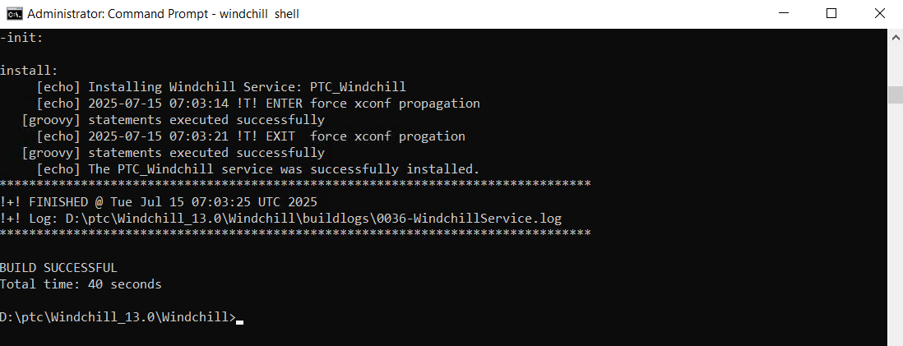

3. Open services → Right click on Windchill service → Click on Properties.

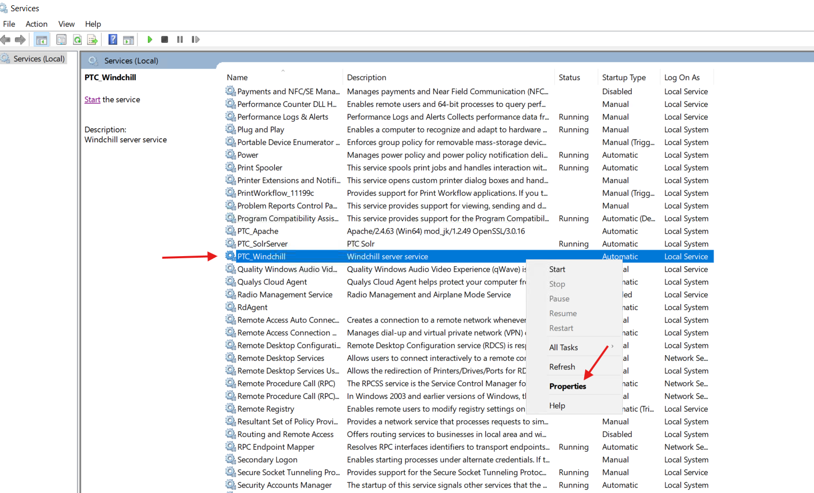

 4. Click on Log On.

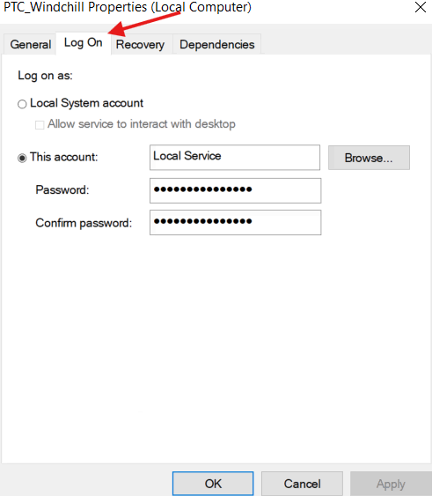

5. Change Log on as: to Local System account as shown below and click on Ok.

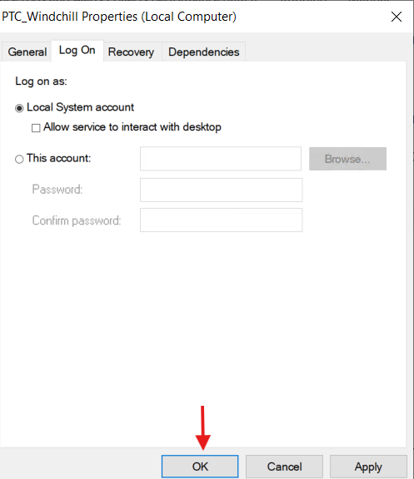

## Windchill DS (Open DJ):

1. Navigate to the below location and launch control-panel.bat as administrator.

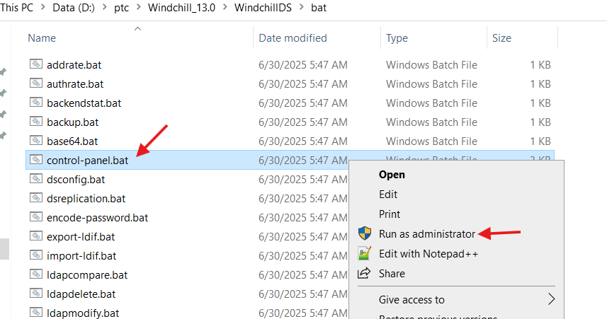

2. Click on Ok.

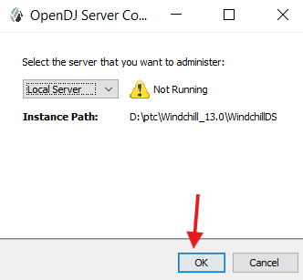

3. Expand Runtime Options and select Windows Service.

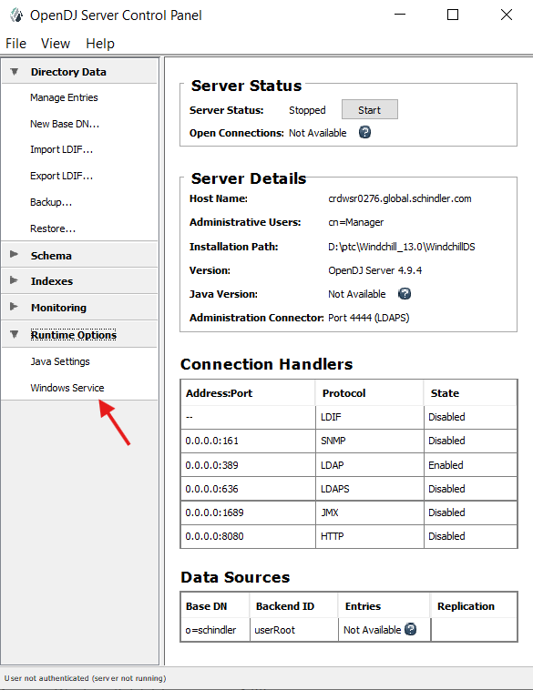

4. Click on Enable.

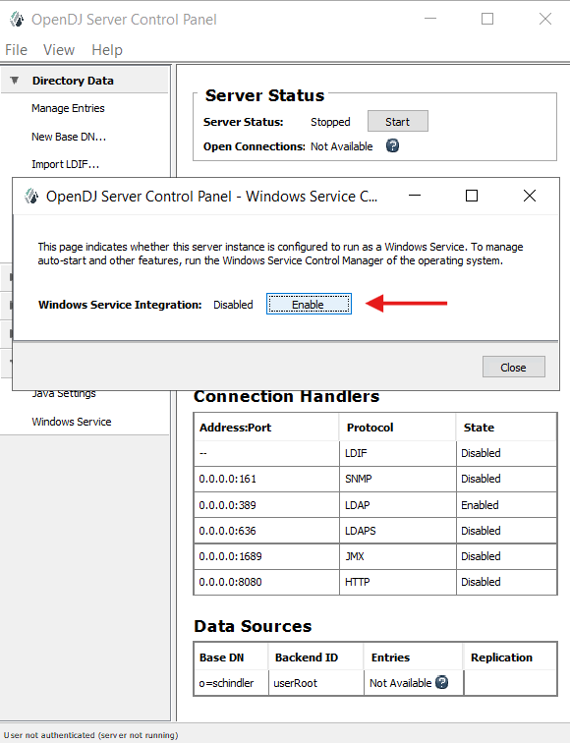

5. Make sure it enabled successfully.

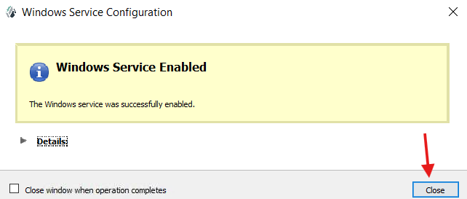

6. Clean cache and start Windchill services.

# Disable unused Workflows/Life Cycles enabled for Source WinDU

1. Log into Windchill as admin.
2. Navigate to Organization → Utilities → Life Cycle Template Administration.

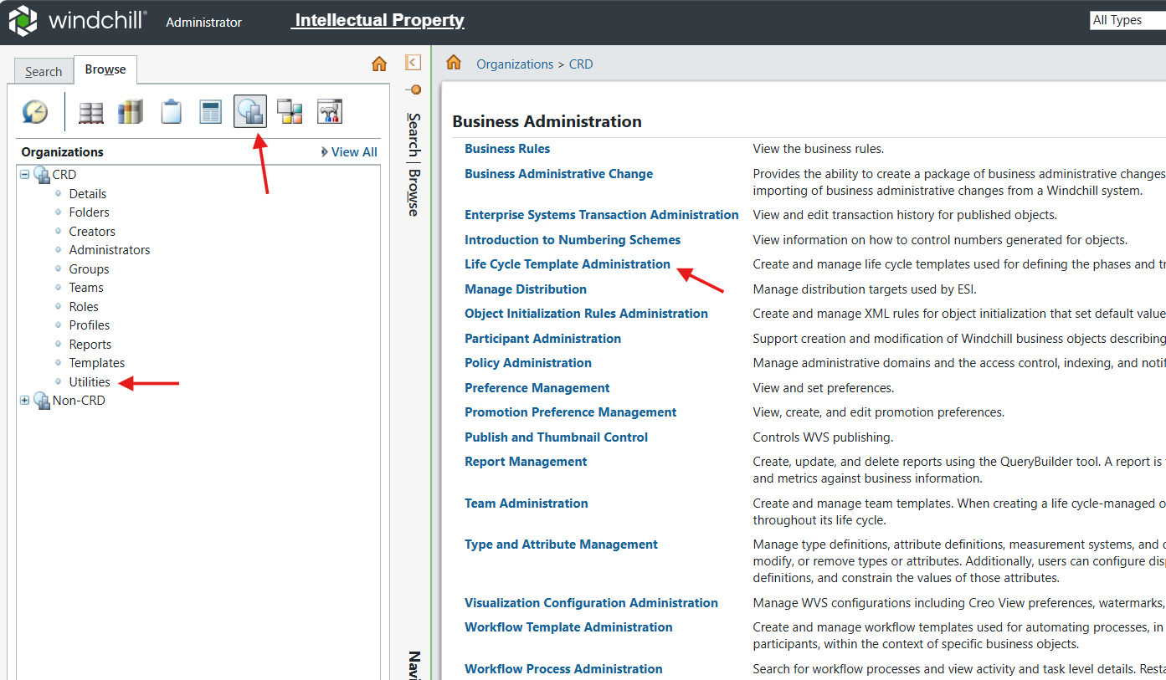

3. Disable the below Life Cycles as shown below.

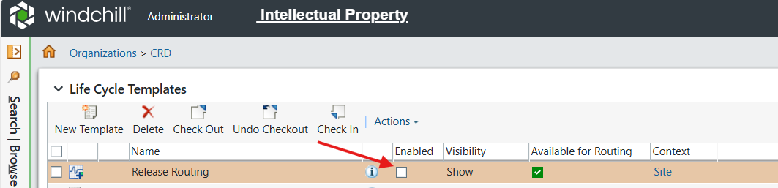

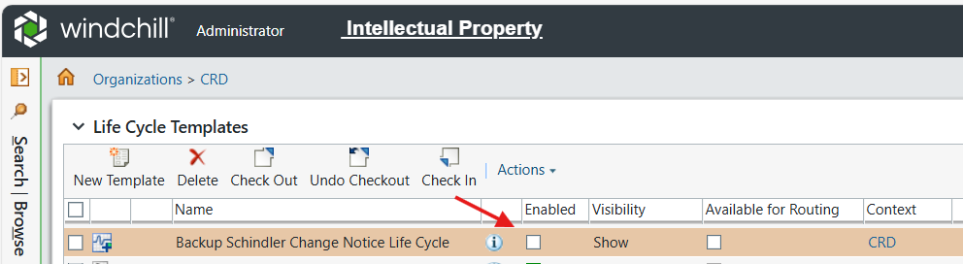

4. Navigate to Organization → Utilities → Workflow Template Administration.

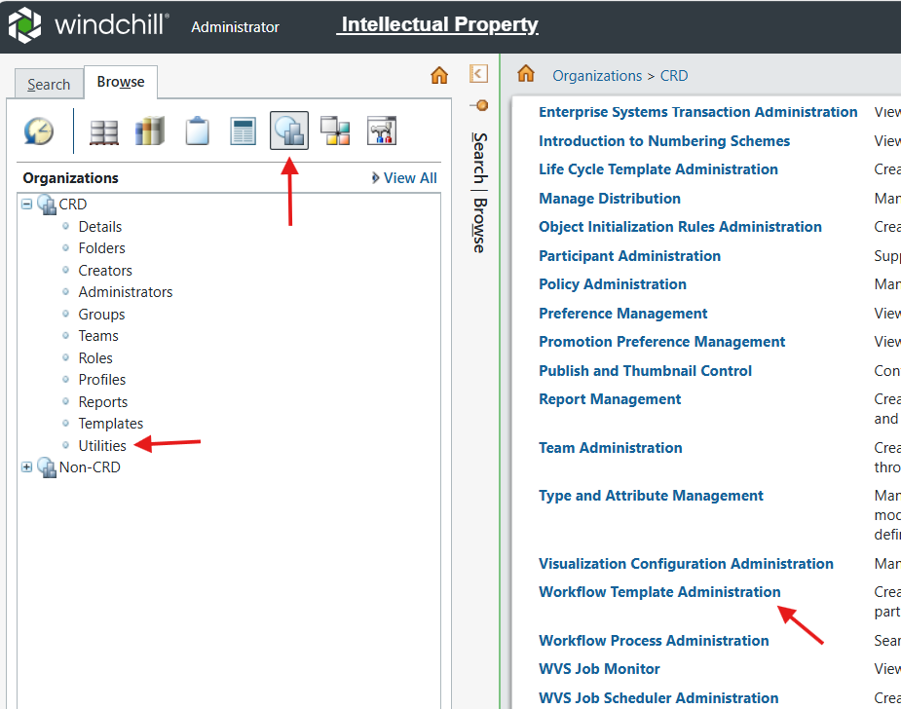

5. Disable the below workflows as shown.

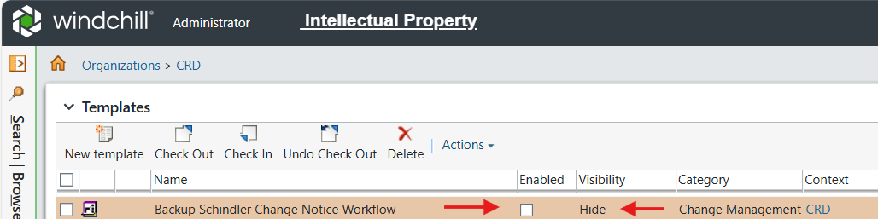

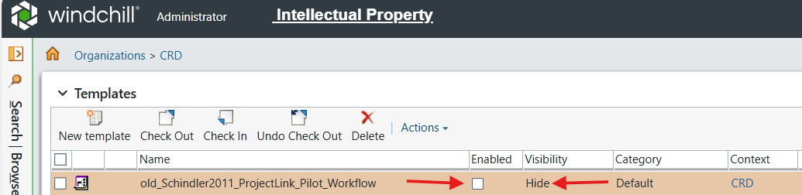

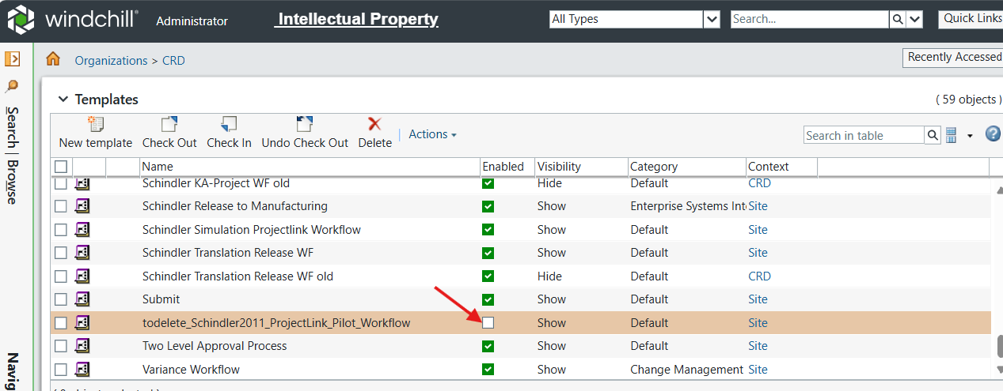

# Perform Check Syntax for Workflows

1. Log into Windchill as admin.
2. Navigate to Organization → Utilities → Workflow Template Administration.
3. Right click on the required workflow and click on View in Workflow Definer.
4. In the header section of the workflow click on Process and then click on 'Validate All'.
5. Once the validation is completed, click on Ok and close the workflow.
6. Repeat the above process for the below list of workflows.
   * Confidential Office Document Approval Process
   * Core Translation Process
   * Import Translation Process
   * Main Translation Process
   * Notify Process
   * Office Document Approval Process
   * Office Document Notify Process
   * Office Document Review and Release Process
   * Office Document Review Process
   * Package Approval Process
   * Package Content Routing Process
   * Package Delivery Process
   * Post-Import Translation Process
   * Quote Translation Process
   * Release to Manufacturing
   * Representation Generation Workflow
   * Schindler Change Activity Workflow
   * Schindler Change Notice Workflow
   * Schindler Change Request Workflow
   * Schindler Core Translation Process
   * Schindler General UseCase Projectlink Workflow
   * Schindler Information Product WF
   * Schindler KA-Project WF
   * Schindler Release to Manufacturing
   * Schindler Simulation Projectlink Workflow
   * Schindler Translation Release WF

# Add Windchill Shell as Shortcut

1. Reference Article: [Article - CS158529 - How to create a shortcut of Windchill Shell in Windchill PDMLink](https://www.ptc.com/en/support/article/CS158529?source=search&as=1)
2. Log into Windchill Application Server as admin.
3. Right click on the Desktop → New → Shortcut as shown below.

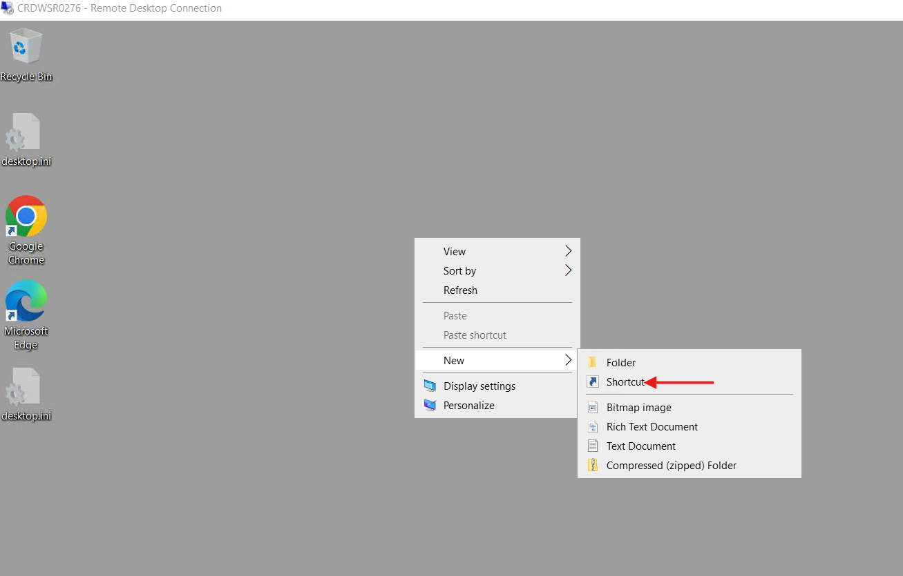

3. In Type location of the Item add below entry.

**Syntax:** **<Windchill_Home>\bin\windchill.exe -w "<Windchill_Home>" --java="<Java_Home>\jre\bin\java.exe" shell**

**Value:** D:\ptc\Windchill_13.0\Windchill\bin\windchill.exe -w "D:\ptc\Windchill_13.0\Windchill" --java="D:\ptc\Windchill_13.0\Java\corretto\jdk17.0.11_9\bin\java.exe" shell

4. Click on Next.

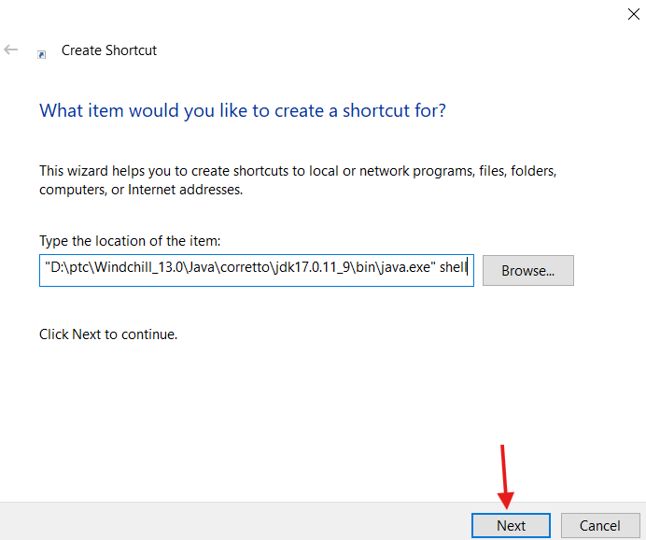

5. Provide the name and click on Finish.

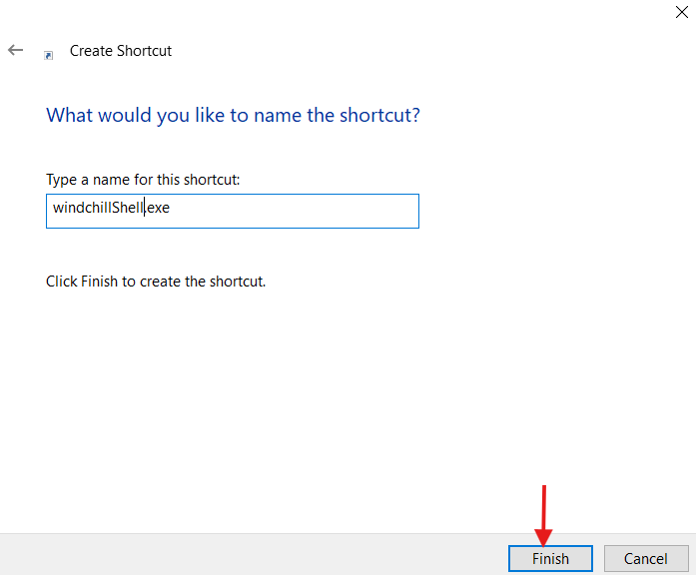

6. Right click on **Shortcut → Properties**,Click **Shortcut**Tab.

7. Provide the Windchill path in **Start in**filed i.e.   **<Windchill_Home>\Windchill\**

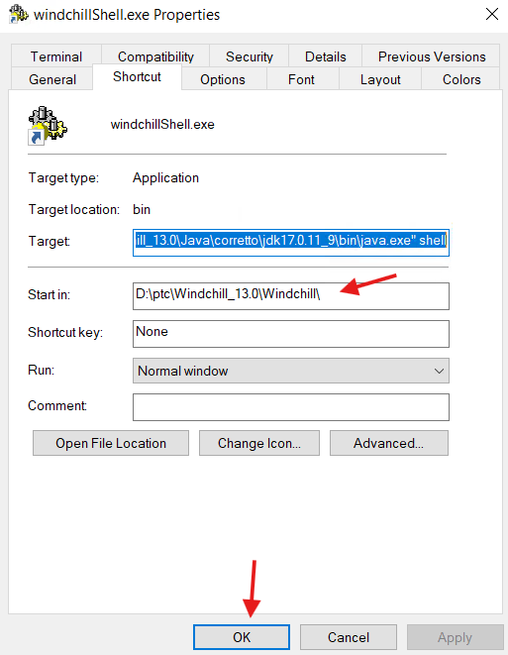

8. Cut and Paste the Shortcut on the below folder location.

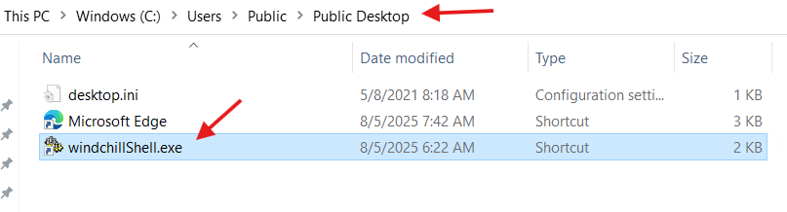

# Errors in Method Server Log

## Error-1:

1. Observed the below error message in MS log during Windchill start up.

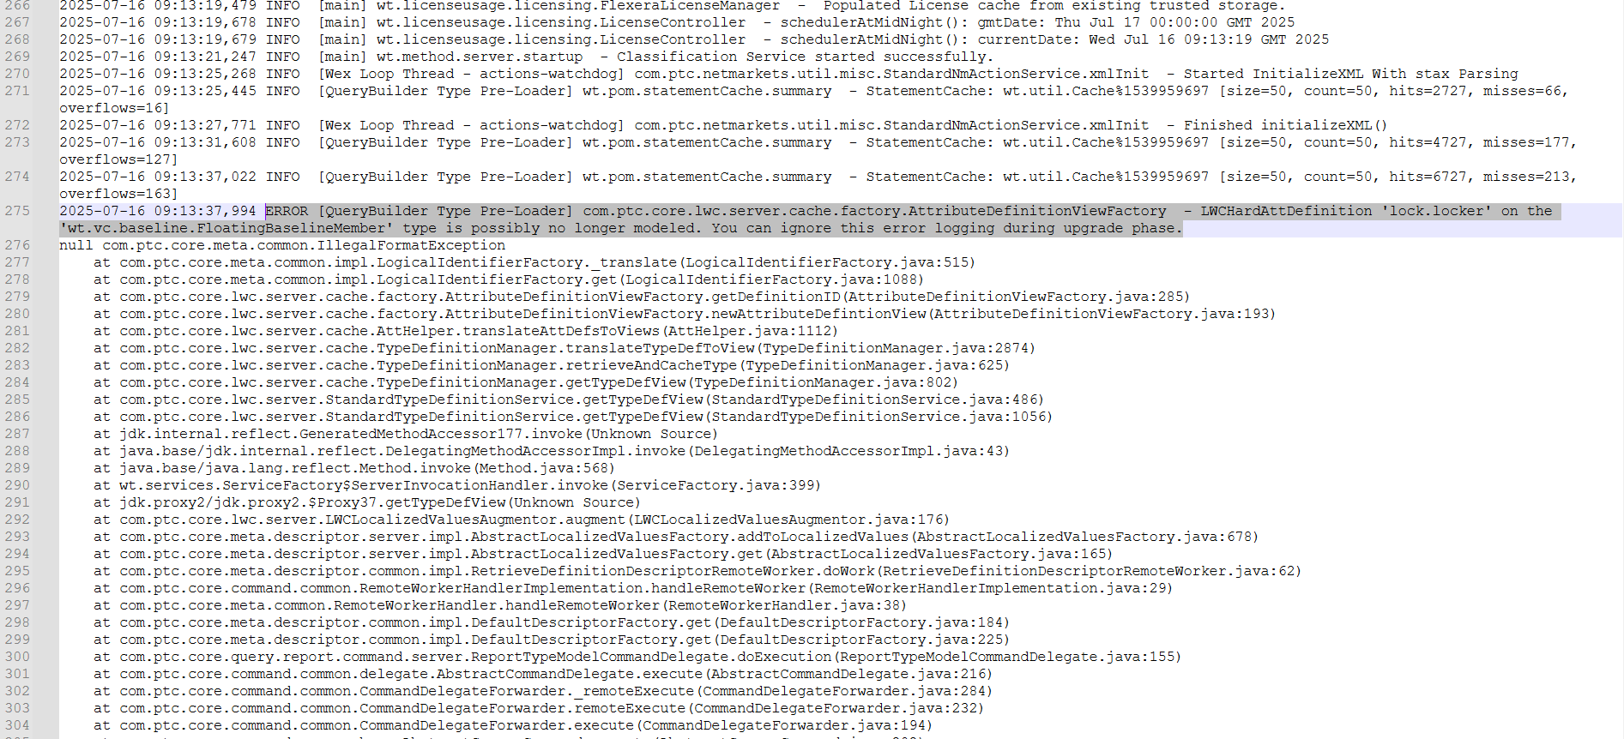

2. Verified in PTC esupport and found the below article to implement the resolution.

**Article:** [Article - CS282233 - 'FloatingBaselineMember type is possibly no longer modeled' message after upgrade in Windchill PDMLink](https://www.ptc.com/en/support/article/CS282233?source=search)

3. Make sure the below highlighted file is available under the following location.

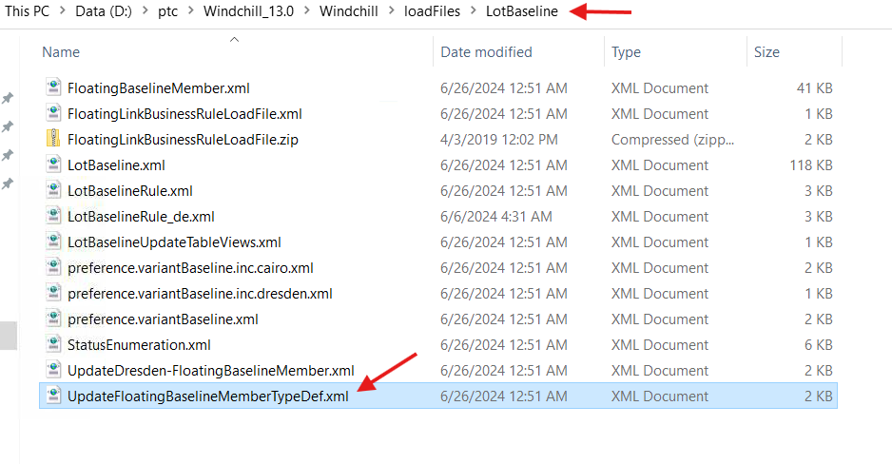

4. Launch Windchill Shell as an admin and execute the below command.

windchill wt.load.LoadFromFile -d D:\ptc\Windchill_13.0\Windchill\loadFiles\LotBaseline\UpdateFloatingBaselineMemberTypeDef.xml -u wtadmin -p password



5. Make sure all objects were loaded successfully.

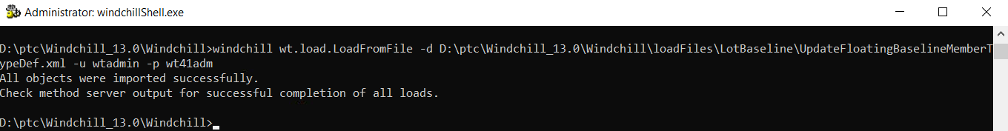

6. Restart Windchill along with clean cache.

## Error-2:

1. Observed the below error message in MS log during Windchill start up.

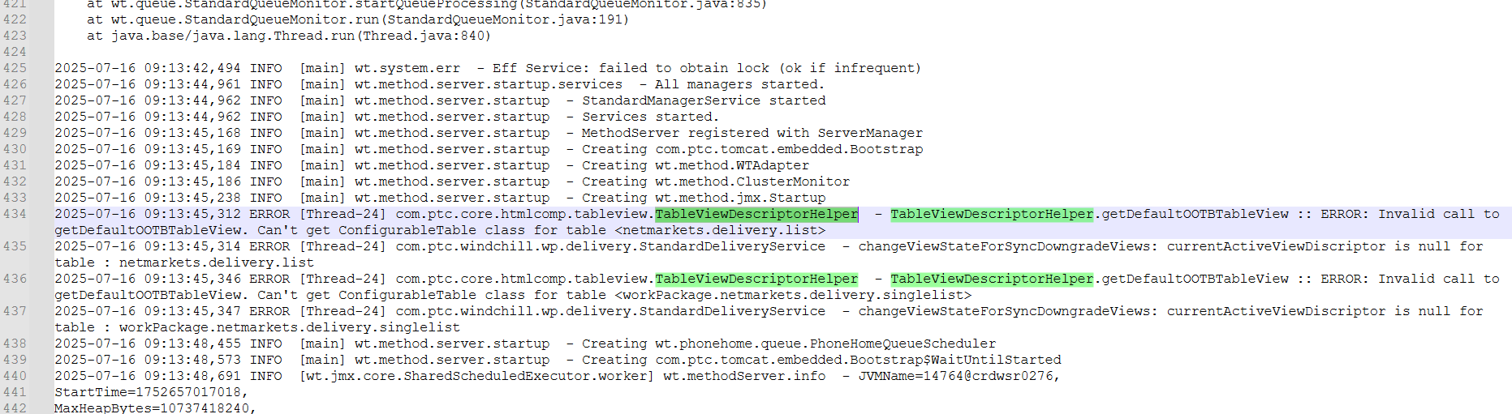

2. Verified in PTC esupport and observed that PTC is planning for a fix for this error in WC 13.1 as per below article.

Article: [Article - CS402745 - TableViewDescriptorHelper reports an error when method server start up in Windchill PDMLink](https://www.ptc.com/en/support/article/CS402745?source=search)

## Error-3:

1. Observed the below error message in MS log.

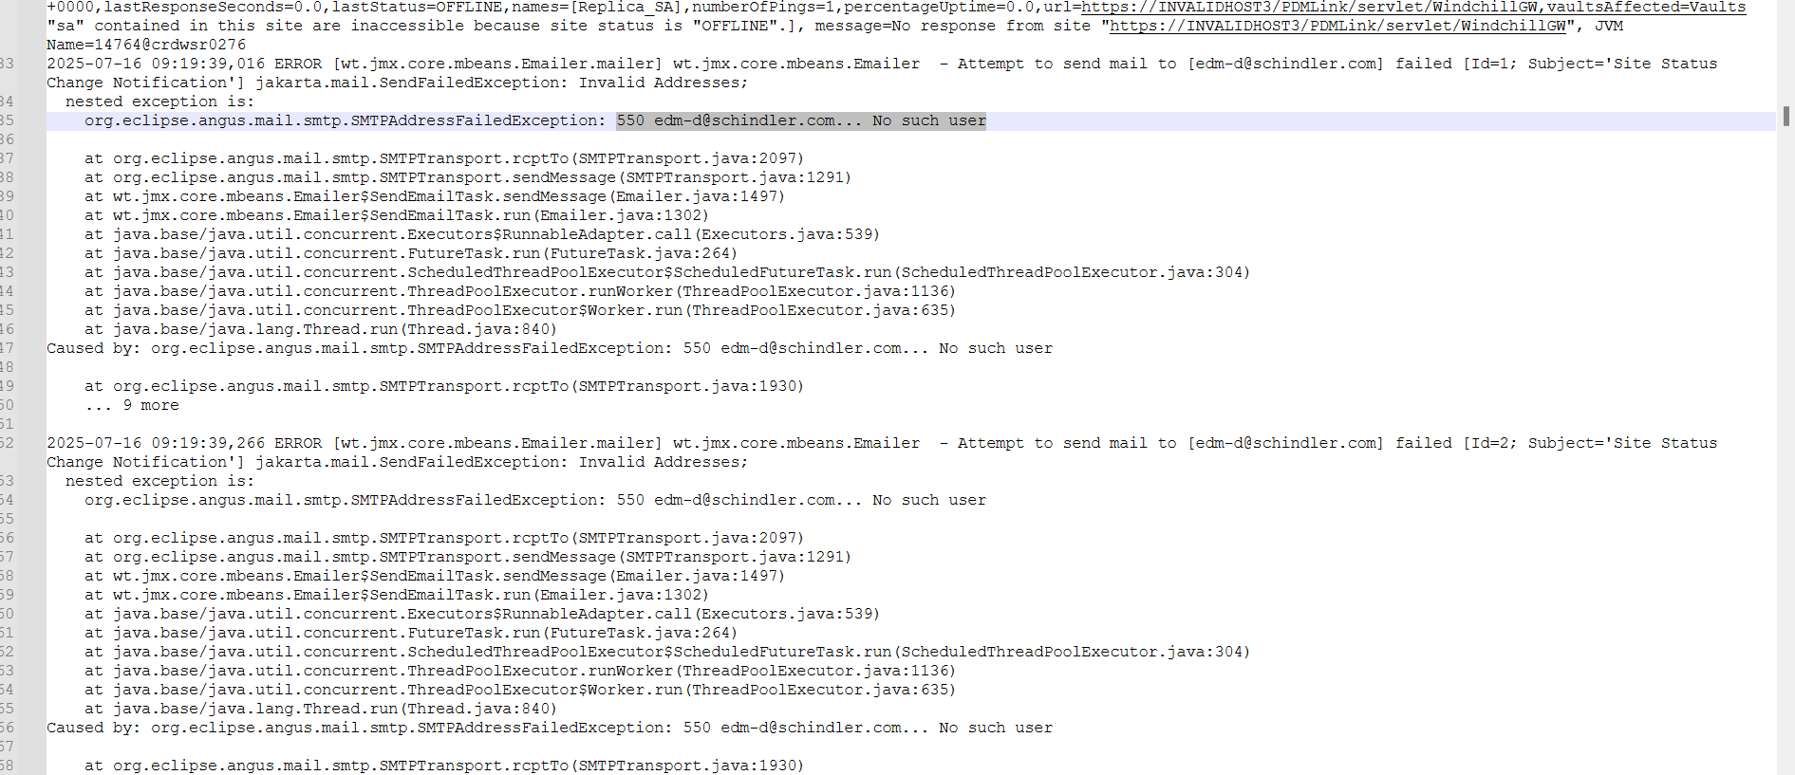

2. This is happening because of wrong input email id value provided during WCA.

3. Followed the below article to update the correct email values.

[Article - CS29374 - Setting up JMX monitors to send automated mail notifications in Windchill](https://www.ptc.com/en/support/article/cs29374)

## Error-4:

1. Observed the below error message in MS log during Windchill start up.

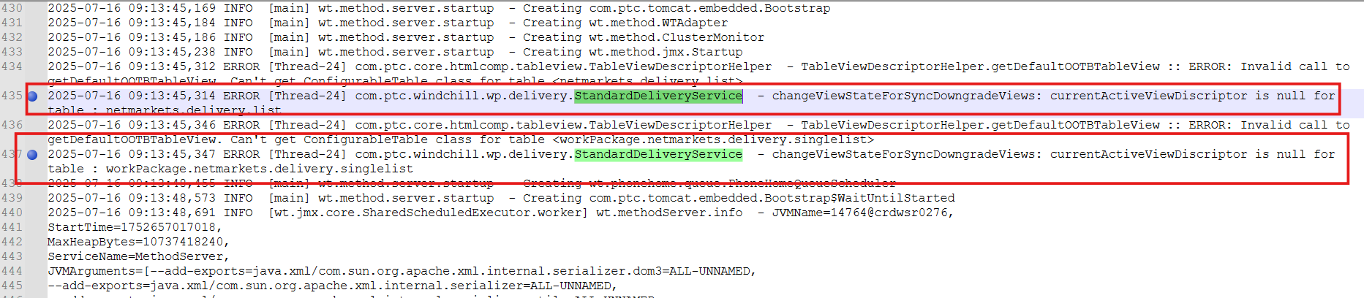

2. Verified in ptc esupport and found the below article to implement the resolution.

Article: [Article - CS300564 - The MethodServer startup shows com.ptc.windchill.wp.delivery.StandardDeliveryService - changeViewStateForSyncDowngradeViews: currentActiveViewDiscriptor is null for table : netmarkets.delivery.list in Windchill PDMLink](https://www.ptc.com/en/support/article/CS300564?source=search)

3. Log into Windchill DB as Windchill DB User (pdmlink).

4. Create backup of TableViewDescriptor table by executing the below query.

select * into TableViewDescriptor_bakAfterWC13Upgrade from TableViewDescriptor;  
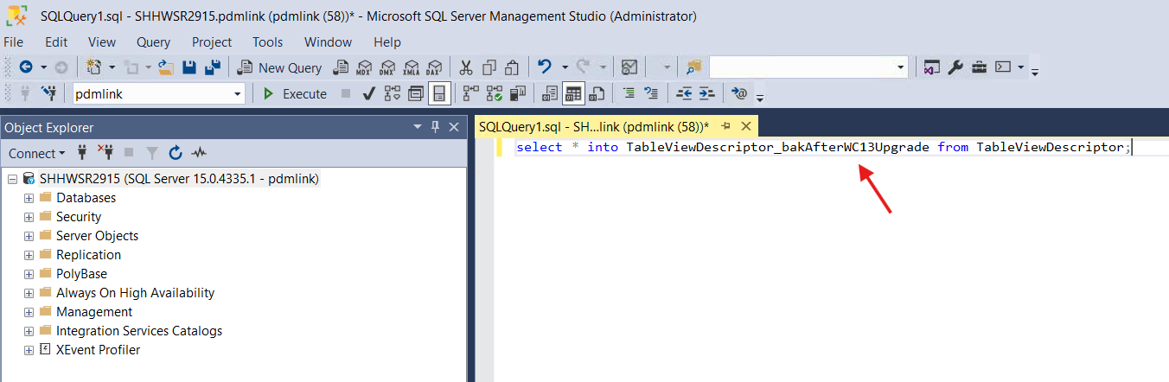  
  
5. Make sure backup completed successfully.  
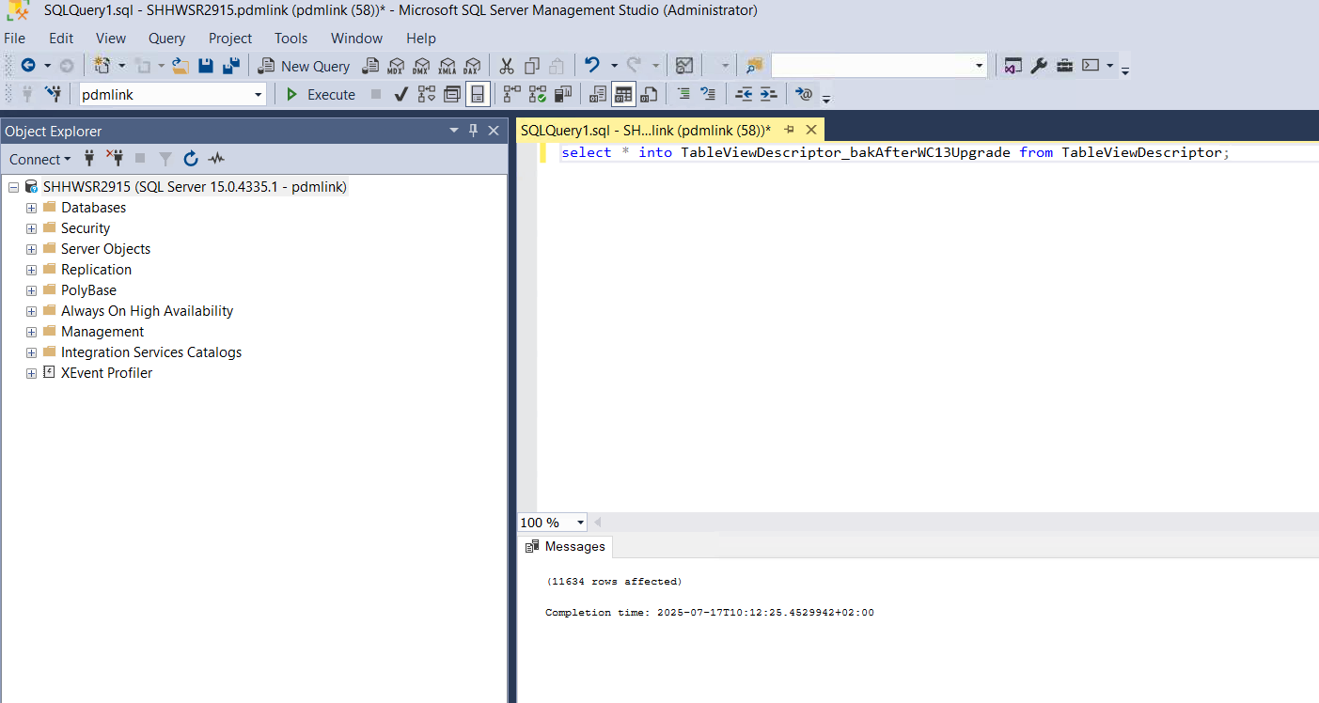  
  
  
6. Execute below queries.

delete from TableViewDescriptor where tableID='netmarkets.delivery.list';

delete from TableViewDescriptor where tableID='workPackage.netmarkets.delivery.singlelist';

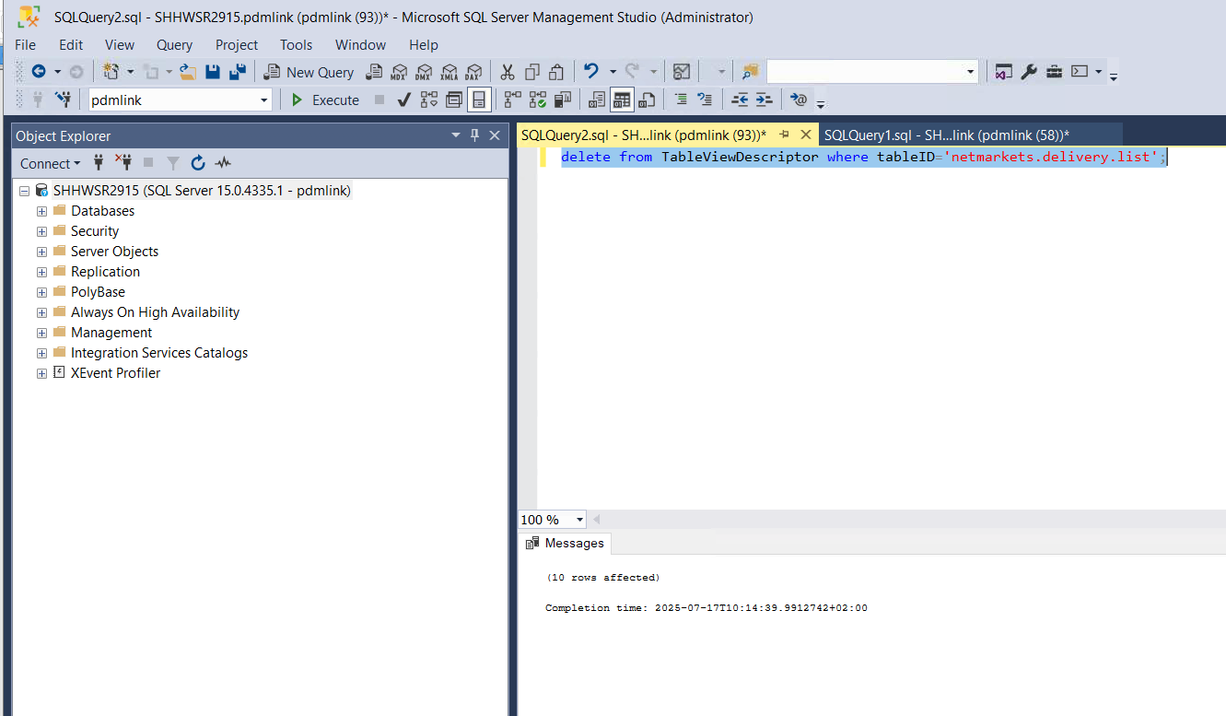

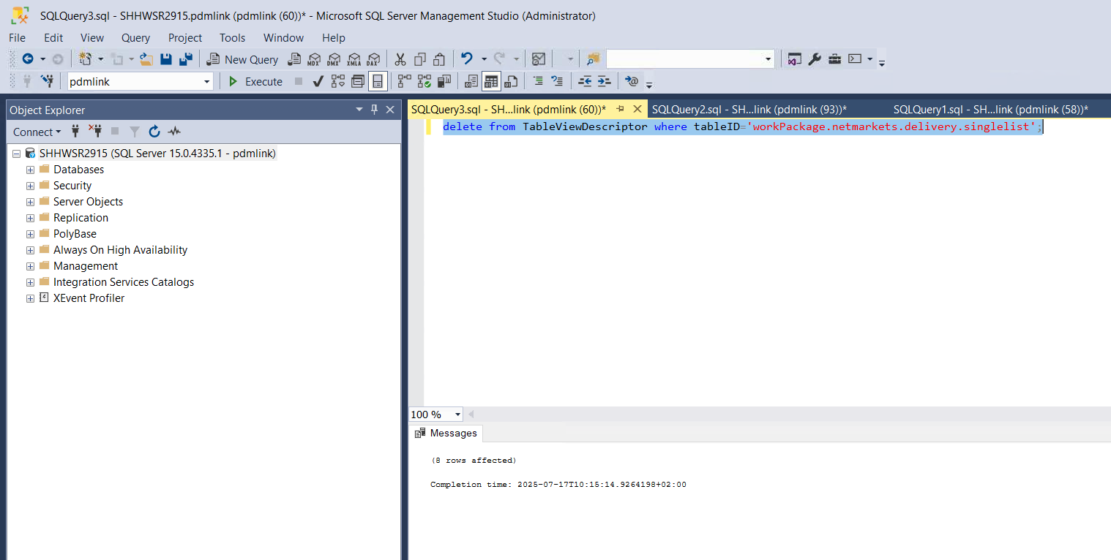

7. Restart Windchill along with clean cache.

# Performance Tuning:

1. Please refer the below documentation.

URL: [Performance Tuning for Rh-1 - Schindler CRD Applications - CRD Confluence](https://confluence.schindler.com/spaces/SCA/pages/623186356/Performance+Tuning+for+Rh-1)

# Windchill Stop and Start Shortcuts on Desktop:

1. Please refer the below documentation.

URL: [Windchill Stop and Start Shortcuts on Desktop - Schindler CRD Applications - CRD Confluence](https://confluence.schindler.com/spaces/SCA/pages/631441097/Windchill+Stop+and+Start+Shortcuts+on+Desktop)

# Procedure to Stop Windchill, Clean Cache and Start Windchill:

1. Please refer the below documentation.

URL: [Procedure to Stop Windchill, clean cache and Start Windchill - Schindler CRD Applications - CRD Confluence](https://confluence.schindler.com/spaces/SCA/pages/631441591/Procedure+to+Stop+Windchill+clean+cache+and+Start+Windchill)